A
PROJECT REPORT ON
“COMPUTER LAB MANAGEMENT SYSTEM”

Semester: -5th&6th
(Submitted By: - Group 1)
Dissertation submitted in partial fulfilment of the requirements for the degree of
diploma in Computer Science and Engineering


DEPARTMENT OF COMPUTER SCIENCE AND ENGINEERING
BHADRAK ENGINEERING SCHOOL AND TECHNOLOGY(BEST)
For Academic Year (2022-2025)

CERTIFICATE
This is to certify that the work in this Project Report entitled
"LAB MANAGEMENT SYSTEM" by 6THsem students has been carried out under my supervision in partial fulfilment of the requirements for the Diploma in Computer Science and Engineering during session 2022- 2025 in Department of Computer Science and Engineering of Bhadrak Engineering School & Technology (BEST) and this work is the original work of the below students.

Om Prakash Behera | F22066007023
Sourav Sundar Pattanayak | F22066007028
Abinash Panda | F22066007002
Subhranshu Behera | F22066007031

Internal Examiner External Examiner

HOD
(Department of Computer Science)

ACKNOWLEDGEMENT

We take this opportunity to express our sincere gratitude to all those who helped us in various capacities in undertaking this project and devising the report. We are privileged to express our sense of gratitude to our respected teacher Er. Satabdi Palit, for providing us with the right guidance and advice at the crucial junctures and for showing me the right way. We extend our sincere thanks to our respected head of the dept. Er. Jyotsna Mayee Jena, for allowing us to use the facilities available. We also take this opportunity to express a deep sense of gratitude to our principal Er. Rabindra Kumar Jena for his cordial support, valuable suggestions and guidance. We would like to thank the other faculty members of our department also, at this occasion.

Last but not the least, we would like to thank our friends and family for the support and encouragement they have given us during the course of our work

TABLE OF CONTENT

SL. No | Chapter Name | Page
1 | Introduction
2 | Background
3 | Target Audience
4 | Purposed Project
5 | Design
6 | Coding
7 | Benefits / Advantages
8 | Conclusion
9 | Future Scope
10 | Reference

TABLE OF FIGURE

SL. No | Chapter Name | Page
1 | Introduction
2 | Background
3 | Target Audience
4 | Purposed Project
5 | Design
6 | Coding
7 | Benefits / Advantages
8 | Conclusion
9 | Future Scope
10 | Reference

ABSTRACT
The Computer Lab Management System (CLMS) is a comprehensive web-based software application designed to streamline and automate the administration of computer laboratories in educational institutions, particularly in colleges. As computer labs grow in complexity and scale, traditional manual methods of managing assets, devices, issues, and records become increasingly inefficient, error-prone, and time-consuming. CLMS addresses these challenges by offering a centralized, intuitive platform that enables lab administrators to manage all aspects of the lab operations from a single dashboard.
The CLMS is developed using PHP for backend logic, MySQL for relational database management, and HTML/CSS (with responsive styling and Boxicons) for front-end presentation. It also ensures secure user sessions with login-based access control and allows management at the individual lab level (e.g., Lab A, Lab B), providing flexibility and scalability.

INTRODUCTION
The effective management of college computer labs is essential for ensuring smooth academic operations, proper equipment maintenance, and the tracking of system usage and issues. A centralized, automated Computer Lab Management System (CLMS) provides administrators with the necessary tools to efficiently manage multiple computer labs. This SRS document outlines the specifications for a comprehensive system designed to facilitate various administrative tasks such as device tracking, system updates, inventory management, QR-based data entry, issue resolution, and more.
This document is intended to communicate the system’s functionalities, design requirements, and implementation strategy in a clear and structured format for both technical and non-technical stakeholders. The system will significantly reduce manual errors, improve equipment traceability, and streamline administrative workflows.

BACKGROUND
Traditional methods of managing computer labs in educational institutions often involve manual record-keeping and decentralized documentation, leading to inefficiencies and errors. With increasing reliance on technology in education, it has become essential to modernize the way computer labs are administered.
Common issues faced include:
- Inaccurate or lost records of systems and peripherals.
- Difficulty in identifying and resolving system-related issues.
- Lack of centralized control for multiple lab environments.
- Inability to track inventory efficiently.
- Poor visibility of historical maintenance or issue data.
This project aims to address these challenges by introducing a robust, scalable, and user-friendly web-based management platform. This system will also help technical staff and college administrators in achieving better control and supervision over lab resources.

LITERATURE SURVEY
The development of the Computer Lab Management System (LMS) is grounded in a comprehensive review of existing technologies, systems, and academic contributions in the area of IT asset management, lab automation, and educational resource tracking. This literature survey explores relevant past work, identifies gaps in current systems, and justifies the need for the proposed solution.

1. Traditional Lab Management Systems
Traditional computer lab management primarily relied on manual documentation using logbooks, spreadsheets, and verbal communication between faculty and lab assistants. Although cost-effective, these methods suffer from:
- High error rates in data entry and tracking
- Loss or misplacement of data
- Difficulty in updating or scaling as labs grow
- Poor accountability and transparency
Manual systems are not feasible in institutions with multiple labs and hundreds of systems. Hence, digitization became necessary for accuracy, efficiency, and accessibility.

2. Existing Digital Lab Management Solutions
Numerous software applications exist for IT asset management and lab tracking. Commonly known systems include:
a) GLPI (Gestionnaire Libre de Parc Informatique)
GLPI is an open-source asset management system widely used in educational institutions and corporate settings. It offers:
- Inventory management
- Ticket-based issue handling
- Plugins for QR code integration
However, GLPI is often too complex for smaller institutions and may require dedicated technical teams for deployment and maintenance.
b) iTALC (Intelligent Teaching and Learning with Computers)
iTALC allows teachers to view and control student PCs remotely, monitor lab activity, and broadcast their screen. While powerful for classroom management, it does not manage hardware inventory, stocks, or receipts.
c) Spiceworks IT Desktop
A free IT helpdesk and asset tracking solution popular in small offices. Its issue tracking and reporting features are helpful but are heavily focused on enterprise-level use, lacking educational lab-specific features such as system mapping by location or QR-based login systems.

3. QR Code-Based Systems in Education
QR code integration has gained traction in student attendance tracking and device identification:
- QR Attendance Systems: Multiple colleges have implemented QR-based attendance to reduce manual record-keeping. These systems are efficient but are rarely integrated with lab hardware or stock management.
- QR for Asset Tagging: QR codes have replaced barcodes in many institutions due to better smartphone compatibility and dynamic linking ability. Most systems, however, use third-party platforms with limited customization options.
LMS uniquely integrates QR codes both for device management and user login, offering a cohesive and extensible design.

4. Academic Research Contributions
Several academic studies and projects have explored similar ideas:
a) “A Web-Based Laboratory Equipment Management System for University Campuses”
Published in the International Journal of Computer Applications, this study emphasized the need for scalable and secure web-based tools to manage laboratory resources.
b) “Development of IT Asset Tracking System Using QR Code Technology”
This project demonstrated the practical use of QR codes to identify and track IT equipment in a university setting, confirming high reliability and faster inventory verification.
These studies support the feasibility and effectiveness of digitized lab tracking systems but do not offer all-in-one platforms combining hardware, QR scanning, and real-time system mapping, as LMS does.

5. Gaps in Current Systems
Based on the surveyed tools and research:
- Lack of Integration: Existing systems often handle only a portion of the lab’s needs (e.g., only device inventory, or only issue tracking).
- Complexity and Cost: Many tools require a steep learning curve or paid licenses, making them unsuitable for polytechnic or smaller educational institutions.
- Limited Customization: Out-of-the-box tools may not allow lab-specific configurations such as lab-wise system grouping, custom receipt printing, or manual status updates.

6. LMS Contributions
The proposed LMS addresses these gaps by:
- Offering a simple web-based dashboard for all key tasks: device management, stock updates, QR login, issue handling, and logs
- Supporting QR scanning for both system access and inventory validation
- Generating receipts and reports dynamically
- Structuring the system for lab-specific usage (Lab A, B, C, D)
- Using open-source tools (PHP, MySQL) for budget-friendliness

7. Conclusion of Survey
The literature reveals that while several digital systems exist for lab and IT management, few are tailored to the specific needs of educational labs. The LMS project is designed to fill this void by offering a unified, intuitive, and modular solution. Drawing insights from academic work and practical tools, LMS blends simplicity and functionality to modernize lab administration without introducing unnecessary complexity.

TARGET AUDIENCE
The target users of the Computer Lab Management System include:
- System Administrators: Manage lab data, add/remove systems, monitor activities.
- Lab Technicians: Record and address technical issues, update hardware logs.
- College IT Officers: Oversee lab efficiency, generate reports, and enforce policies.
- Non-technical Staff: Use simplified interfaces for tracking inventory or printing receipts.
The system is designed with a user-friendly interface that minimizes the learning curve, especially for non-technical users.

ADMINSTRATOR

PURPOSED PROJECT
HARDWARE AND SOFTWARE SPECIFICATIONS
A robust, secure, and efficient Computer Lab Management System (CLMS) requires both hardware and software components to function effectively. This section details the minimum and recommended hardware and software specifications required for the development, deployment, and maintenance of the system.
1. Hardware Requirements
The hardware requirements are divided into three categories: Server-side (Admin), Client-side (Users), and Network infrastructure.
1.1 Server-Side (Admin Panel Hosting Machine)
Component | Minimum Requirement | Recommended Specification
Processor | Intel Core i3 or AMD Ryzen 3 | Intel Core i5/i7 or AMD Ryzen 5/7
RAM | 4 GB | 8 GB or more
Hard Disk | 128 GB SSD or 500 GB HDD | 256 GB SSD or higher
Network Interface | Ethernet/Wi-Fi | Gigabit Ethernet or Dual-band Wi-Fi
Operating System | Windows 10 / Linux (Ubuntu 20.04+) | Ubuntu Server 22.04 LTS / Windows Server 2019

1.2 Client-Side (Student & Lab Use)
Component | Minimum Requirement | Recommended Specification
Processor | Intel Pentium or equivalent | Intel Core i3 or higher
RAM | 2 GB | 4 GB or more
Hard Disk | 120 GB | 256 GB SSD
Display | 15.6" Monitor, 1024x768 resolution | Full HD Monitor (1920x1080)
Network | Ethernet or Wi-Fi | Ethernet preferred for speed and reliability
Peripherals | Keyboard, Mouse, Webcam (for QR scan) | Same

1.3 Network Infrastructure
Component | Description
Router/Switch | 10/100/1000 Mbps compatible
Access Points | For wireless connectivity (optional)
Cabling | Cat5e or Cat6 Ethernet cables
QR Code Scanner | External USB scanner or smartphone camera

2. Software Requirements
The software stack used in the CLMS project is open-source and highly compatible with educational institutions' needs.

2.1 System Software
Software | Description
Operating System | Windows 10/11, Linux (Ubuntu)
Web Server | Apache or Nginx
Database Server | MySQL / MariaDB
Programming Language | PHP 7.4+
Frontend Technologies | HTML5, CSS3, JavaScript, Bootstrap
QR Code Libraries | PHP QR Code Library / JavaScript QR
Version Control | Git

2.2 Development Tools
Tool | Purpose
VS Code / Sublime Text | Code editor
XAMPP / LAMP Stack | Local server environment
phpMyAdmin | MySQL DB management
Figma / Canva | UI/UX design and wireframing
GitHub / GitLab | Code repository and version control

2.3 Browser Compatibility
The CLMS web interface is designed to work on all modern browsers:
- Google Chrome (v80+)
- Mozilla Firefox (v75+)
- Microsoft Edge (v85+)
- Safari (v13+)

3. Optional Technologies for Enhancement
Technology | Use Case
Python (Flask/Django) | API Integration, QR Code Generation
React.js / Vue.js | Advanced frontend interactivity
Mobile App (Flutter) | Extend QR Scan and Reporting on Android/iOS
Docker | For containerized deployment

4. Security Tools
Tool | Purpose
HTTPS/SSL | Secure communication
Firewall / Antivirus | System protection
Role-Based Access | Admin and user-level access separation
CAPTCHA integration | Protect login and forms

PROJECT DESCRIPTION
The Computer Lab Management System (CLMS) is a PHP-based web application integrated with databases for multiple labs (Lab A, Lab B, Lab C, Lab D). Each lab operates with its own dataset for:
- Devices (monitors, keyboards, etc.)
- CPUs and systems
- UPS units
- QR scan data for system authentication and tracking
- Lab locations
- Stock records
- Issue tracking and resolution
- System logs
The application includes modules for:
- User Authentication: Login and session management using secure authentication.
- Dashboard: A visual summary of all lab data, accessible per lab.
- Device Management: Track and update devices assigned to each lab.
- System Management: Monitor computers and system specs (RAM, storage, OS).
- Stock Management: Maintain inventory of parts and consumables.
- Issue Tracking: Record new problems and manage resolutions.
- QR Integration: Log entries and authenticate devices via QR code scans.
- Logs & Receipts: Generate receipts and track system logs.
- Lab Location Tracking: View and update physical lab details.

File Organize
CLMS-
Admin – directory containing the under files those are bulleted
- dashboard.php
- lab_location.php
- lab_panel.php
- manage_devices.php
- manage_systems.php
- manage_stocks.php
- manage_systems.php
- print_receipt.php
- qr_profile.php
- resolve_issues.php
- scan.php
- search_devices.php
- search_issues.php
- search_logs.php
- search_stock.php
- search_systems.php
- system_logs.php
assests
- images
- style.css
assets
- css
  - animate.css
  - bootstrap.min.css
  - glightbox.min.css
  - lineicons.css
  - style.css
  - style.css.map
- fonts
- LineIcons.eot
- LineIcons.svg
- LineIcons.ttf
- LineIcons.woff
- LineIcons.woff2
- Images
  - About
  - Blog
  - Brands
  - Footer
  - Header
  - logo
  - services
  - team
  - testimonials
  - video
  - favicon.png
- js
  - bootstrap.min.js
  - count-up.min.js
  - glightbox.min.js
  - main.js
  - particles.min.js
  - wow.min.js

include
  - auth_check.php
  - config.php
  - db.php
  - phpqrcode module
public
- forget_password.php
- login.php
- logout.php
- qr_reg.php
qr_code
directory where the qr code is saved
index.html
team.css
team.html

IMPLEMENTATION DETAILS
The implementation of the Computer Lab Management System (CLMS) is the process by which the system’s planned functionality is developed, integrated, and deployed in a real-world environment. The goal is to ensure that every module works effectively, with minimal user input and maximum operational clarity for lab administrators and educational staff.
1. Development Environment
- Frontend: HTML5, CSS3, JavaScript (Boxicons and modern UI techniques)
- Backend: PHP 8.x (for processing logic, authentication, and data handling)
- Database: MySQL (used for storing lab data, user information, logs, and device records)
- QR Code Integration: PHP QR code library for generating and scanning QR codes
- IDE Used: Visual Studio Code
- Version Control: Git (for project backup and versioning)
- Server Stack: XAMPP or LAMP (used for local development and deployment)

2. System Modules and Implementation
The CLMS is designed modularly, with each core function handled by a specific module. Here are the major components:
a) Manage Devices
- Admins can add, update, delete, and view all computer lab devices (monitors, CPUs, mice, etc.)
- Devices are categorized and uniquely identified
- Device health/status can be updated manually
b) Manage Systems
- Tracks complete computer setups, allowing admins to assign and configure systems
- Links monitors, CPUs, and peripherals into one logical "system" unit
- Assigns systems to specific lab rooms or tables
c) Manage Stocks
- Admins can manage inventory records for spare parts, cables, software licenses, and other consumables
- Stock status: available, low, used, replaced
- Notification triggers can be implemented in future versions
d) Print Receipts
- Generates printable receipts after hardware updates, repairs, or stock consumption
- Receipts include timestamp, admin signature, and detailed item list
- Stored digitally in the system for audit history
e) QR Code Scanner & Login
- QR Code generation for devices and systems
- QR code login for student or staff attendance and device check-in/out
- Scanner supports web-camera or external scanner integration
f) Resolved Issues
- Admins can log and view hardware/software issues reported
- A “resolve” action marks the issue as completed and stores timestamp
- Issue types are categorized (hardware failure, software bug, performance lag, etc.)
g) System Logs
- Logs all user and system activities (device edits, logins, issue status, etc.)
- Logs can be filtered by user, date, module, or action
- Helps in auditing lab usage and staff accountability
h) Lab Location
- Each system or device can be mapped to a specific lab room and location within that room (e.g., Lab B – Table 4)
- Helps in quick tracking and management of inventory

3. Database Design
The system uses relational database principles to ensure data integrity and efficient access.
Main Tables:
- devices: Stores individual device records (ID, type, model, status)
- systems: Stores entire system setup information (linked with devices)
- stocks: Inventory of consumables
- issues: Issue tracking data
- logs: Records of all admin/user actions
- qr_scans: QR login/session records
- locations: Mapping of systems/devices to labs
- users: Admin credentials and roles
Relationships:
- Foreign keys maintain integrity (e.g., devices linked to systems, logs linked to users)

4. User Interface
The UI is simple and intuitive, created using responsive HTML and CSS. Each module is displayed using clear icon-based cards with bold titles such as:
- Manage Devices
- Manage Systems
- Resolved Issues
- System Logs
Color-coded modules help users quickly navigate. Minimal training is needed for operation, as every action follows a logical button-based flow (e.g., Add ➝ View ➝ Edit ➝ Delete).

5. Security and Access Control
- Admin login with session management
- Future versions can include roles (e.g., junior admin, super admin)
- Sensitive actions (like device deletion or stock update) require confirmation

6. Testing and Debugging
- Manual testing was conducted for each module
- Common bugs related to QR code scanning, foreign key mismatches, and form validation were resolved
- The system was tested with sample data for all four labs (Lab A, B, C, D)

7. Deployment
- Can be deployed on any local server environment (XAMPP/LAMP)
- Future deployment to a cloud server (e.g., Apache on AWS) is possible
- Backup system included by exporting MySQL database

8. Maintenance Plan
- Future updates include features like automatic issue alerts, cloud backup, email notifications
- Easy for future developers to extend due to clean modular design

DESIGN
Backend-
ER Diagram-
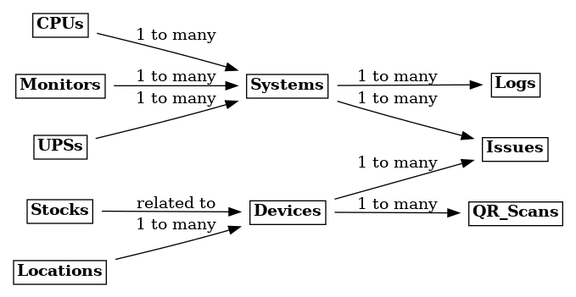
System Design-
DFD LEVEL 0
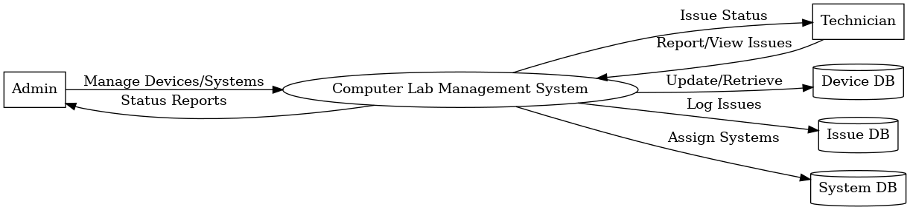

DFD LEVEL 1
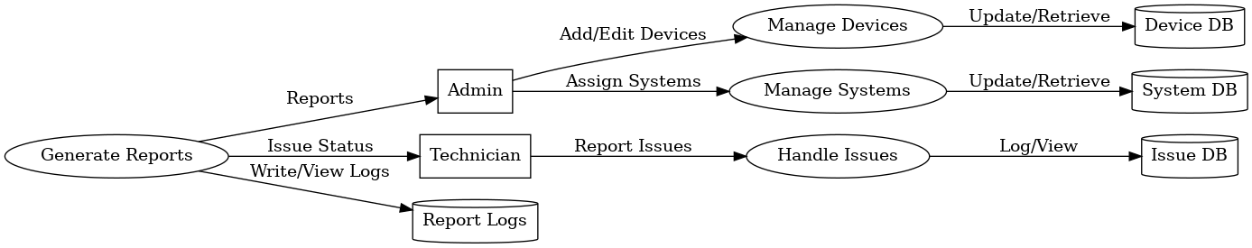

Frontend Interfaces-
📌 1. Dashboard Interface-

📌 2. LAB Panel Interface-

📌 3. Landing Page Interface-
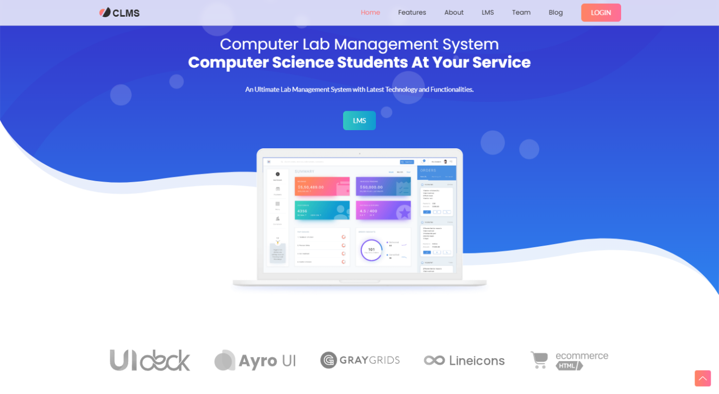
📌 4. Login Interface-
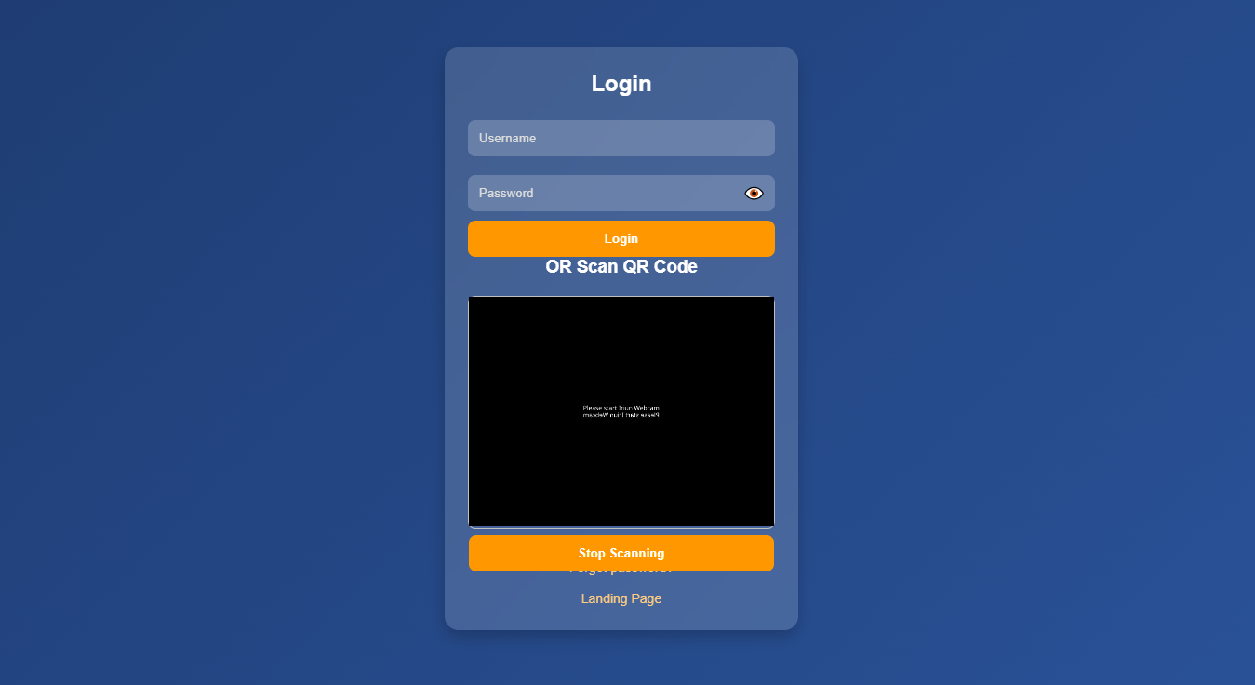

📌 5. Password Forget Interface-
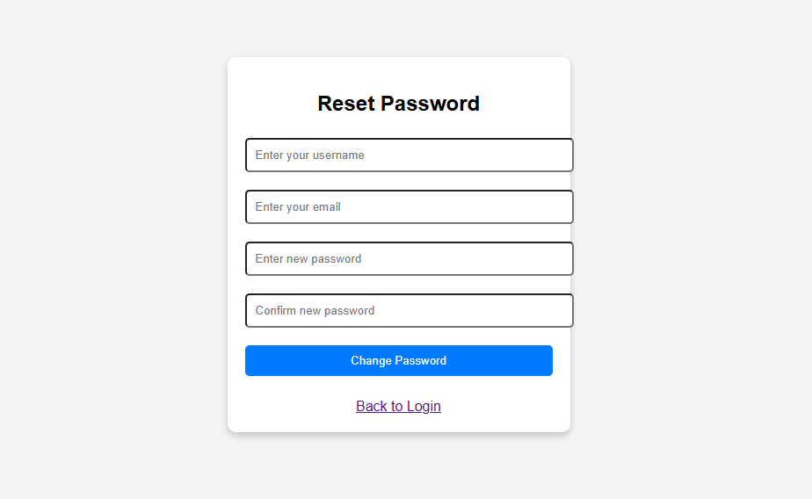
📌 6. Manage Device Interface-
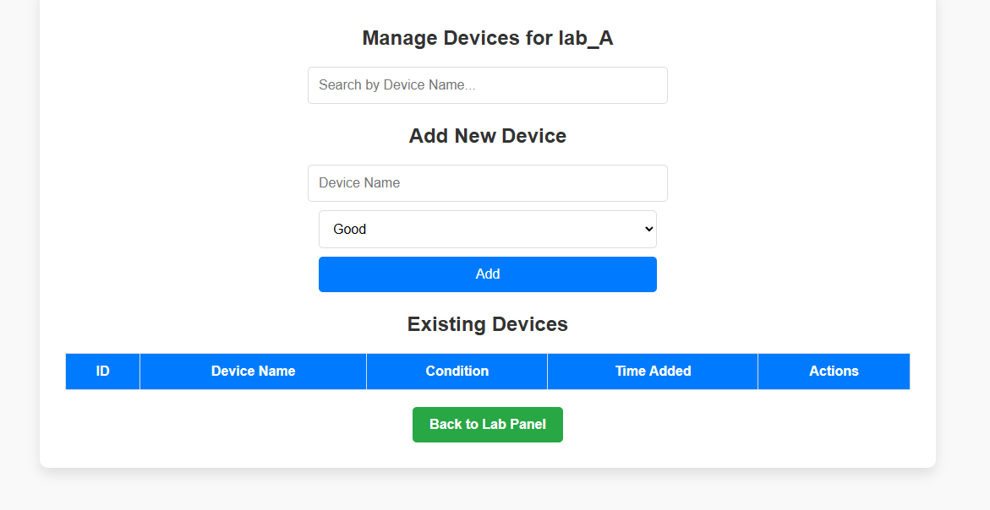

📌 7. Manage System Interface-
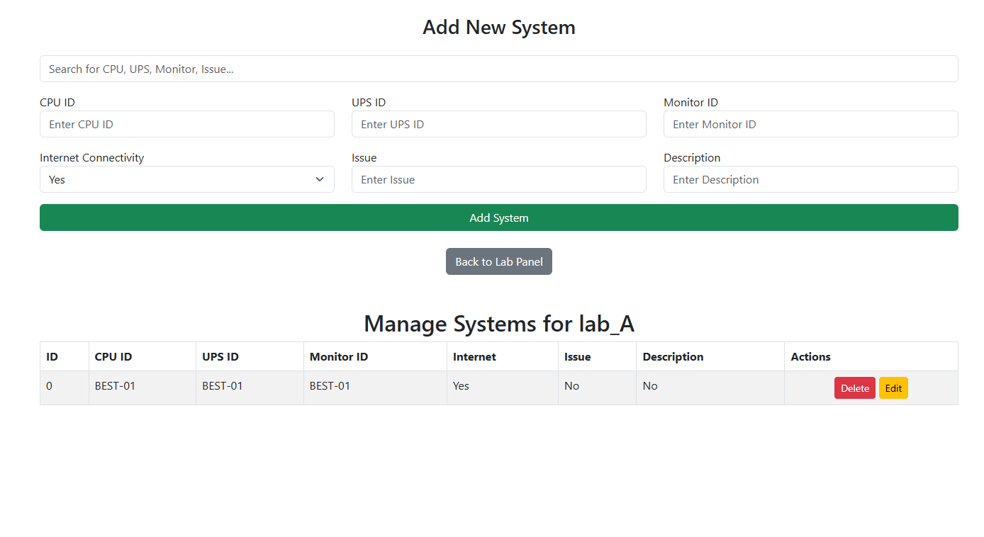
📌 8. Manage Stock Interface-
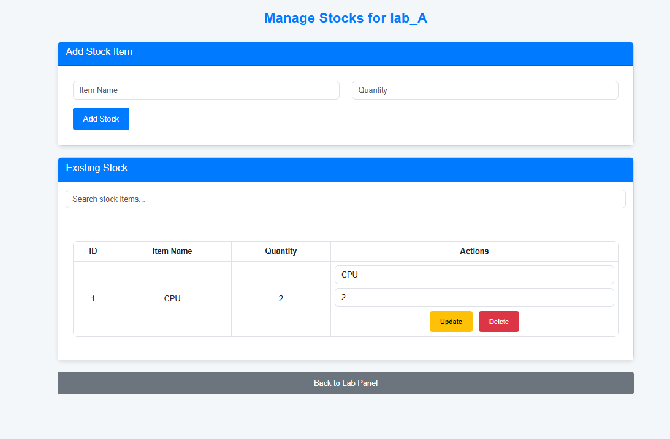

📌 9. Print Reciept Interface-
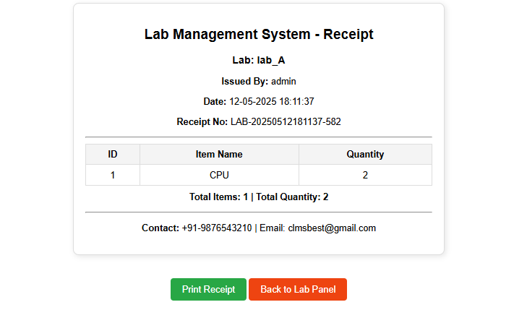
📌 10. Manage Issues Interface-
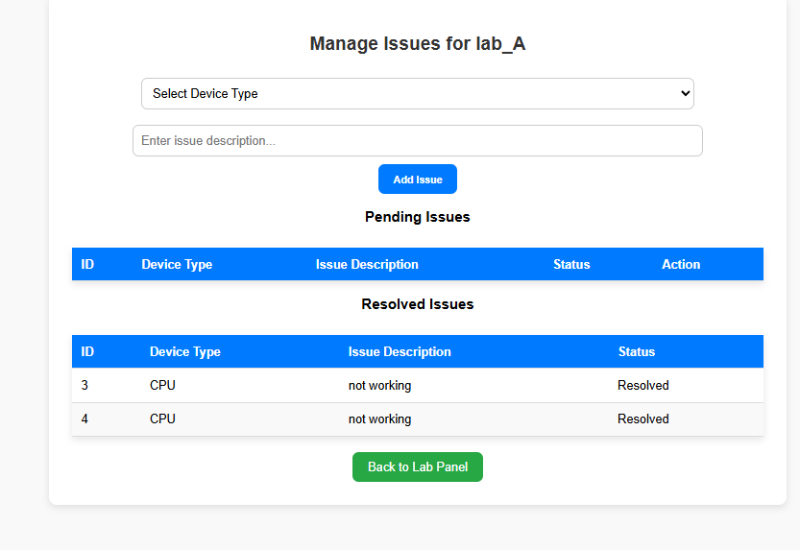
📌 11. System Logs Interface-
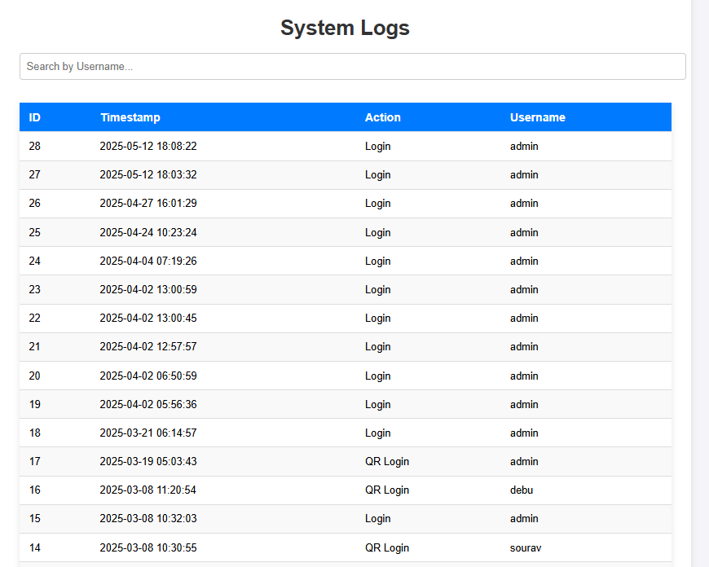 📌 12. QR Scan of systems Interface-
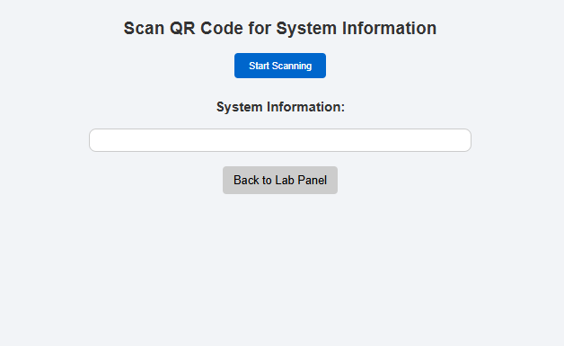

📌 13. Lab Location Interface-
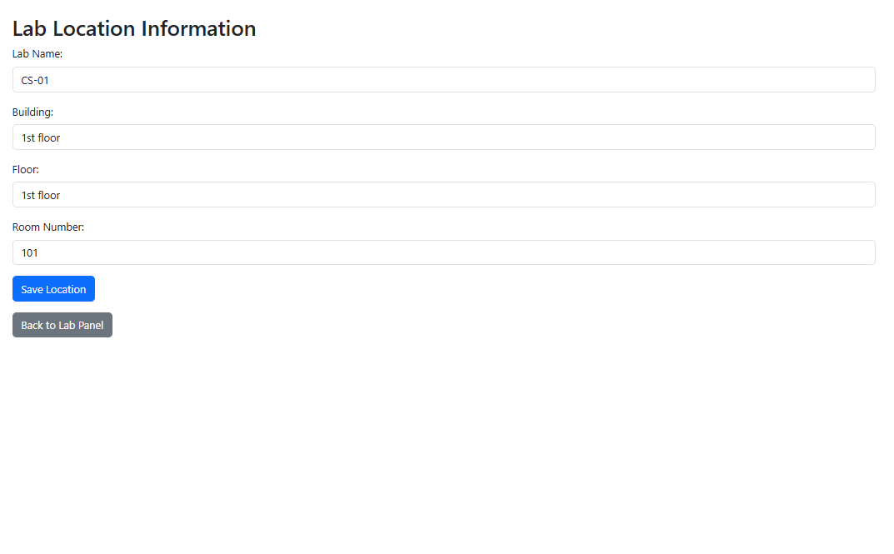

CODING
Backend
SQL
Execution to create databases
CREATE DATABASE main_auth;
CREATE DATABASE lab_a;
USE DATABASE lab_a;

Lab-A
-- phpMyAdmin SQL Dump
-- version 5.2.1
-- https://www.phpmyadmin.net/
--
-- Host: 127.0.0.1
-- Generation Time: Mar 21, 2025 at 07:02 AM
-- Server version: 10.4.32-MariaDB
-- PHP Version: 8.2.12

SET SQL_MODE = "NO_AUTO_VALUE_ON_ZERO";
START TRANSACTION;
SET time_zone = "+00:00";

/*!40101 SET @OLD_CHARACTER_SET_CLIENT=@@CHARACTER_SET_CLIENT */;
/*!40101 SET @OLD_CHARACTER_SET_RESULTS=@@CHARACTER_SET_RESULTS */;
/*!40101 SET @OLD_COLLATION_CONNECTION=@@COLLATION_CONNECTION */;
/*!40101 SET NAMES utf8mb4 */;

--
-- Database: `lab_a`
--

-- --------------------------------------------------------

--
-- Table structure for table `devices`
--

CREATE TABLE `devices` (
`id` int(11) NOT NULL,
`device_name` varchar(255) NOT NULL,
`working_condition` enum('Good','Needs Repair','Not Working') DEFAULT 'Good',
`time_added` timestamp NOT NULL DEFAULT current_timestamp()
) ENGINE=InnoDB DEFAULT CHARSET=utf8mb4 COLLATE=utf8mb4_general_ci;

-- --------------------------------------------------------

--
-- Table structure for table `lab_a_cpus`
--

CREATE TABLE `lab_a_cpus` (
`id` int(11) NOT NULL,
`cpu_id` varchar(50) NOT NULL
) ENGINE=InnoDB DEFAULT CHARSET=utf8mb4 COLLATE=utf8mb4_general_ci;

-- --------------------------------------------------------

--
-- Table structure for table `lab_a_issues`
--

CREATE TABLE `lab_a_issues` (
`id` int(11) NOT NULL,
`device_type` varchar(20) DEFAULT NULL,
`description` text NOT NULL,
`status` enum('Pending','Resolved') DEFAULT 'Pending'
) ENGINE=InnoDB DEFAULT CHARSET=utf8mb4 COLLATE=utf8mb4_general_ci;

--
-- Dumping data for table `lab_a_issues`
--

INSERT INTO `lab_a_issues` (`id`, `device_type`, `description`, `status`) VALUES
(3, 'CPU', 'not working', 'Resolved'),
(4, 'CPU', 'not working', 'Resolved');

-- --------------------------------------------------------

--
-- Table structure for table `lab_a_locations`
--

CREATE TABLE `lab_a_locations` (
`id` int(11) NOT NULL,
`lab_name` varchar(255) NOT NULL,
`building` varchar(255) NOT NULL,
`floor` varchar(50) NOT NULL,
`room_number` varchar(50) NOT NULL,
`lab_id` varchar(255) DEFAULT NULL
) ENGINE=InnoDB DEFAULT CHARSET=utf8mb4 COLLATE=utf8mb4_general_ci;

--
-- Dumping data for table `lab_a_locations`
--

INSERT INTO `lab_a_locations` (`id`, `lab_name`, `building`, `floor`, `room_number`, `lab_id`) VALUES
(1, 'CS-01', '1st floor', '1st floor', '101', 'lab_A');

-- --------------------------------------------------------

--
-- Table structure for table `lab_a_logs`
--

CREATE TABLE `lab_a_logs` (
`id` int(11) NOT NULL,
`timestamp` timestamp NOT NULL DEFAULT current_timestamp(),
`activity` text NOT NULL,
`username` varchar(50) DEFAULT NULL
) ENGINE=InnoDB DEFAULT CHARSET=utf8mb4 COLLATE=utf8mb4_general_ci;

-- --------------------------------------------------------

--
-- Table structure for table `lab_a_monitors`
--

CREATE TABLE `lab_a_monitors` (
`id` int(11) NOT NULL,
`monitor_id` varchar(50) NOT NULL
) ENGINE=InnoDB DEFAULT CHARSET=utf8mb4 COLLATE=utf8mb4_general_ci;

-- --------------------------------------------------------

--
-- Table structure for table `lab_a_qr_scans`
--

CREATE TABLE `lab_a_qr_scans` (
`id` int(11) NOT NULL,
`system_id` int(11) NOT NULL,
`scan_time` timestamp NOT NULL DEFAULT current_timestamp()
) ENGINE=InnoDB DEFAULT CHARSET=utf8mb4 COLLATE=utf8mb4_general_ci;

-- --------------------------------------------------------

--
-- Table structure for table `lab_a_stocks`
--

CREATE TABLE `lab_a_stocks` (
`id` int(11) NOT NULL,
`item_name` varchar(100) NOT NULL,
`quantity` int(11) NOT NULL
) ENGINE=InnoDB DEFAULT CHARSET=utf8mb4 COLLATE=utf8mb4_general_ci;

--
-- Dumping data for table `lab_a_stocks`
--

INSERT INTO `lab_a_stocks` (`id`, `item_name`, `quantity`) VALUES
(1, 'CPU', 2);

-- --------------------------------------------------------

--
-- Table structure for table `lab_a_systems`
--

CREATE TABLE `lab_a_systems` (
`id` int(11) NOT NULL,
`cpu_id` int(11) NOT NULL,
`ups_id` int(11) NOT NULL,
`monitor_id` int(11) NOT NULL,
`internet` varchar(10) NOT NULL,
`issue` varchar(255) NOT NULL,
`description` text DEFAULT NULL
) ENGINE=InnoDB DEFAULT CHARSET=utf8mb4 COLLATE=utf8mb4_general_ci;

-- --------------------------------------------------------

--
-- Table structure for table `lab_a_upss`
--

CREATE TABLE `lab_a_upss` (
`id` int(11) NOT NULL,
`ups_id` varchar(50) NOT NULL
) ENGINE=InnoDB DEFAULT CHARSET=utf8mb4 COLLATE=utf8mb4_general_ci;

--
-- Indexes for dumped tables
--

--
-- Indexes for table `devices`
--
ALTER TABLE `devices`
ADD PRIMARY KEY (`id`);

--
-- Indexes for table `lab_a_cpus`
--
ALTER TABLE `lab_a_cpus`
ADD PRIMARY KEY (`id`),
ADD UNIQUE KEY `cpu_id` (`cpu_id`);

--
-- Indexes for table `lab_a_issues`
--
ALTER TABLE `lab_a_issues`
ADD PRIMARY KEY (`id`);

--
-- Indexes for table `lab_a_locations`
--
ALTER TABLE `lab_a_locations`
ADD PRIMARY KEY (`id`),
ADD KEY `fk_lab_id` (`lab_id`);

--
-- Indexes for table `lab_a_logs`
--
ALTER TABLE `lab_a_logs`
ADD PRIMARY KEY (`id`);

--
-- Indexes for table `lab_a_monitors`
--
ALTER TABLE `lab_a_monitors`
ADD PRIMARY KEY (`id`),
ADD UNIQUE KEY `monitor_id` (`monitor_id`);

--
-- Indexes for table `lab_a_qr_scans`
--
ALTER TABLE `lab_a_qr_scans`
ADD PRIMARY KEY (`id`),
ADD KEY `system_id` (`system_id`);

--
-- Indexes for table `lab_a_stocks`
--
ALTER TABLE `lab_a_stocks`
ADD PRIMARY KEY (`id`);

--
-- Indexes for table `lab_a_systems`
--
ALTER TABLE `lab_a_systems`
ADD PRIMARY KEY (`id`),
ADD KEY `cpu_id` (`cpu_id`),
ADD KEY `ups_id` (`ups_id`),
ADD KEY `monitor_id` (`monitor_id`);

--
-- Indexes for table `lab_a_upss`
--
ALTER TABLE `lab_a_upss`
ADD PRIMARY KEY (`id`),
ADD UNIQUE KEY `ups_id` (`ups_id`);

--
-- AUTO_INCREMENT for dumped tables
--

--
-- AUTO_INCREMENT for table `devices`
--
ALTER TABLE `devices`
MODIFY `id` int(11) NOT NULL AUTO_INCREMENT;

--
-- AUTO_INCREMENT for table `lab_a_cpus`
--
ALTER TABLE `lab_a_cpus`
MODIFY `id` int(11) NOT NULL AUTO_INCREMENT;

--
-- AUTO_INCREMENT for table `lab_a_issues`
--
ALTER TABLE `lab_a_issues`
MODIFY `id` int(11) NOT NULL AUTO_INCREMENT, AUTO_INCREMENT=5;

--
-- AUTO_INCREMENT for table `lab_a_locations`
--
ALTER TABLE `lab_a_locations`
MODIFY `id` int(11) NOT NULL AUTO_INCREMENT, AUTO_INCREMENT=2;

--
-- AUTO_INCREMENT for table `lab_a_logs`
--
ALTER TABLE `lab_a_logs`
MODIFY `id` int(11) NOT NULL AUTO_INCREMENT;

--
-- AUTO_INCREMENT for table `lab_a_monitors`
--
ALTER TABLE `lab_a_monitors`
MODIFY `id` int(11) NOT NULL AUTO_INCREMENT;

--
-- AUTO_INCREMENT for table `lab_a_qr_scans`
--
ALTER TABLE `lab_a_qr_scans`
MODIFY `id` int(11) NOT NULL AUTO_INCREMENT;

--
-- AUTO_INCREMENT for table `lab_a_stocks`
--
ALTER TABLE `lab_a_stocks`
MODIFY `id` int(11) NOT NULL AUTO_INCREMENT, AUTO_INCREMENT=2;

--
-- AUTO_INCREMENT for table `lab_a_upss`
--
ALTER TABLE `lab_a_upss`
MODIFY `id` int(11) NOT NULL AUTO_INCREMENT;

--
-- Constraints for dumped tables
--

--
-- Constraints for table `lab_a_locations`
--
ALTER TABLE `lab_a_locations`
ADD CONSTRAINT `fk_lab_id` FOREIGN KEY (`lab_id`) REFERENCES `main_auth`.`labs` (`database_name`) ON DELETE CASCADE;

--
-- Constraints for table `lab_a_qr_scans`
--
ALTER TABLE `lab_a_qr_scans`
ADD CONSTRAINT `lab_a_qr_scans_ibfk_1` FOREIGN KEY (`system_id`) REFERENCES `lab_a_systems` (`id`) ON DELETE CASCADE;

--
-- Constraints for table `lab_a_systems`
--
ALTER TABLE `lab_a_systems`
ADD CONSTRAINT `lab_a_systems_ibfk_1` FOREIGN KEY (`cpu_id`) REFERENCES `lab_a_cpus` (`id`) ON DELETE CASCADE,
ADD CONSTRAINT `lab_a_systems_ibfk_2` FOREIGN KEY (`ups_id`) REFERENCES `lab_a_upss` (`id`) ON DELETE CASCADE,
ADD CONSTRAINT `lab_a_systems_ibfk_3` FOREIGN KEY (`monitor_id`) REFERENCES `lab_a_monitors` (`id`) ON DELETE CASCADE;
COMMIT;

/*!40101 SET CHARACTER_SET_CLIENT=@OLD_CHARACTER_SET_CLIENT */;
/*!40101 SET CHARACTER_SET_RESULTS=@OLD_CHARACTER_SET_RESULTS */;
/*!40101 SET COLLATION_CONNECTION=@OLD_COLLATION_CONNECTION */;

Labs
CREATE DATABASE lab_B;
CREATE DATABASE lab_C;
CREATE DATABASE lab_D;

-- Lab Devices
CREATE TABLE lab_B.devices LIKE lab_A.devices;
CREATE TABLE lab_C.devices LIKE lab_A.devices;
CREATE TABLE lab_D.devices LIKE lab_A.devices;

-- Lab CPUS
CREATE TABLE lab_B.lab_B_cpus LIKE lab_A.lab_A_cpus;
CREATE TABLE lab_C.lab_C_cpus LIKE lab_A.lab_A_cpus;
CREATE TABLE lab_D.lab_D_cpus LIKE lab_A.lab_A_cpus;

-- Lab Issues
CREATE TABLE lab_B.lab_B_issues LIKE lab_A.lab_A_issues;
CREATE TABLE lab_C.lab_C_issues LIKE lab_A.lab_A_issues;
CREATE TABLE lab_D.lab_D_issues LIKE lab_A.lab_A_issues;

-- Lab Location
CREATE TABLE lab_B.lab_B_locations LIKE lab_A.lab_A_locations;
CREATE TABLE lab_C.lab_C_locations LIKE lab_A.lab_A_locations;
CREATE TABLE lab_D.lab_D_locations LIKE lab_A.lab_A_locations;

-- Lab Monitors
CREATE TABLE lab_B.lab_B_monitors LIKE lab_A.lab_A_monitors;
CREATE TABLE lab_C.lab_C_monitors LIKE lab_A.lab_A_monitors;
CREATE TABLE lab_D.lab_D_monitors LIKE lab_A.lab_A_monitors;

-- Lab QR Scans
CREATE TABLE lab_B.lab_B_qr_scans LIKE lab_A.lab_A_qr_scans;
CREATE TABLE lab_C.lab_C_qr_scans LIKE lab_A.lab_A_qr_scans;
CREATE TABLE lab_D.lab_D_qr_scans LIKE lab_A.lab_A_qr_scans;

-- Lab Stocks
CREATE TABLE lab_B.lab_B_stocks LIKE lab_A.lab_A_stocks;
CREATE TABLE lab_C.lab_C_stocks LIKE lab_A.lab_A_stocks;
CREATE TABLE lab_D.lab_D_stocks LIKE lab_A.lab_A_stocks;

-- Lab Systems
CREATE TABLE lab_B.lab_B_systems LIKE lab_A.lab_A_systems;
CREATE TABLE lab_C.lab_C_systems LIKE lab_A.lab_A_systems;
CREATE TABLE lab_D.lab_D_systems LIKE lab_A.lab_A_systems;

-- Lab UPS
CREATE TABLE lab_B.lab_B_upss LIKE lab_A.lab_A_upss;
CREATE TABLE lab_C.lab_C_upss LIKE lab_A.lab_A_upss;
CREATE TABLE lab_D.lab_D_upss LIKE lab_A.lab_A_upss;

Main auth
-- phpMyAdmin SQL Dump
-- version 5.2.1
-- https://www.phpmyadmin.net/
--
-- Host: 127.0.0.1
-- Generation Time: Apr 04, 2025 at 08:15 AM
-- Server version: 10.4.32-MariaDB
-- PHP Version: 8.2.12

SET SQL_MODE = "NO_AUTO_VALUE_ON_ZERO";
START TRANSACTION;
SET time_zone = "+00:00";

/*!40101 SET @OLD_CHARACTER_SET_CLIENT=@@CHARACTER_SET_CLIENT */;
/*!40101 SET @OLD_CHARACTER_SET_RESULTS=@@CHARACTER_SET_RESULTS */;
/*!40101 SET @OLD_COLLATION_CONNECTION=@@COLLATION_CONNECTION */;
/*!40101 SET NAMES utf8mb4 */;

--
-- Database: `main_auth`
--

-- --------------------------------------------------------

--
-- Table structure for table `labs`
--

CREATE TABLE `labs` (
`id` int(11) NOT NULL,
`lab_name` varchar(100) NOT NULL,
`database_name` varchar(100) NOT NULL
) ENGINE=InnoDB DEFAULT CHARSET=utf8mb4 COLLATE=utf8mb4_general_ci;

--
-- Dumping data for table `labs`
--

INSERT INTO `labs` (`id`, `lab_name`, `database_name`) VALUES
(1, 'CS-01', 'lab_A'),
(2, 'CS-02', 'lab_B'),
(3, 'CAD', 'lab_C'),
(4, 'MAT', 'lab_D');

-- --------------------------------------------------------

--
-- Table structure for table `system_logs`
--

CREATE TABLE `system_logs` (
`id` int(11) NOT NULL,
`username` varchar(255) NOT NULL,
`action` varchar(50) NOT NULL,
`ip_address` varchar(50) DEFAULT NULL,
`timestamp` datetime DEFAULT current_timestamp()
) ENGINE=InnoDB DEFAULT CHARSET=utf8mb4 COLLATE=utf8mb4_general_ci;

-- --------------------------------------------------------

--
-- Table structure for table `users`
--

CREATE TABLE `users` (
`id` int(11) NOT NULL,
`username` varchar(50) NOT NULL,
`password_hash` varchar(255) NOT NULL,
`rmail` varchar(255) DEFAULT NULL,
`qr_code` varchar(255) DEFAULT NULL
) ENGINE=InnoDB DEFAULT CHARSET=utf8mb4 COLLATE=utf8mb4_general_ci;

--
-- Dumping data for table `users`
--

INSERT INTO `users` (`id`, `username`, `password_hash`, `rmail`, `qr_code`) VALUES
(1, 'admin', '$2y$10$o7010FYzGXbwiRFfIFRKfuFN0giH8evDLW.bdoMng4H40TIRILhAy', 'admin@gmail.com', 'user_admin_67cc0abe4d5c8'),
--
-- Indexes for dumped tables
--

--
-- Indexes for table `labs`
--
ALTER TABLE `labs`
ADD PRIMARY KEY (`id`),
ADD UNIQUE KEY `lab_name` (`lab_name`),
ADD UNIQUE KEY `database_name` (`database_name`),
ADD UNIQUE KEY `unique_lab_name` (`lab_name`);

--
-- Indexes for table `system_logs`
--
ALTER TABLE `system_logs`
ADD PRIMARY KEY (`id`);

--
-- Indexes for table `users`
--
ALTER TABLE `users`
ADD PRIMARY KEY (`id`),
ADD UNIQUE KEY `qr_code` (`qr_code`);

--
-- AUTO_INCREMENT for dumped tables
--

--
-- AUTO_INCREMENT for table `labs`
--
ALTER TABLE `labs`
MODIFY `id` int(11) NOT NULL AUTO_INCREMENT, AUTO_INCREMENT=5;

--
-- AUTO_INCREMENT for table `system_logs`
--
ALTER TABLE `system_logs`
MODIFY `id` int(11) NOT NULL AUTO_INCREMENT, AUTO_INCREMENT=25;

--
-- AUTO_INCREMENT for table `users`
--
ALTER TABLE `users`
MODIFY `id` int(11) NOT NULL AUTO_INCREMENT, AUTO_INCREMENT=4;
COMMIT;

/*!40101 SET CHARACTER_SET_CLIENT=@OLD_CHARACTER_SET_CLIENT */;
/*!40101 SET CHARACTER_SET_RESULTS=@OLD_CHARACTER_SET_RESULTS */;
/*!40101 SET COLLATION_CONNECTION=@OLD_COLLATION_CONNECTION */;

Frontend
Containing –
Admin directory with admin usable resources
Public directory with authenticate and forget features
Home directory with having the index.html for the landing page, team.html
Assests and assets for the style and images, javascript
Public Page-
Containing
  - Login Page php
  - Forgot Password php
  - Logout php
  - Qr Reg
Landing Page –
<!DOCTYPE html>
<html class="no-js" lang="en">
<head>
<meta charset="utf-8" />

<!--====== Title ======-->
<title>CLMS | Lab Management System</title>

<meta name="description" content="" />
<meta name="viewport" content="width=device-width, initial-scale=1" />

<!--====== Favicon Icon ======-->
<link
rel="shortcut icon"
href="assets/images/favicon.png"
type="image/png"
/>

<!--====== CSS Files LinkUp ======-->
<link rel="stylesheet" href="assets/css/animate.css" />
<link rel="stylesheet" href="assets/css/glightbox.min.css" />
<link rel="stylesheet" href="assets/css/lineIcons.css" />
<link rel="stylesheet" href="assets/css/bootstrap.min.css" />
<link rel="stylesheet" href="assets/css/style.css" />
</head>

<body>
<!--[if IE]>
<p class="browserupgrade">
You are using an <strong>outdated</strong> browser. Please
<a href="https://browsehappy.com/">upgrade your browser</a> to improve
your experience and security.
</p>
<![endif]-->

<!--====== PRELOADER PART START ======-->
<div class="preloader">
<div class="loader">
<div class="spinner">
<div class="spinner-container">
<div class="spinner-rotator">
<div class="spinner-left">
<div class="spinner-circle"></div>
</div>
<div class="spinner-right">
<div class="spinner-circle"></div>
</div>
</div>
</div>
</div>
</div>
</div>
<!--====== PRELOADER PART ENDS ======-->

<!--====== HEADER PART START ======-->
<header class="header-area">
<div class="navbar-area">
<div class="container">
<div class="row">
<div class="col-lg-12">
<nav class="navbar navbar-expand-lg">
<a class="navbar-brand" href="index.html">
<img src="assets/images/logo/logo.svg" alt="Logo" />
</a>
<button
class="navbar-toggler"
type="button"
data-bs-toggle="collapse"
data-bs-target="#navbarSupportedContent"
aria-controls="navbarSupportedContent"
aria-expanded="false"
aria-label="Toggle navigation"
>
<span class="toggler-icon"> </span>
<span class="toggler-icon"> </span>
<span class="toggler-icon"> </span>
</button>

<div
class="collapse navbar-collapse sub-menu-bar"
id="navbarSupportedContent"
>
<ul id="nav" class="navbar-nav ms-auto">
<li class="nav-item">
<a class="page-scroll active" href="#home">Home</a>
</li>
<li class="nav-item">
<a class="page-scroll" href="#features">Features</a>
</li>
<li class="nav-item">
<a class="page-scroll" href="#about">About</a>
</li>
<li class="nav-item">
<a class="page-scroll" href="#facts">LMS</a>
</li>
<li class="nav-item">
<a href="javascript:void(0)">Team</a>
</li>
<li class="nav-item">
<a href="javascript:void(0)">Blog</a>
</li>
</ul>
</div>
<!-- navbar collapse -->

<div class="navbar-btn d-none d-sm-inline-block">
<a
class="main-btn"
data-scroll-nav="0"
href="public/login.php"
rel="nofollow"
>
LOGIN
</a>
</div>
</nav>
<!-- navbar -->
</div>
</div>
<!-- row -->
</div>
<!-- container -->
</div>
<!-- navbar area -->

<div
id="home"
class="header-hero bg_cover"
style="background-image: url(assets/images/header/banner-bg.svg)"
>
<div class="container">
<div class="row justify-content-center">
<div class="col-lg-8">
<div class="header-hero-content text-center">
<h3
class="header-sub-title wow fadeInUp"
data-wow-duration="1.3s"
data-wow-delay="0.2s"
>
Computer Lab Management System
</h3>
<h2
class="header-title wow fadeInUp"
data-wow-duration="1.3s"
data-wow-delay="0.5s"
>
Computer Science Students At Your Service
</h2>
<p
class="text wow fadeInUp"
data-wow-duration="1.3s"
data-wow-delay="0.8s"
>
An Ultimate Lab Management System with Latest Technology and Functionalities.
</p>
<a
href="public/login.php"
class="main-btn wow fadeInUp"
data-wow-duration="1.3s"
data-wow-delay="1.1s"
>
LMS
</a>
</div>
<!-- header hero content -->
</div>
</div>
<!-- row -->
<div class="row">
<div class="col-lg-12">
<div
class="header-hero-image text-center wow fadeIn"
data-wow-duration="1.3s"
data-wow-delay="1.4s"
>
<img src="assets/images/header/header-hero.png" alt="hero" />
</div>
<!-- header hero image -->
</div>
</div>
<!-- row -->
</div>
<!-- container -->
<div id="particles-1" class="particles"></div>
</div>
<!-- header hero -->
</header>
<!--====== HEADER PART ENDS ======-->

<!--====== BRAND PART START ======-->
<div class="brand-area pt-90">
<div class="container">
<div class="row">
<div class="col-lg-12">
<div
class="
brand-logo
d-flex
align-items-center
justify-content-center justify-content-md-between
"
>
<div
class="single-logo mt-30 wow fadeIn"
data-wow-duration="1s"
data-wow-delay="0.2s"
>
<img src="assets/images/brands/uideck.svg" alt="brand" />
</div>
<!-- single logo -->
<div
class="single-logo mt-30 wow fadeIn"
data-wow-duration="1.5s"
data-wow-delay="0.2s"
>
<img src="assets/images/brands/ayroui.svg" alt="brand" />
</div>
<!-- single logo -->
<div
class="single-logo mt-30 wow fadeIn"
data-wow-duration="1.5s"
data-wow-delay="0.3s"
>
<img src="assets/images/brands/graygrids.svg" alt="brand" />
</div>
<!-- single logo -->
<div
class="single-logo mt-30 wow fadeIn"
data-wow-duration="1.5s"
data-wow-delay="0.4s"
>
<img src="assets/images/brands/lineicons.svg" alt="brand" />
</div>
<!-- single logo -->
<div
class="single-logo mt-30 wow fadeIn"
data-wow-duration="1.5s"
data-wow-delay="0.5s"
>
<img
src="assets/images/brands/ecommerce-html.svg"
alt="brand"
/>
</div>
<!-- single logo -->
</div>
<!-- brand logo -->
</div>
</div>
<!-- row -->
</div>
<!-- container -->
</div>
<!--====== BRAND PART ENDS ======-->

<!--====== SERVICES PART START ======-->
<section id="features" class="services-area pt-120">
<div class="container">
<div class="row justify-content-center">
<div class="col-lg-10">
<div class="section-title text-center pb-40">
<div class="line m-auto"></div>
<h3 class="title">
Efficient and Smart Management,
<span> Streamline your Computer Lab Operations with Ease!</span>
</h3>
</div>
<!-- section title -->
</div>
</div>
<!-- row -->
<div class="row justify-content-center">
<div class="col-lg-4 col-md-7 col-sm-8">
<div
class="single-services text-center mt-30 wow fadeIn"
data-wow-duration="1s"
data-wow-delay="0.2s"
>
<div class="services-icon">
<img
class="shape"
src="assets/images/services/services-shape.svg"
alt="shape"
/>
<img
class="shape-1"
src="assets/images/services/services-shape-1.svg"
alt="shape"
/>
<i class="lni lni-monitor"> </i>
</div>
<div class="services-content mt-30">
<h4 class="services-title">
<a href="javascript:void(0)">Device Management</a>
</h4>
<p class="text">
Keep track of all computers and peripherals in the lab, monitor hardware status, and manage device assignments effortlessly.
</p>
<a class="more" href="javascript:void(0)"
>Learn More <i class="lni lni-chevron-right"> </i>
</a>
</div>
</div>
<!-- single services -->
</div>
<div class="col-lg-4 col-md-7 col-sm-8">
<div
class="single-services text-center mt-30 wow fadeIn"
data-wow-duration="1s"
data-wow-delay="0.5s"
>
<div class="services-icon">
<img
class="shape"
src="assets/images/services/services-shape.svg"
alt="shape"
/>
<img
class="shape-1"
src="assets/images/services/services-shape-2.svg"
alt="shape"
/>
<i class="lni lni-database"> </i>
</div>
<div class="services-content mt-30">
<h4 class="services-title">
<a href="javascript:void(0)">Inventory Control</a>
</h4>
<p class="text">
Manage stock levels of lab equipment, software licenses, and consumables like printer ink and paper efficiently.
</p>
<a class="more" href="javascript:void(0)"
>Learn More <i class="lni lni-chevron-right"> </i>
</a>
</div>
</div>
<!-- single services -->
</div>
<div class="col-lg-4 col-md-7 col-sm-8">
<div
class="single-services text-center mt-30 wow fadeIn"
data-wow-duration="1s"
data-wow-delay="0.8s"
>
<div class="services-icon">
<img
class="shape"
src="assets/images/services/services-shape.svg"
alt="shape"
/>
<img
class="shape-1"
src="assets/images/services/services-shape-3.svg"
alt="shape"
/>
<i class="lni lni-support"> </i>
</div>
<div class="services-content mt-30">
<h4 class="services-title">
<a href="javascript:void(0)">Issue Tracking</a>
</h4>
<p class="text">
Report and resolve technical issues quickly with a built-in ticketing system, ensuring smooth lab operations.
</p>
<a class="more" href="javascript:void(0)"
>Learn More <i class="lni lni-chevron-right"> </i>
</a>
</div>
</div>
<!-- single services -->
</div>
</div>
<!-- row -->
</div>
<!-- container -->
</section>

<!--====== SERVICES PART ENDS ======-->

<section id="about">
<!--====== ABOUT PART START ======-->
<div class="about-area pt-70">
<div class="container">
<div class="row">
<div class="col-lg-6">
<div
class="about-content mt-50 wow fadeInLeftBig"
data-wow-duration="1s"
data-wow-delay="0.5s"
>
<div class="section-title">
<div class="line"></div>
<h3 class="title">
Smart & Efficient <span>Computer Lab Management</span>
</h3>
</div>
<!-- section title -->
<p class="text">
Our Computer Lab Management System streamlines lab operations by providing easy tracking of devices, inventory control, and issue resolution. Designed for efficiency, it ensures smooth workflow management and enhanced productivity for administrators and users alike.
</p>
<a href="javascript:void(0)" class="main-btn">Get Started</a>
</div>
<!-- about content -->
</div>
<div class="col-lg-6">
<div
class="about-image text-center mt-50 wow fadeInRightBig"
data-wow-duration="1s"
data-wow-delay="0.5s"
>
<img src="assets/images/about/about1.svg" alt="about" />
</div>
<!-- about image -->
</div>
</div>
<!-- row -->
</div>
<!-- container -->
<div class="about-shape-1">
<img src="assets/images/about/about-shape-1.svg" alt="shape" />
</div>
</div>

<div class="about-area pt-70">
<div class="about-shape-2">
<img src="assets/images/about/about-shape-2.svg" alt="shape" />
</div>
<div class="container">
<div class="row align-items-center">
<div class="col-lg-6 order-lg-last">
<div
class="about-content ms-lg-auto mt-50 wow fadeInLeftBig"
data-wow-duration="1s"
data-wow-delay="0.5s"
>
<div class="section-title">
<div class="line"></div>
<h3 class="title">
Modern & Reliable <span>Lab Infrastructure</span>
</h3>
</div>
<!-- section title -->
<p class="text">
The system provides a modern and reliable infrastructure for managing computer labs. It features automated device monitoring, real-time usage tracking, and seamless integration with existing networks to ensure smooth lab operations.
</p>
<a href="javascript:void(0)" class="main-btn">Learn More</a>
</div>
<!-- about content -->
</div>
<div class="col-lg-6 order-lg-first">
<div
class="about-image text-center mt-50 wow fadeInRightBig"
data-wow-duration="1s"
data-wow-delay="0.5s"
>
<img src="assets/images/about/about2.svg" alt="about" />
</div>
<!-- about image -->
</div>
</div>
<!-- row -->
</div>
<!-- container -->
</div>
<!--====== ABOUT PART ENDS ======-->

<!--====== ABOUT PART START ======-->
<div class="about-area pt-70">
<div class="container">
<div class="row">
<div class="col-lg-6">
<div
class="about-content mt-50 wow fadeInLeftBig"
data-wow-duration="1s"
data-wow-delay="0.5s"
>
<div class="section-title">
<div class="line"></div>
<h3 class="title">
<span>Designed for</span> Efficient Lab Management
</h3>
</div>
<!-- section title -->
<p class="text">
Built specifically for computer labs, our system optimizes resource allocation, schedules maintenance, and enhances user experience. It reduces downtime and ensures that all systems function optimally, allowing for a seamless computing environment.
</p>
<a href="javascript:void(0)" class="main-btn">Explore Features</a>
</div>
<!-- about content -->
</div>
<div class="col-lg-6">
<div
class="about-image text-center mt-50 wow fadeInRightBig"
data-wow-duration="1s"
data-wow-delay="0.5s"
>
<img src="assets/images/about/about3.svg" alt="about" />
</div>
<!-- about image -->
</div>
</div>
<!-- row -->
</div>
<!-- container -->
<div class="about-shape-1">
<img src="assets/images/about/about-shape-1.svg" alt="shape" />
</div>
</div>
<!--====== ABOUT PART ENDS ======-->
</section>

<!--====== VIDEO COUNTER PART START ======-->
<section id="facts" class="video-counter pt-70">
<div class="container">
<div class="row">
<div class="col-lg-6 order-lg-last">
<div
class="counter-wrapper mt-50 wow fadeIn"
data-wow-duration="1s"
data-wow-delay="0.8s"
>
<div class="counter-content">
<div class="section-title">
<div class="line"></div>
<h3 class="title">Key Metrics <span> of Our Lab System</span></h3>
</div>
<!-- section title -->
<p class="text">
Our Computer Lab Management System is trusted by numerous institutions, ensuring seamless operations, efficient resource utilization, and user satisfaction.
</p>
</div>
<!-- counter content -->
<div class="row no-gutters">
<div class="col-4">
<div
class="
single-counter
counter-color-1
d-flex
align-items-center
justify-content-center
"
>
<div class="counter-items text-center">
<span
class="count countup text-uppercase"
cup-end="5000"
></span>

<p class="text">Devices Managed</p>
</div>
</div>
<!-- single counter -->
</div>
<div class="col-4">
<div
class="
single-counter
counter-color-2
d-flex
align-items-center
justify-content-center
"
>
<div class="counter-items text-center">
<span
class="count countup text-uppercase"
cup-end="3500"
></span>
<p class="text">Active Users</p>
</div>
</div>
<!-- single counter -->
</div>
<div class="col-4">
<div
class="
single-counter
counter-color-3
d-flex
align-items-center
justify-content-center
"
>
<div class="counter-items text-center">
<span
class="count countup text-uppercase"
cup-end="4.8"
></span>
<p class="text">User Rating</p>
</div>
</div>
<!-- single counter -->
</div>
</div>
<!-- row -->
</div>
<!-- counter wrapper -->
</div>
<div class="col-lg-6">
<div
class="video-content mt-50 wow fadeIn"
data-wow-duration="1s"
data-wow-delay="0.5s"
>
<img class="dots" src="assets/images/video/dots.svg" alt="dots" />
<div class="video-wrapper">
<div class="video-image">
<img src="assets/images/video/video.png" alt="video" />
</div>
<div class="video-icon">
<a
href="https://www.youtube.com/watch?v=r44RKWyfcFw"
class="video-popup glightbox"
>
<i class="lni lni-play"> </i>
</a>
</div>
</div>
<!-- video wrapper -->
</div>
<!-- video content -->
</div>
</div>
<!-- row -->
</div>
<!-- container -->
</section>

<!--====== VIDEO COUNTER PART ENDS ======-->

<!--====== FOOTER PART START ======-->
<footer id="footer" class="footer-area pt-120">
<div class="container">
<div
class="subscribe-area wow fadeIn"
data-wow-duration="1s"
data-wow-delay="0.5s"
>
<div class="row">
<div class="col-lg-6">
<div class="subscribe-content mt-45">
<h2 class="subscribe-title">
Subscribe to Our Newsletter <span>stay updated with the latest news</span>
</h2>
</div>
</div>
<div class="col-lg-6">
<div class="subscribe-form mt-50">
<form action="#">
<input type="text" placeholder="Enter your email" />
<button class="main-btn">Subscribe</button>
</form>
</div>
</div>
</div>
</div>
<div class="footer-widget pb-100">
<div class="row">
<div class="col-lg-4 col-md-6 col-sm-8">
<div
class="footer-about mt-50 wow fadeIn"
data-wow-duration="1s"
data-wow-delay="0.2s"
>
<a class="logo" href="javascript:void(0)">
<img src="assets/images/logo/logo.svg" alt="logo" />
</a>
<p class="text">
Empowering technology with innovation. Our lab management system simplifies operations, enhances efficiency, and ensures smooth workflow.
</p>
<ul class="social">
<li>
<a href="javascript:void(0)">
<i class="lni lni-facebook-filled"> </i>
</a>
</li>
<li>
<a href="javascript:void(0)">
<i class="lni lni-twitter-filled"> </i>
</a>
</li>
<li>
<a href="javascript:void(0)">
<i class="lni lni-instagram-filled"> </i>
</a>
</li>
<li>
<a href="javascript:void(0)">
<i class="lni lni-linkedin-original"> </i>
</a>
</li>
</ul>
</div>
</div>
<div class="col-lg-5 col-md-7 col-sm-12">
<div class="footer-link d-flex mt-50 justify-content-sm-between">
<div
class="link-wrapper wow fadeIn"
data-wow-duration="1s"
data-wow-delay="0.4s"
>
<div class="footer-title">
<h4 class="title">Quick Links</h4>
</div>
<ul class="link">
<li><a href="javascript:void(0)">Dashboard</a></li>
<li><a href="javascript:void(0)">User Guide</a></li>
<li><a href="javascript:void(0)">Support</a></li>
<li><a href="javascript:void(0)">Terms of Service</a></li>
<li><a href="javascript:void(0)">Pricing</a></li>
</ul>
</div>
<div
class="link-wrapper wow fadeIn"
data-wow-duration="1s"
data-wow-delay="0.6s"
>
<div class="footer-title">
<h4 class="title">Resources</h4>
</div>
<ul class="link">
<li><a href="javascript:void(0)">Home</a></li>
<li><a href="javascript:void(0)">Features</a></li>
<li><a href="javascript:void(0)">Documentation</a></li>
<li><a href="javascript:void(0)">Blog</a></li>
<li><a href="javascript:void(0)">Contact</a></li>
</ul>
</div>
</div>
</div>
<div class="col-lg-3 col-md-5 col-sm-12">
<div
class="footer-contact mt-50 wow fadeIn"
data-wow-duration="1s"
data-wow-delay="0.8s"
>
<div class="footer-title">
<h4 class="title">Contact Us</h4>
</div>
<ul class="contact">
<li>+91 7205252871</li>
<li>omprakashbehera.cse@gmail.com</li>
<li>domain.com</li>
<li>
BEST, Asurali <br />
Bhadrak, Odisha, 756137.
</li>
</ul>
</div>
</div>
</div>
</div>
<div class="footer-copyright">
<div class="row">
<div class="col-lg-12">
<div class="copyright d-sm-flex justify-content-between">
<div class="copyright-content">
<p class="text">
Designed and Developed by
<a href="https://yourcompany.com" rel="nofollow">A Group CSE Students</a>
</p>
</div>
</div>
</div>
</div>
</div>
</div>
<div id="particles-2"></div>
</footer>

<!--====== FOOTER PART ENDS ======-->

<!--====== BACK TOP TOP PART START ======-->
<a href="#" class="back-to-top"> <i class="lni lni-chevron-up"> </i> </a>
<!--====== BACK TOP TOP PART ENDS ======-->

<!--====== Javascript Files ======-->
<script src="assets/js/bootstrap.bundle.min.js"></script>
<script src="assets/js/wow.min.js"></script>
<script src="assets/js/glightbox.min.js"></script>
<script src="assets/js/count-up.min.js"></script>
<script src="assets/js/particles.min.js"></script>
<script src="assets/js/main.js"></script>
</body>
</html>

Public Login PHP-
Code –
<?php
session_start();
include '../include/db.php';

$host = "localhost";
$user = "root";
$pass = "";
$dbname = "main_auth";

$conn = new mysqli($host, $user, $pass, $dbname);

if ($conn->connect_error) {
die("Connection failed: " . $conn->connect_error);
}

$error = "";

if ($_SERVER['REQUEST_METHOD'] == 'POST' && isset($_POST['username'], $_POST['password'])) {
$username = trim($_POST['username']);
$password = trim($_POST['password']);

if (!empty($username) && !empty($password)) {
$query = "SELECT * FROM users WHERE username=?";
$stmt = $conn->prepare($query);
$stmt->bind_param("s", $username);
$stmt->execute();
$result = $stmt->get_result();

if ($result->num_rows > 0) {
$row = $result->fetch_assoc();
if (password_verify($password, $row['password_hash'])) {
$_SESSION['username'] = $username;

// ✅ Log login activity
$ip_address = $_SERVER['REMOTE_ADDR'];
$timestamp = date('Y-m-d H:i:s');
$log_query = "INSERT INTO system_logs (username, action, ip_address, timestamp) VALUES (?, 'Login', ?, ?)";
$log_stmt = $conn->prepare($log_query);
$log_stmt->bind_param("sss", $username, $ip_address, $timestamp);
$log_stmt->execute();

header("Location: ../admin/dashboard.php");
exit();
} else {
$error = "Invalid password!";
}
} else {
$error = "User not found!";
}
} else {
$error = "Please fill in all fields.";
}
}

if ($_SERVER['REQUEST_METHOD'] == 'POST' && isset($_POST['qr_data'])) {
$qr_data = $_POST['qr_data'];

$query = "SELECT * FROM users WHERE qr_code=?";
$stmt = $conn->prepare($query);
$stmt->bind_param("s", $qr_data);
$stmt->execute();
$result = $stmt->get_result();

if ($result->num_rows > 0) {
$row = $result->fetch_assoc();
$_SESSION['username'] = $row['username'];

// ✅ Log login activity
$ip_address = $_SERVER['REMOTE_ADDR'];
$timestamp = date('Y-m-d H:i:s');
$log_query = "INSERT INTO system_logs (username, action, ip_address, timestamp) VALUES (?, 'QR Login', ?, ?)";
$log_stmt = $conn->prepare($log_query);
$log_stmt->bind_param("sss", $row['username'], $ip_address, $timestamp);
$log_stmt->execute();

header("Location: ../admin/dashboard.php");
exit();
} else {
$error = "Invalid QR Code!";
}
}
?>

<!DOCTYPE html>
<html lang="en">
<head>
<meta charset="UTF-8">
<meta name="viewport" content="width=device-width, initial-scale=1.0">
<title>Login</title>
<link rel="stylesheet" href="../assets/style.css">
<script src="https://unpkg.com/html5-qrcode"></script>
<style>
* {
box-sizing: border-box;
font-family: 'Poppins', sans-serif;
margin: 0;
padding: 0;
}

body {
background: linear-gradient(135deg, #1e3c72, #2a5298);
display: flex;
justify-content: center;
align-items: center;
height: 100vh;
}

.login-container {
background: rgba(255, 255, 255, 0.15);
backdrop-filter: blur(10px);
padding: 25px;
width: 380px;
border-radius: 15px;
box-shadow: 0 8px 16px rgba(0, 0, 0, 0.2);
text-align: center;
color: white;
}

h2 {
margin-bottom: 15px;
}

.error {
color: white;
background: rgba(255, 0, 0, 0.7);
padding: 10px;
border-radius: 5px;
margin-bottom: 15px;
animation: fadeIn 0.5s;
}

@keyframes fadeIn {
from { opacity: 0; transform: translateY(-10px); }
to { opacity: 1; transform: translateY(0); }
}

input {
width: 100%;
padding: 12px;
margin: 10px 0;
border-radius: 8px;
border: none;
outline: none;
transition: 0.3s;
background: rgba(255, 255, 255, 0.2);
color: white;
}

input::placeholder {
color: #ddd;
}

input:focus {
background: rgba(255, 255, 255, 0.3);
}

.input-group {
position: relative;
width: 100%;
}

.eye-icon {
position: absolute;
right: 10px;
top: 50%;
transform: translateY(-50%);
cursor: pointer;
font-size: 18px;
color: white;
}

button {
width: 100%;
padding: 12px;
background: #ff9800;
border: none;
color: white;
font-weight: bold;
cursor: pointer;
border-radius: 8px;
transition: 0.3s;
}

button:hover {
background: #e68900;
transform: scale(1.05);
}

.qr-scanner {
margin-top: 20px;
border: 2px dashed #ff9800;
width: 100%;
height: 250px;
border-radius: 8px;
}

.link-container {
margin-top: 15px;
}

.link-container a {
color: #ffcc80;
text-decoration: none;
transition: 0.3s;
}

.link-container a:hover {
text-decoration: underline;
}

a {
color: #fff;
font-size: 14px;
text-decoration: none;
}

a:hover {
text-decoration: underline;
}
</style>
</head>
<body>

<div class="login-container">
<h2>Login</h2>

<?php if ($error) { echo "<p class='error'>$error</p>"; } ?>

<form method="post">
<input type="text" name="username" placeholder="Username" required>
<div class="input-group">
<input type="password" name="password" id="password" placeholder="Password" required>
<span class="eye-icon" id="togglePassword">👁️</span>
</div>
<button type="submit">Login</button>
</form>

<h3>OR Scan QR Code</h3>
<div id="qr-reader" class="qr-scanner"></div>
<form method="post" id="qrForm">
<input type="hidden" name="qr_data" id="qr_data">
</form>

<br>
<div class="link-container">
<a href="forgot_password.php">Forgot password?</a>
</div>
<div class="link-container">
<a href="../index.html">Landing Page</a>
</div>
</div>

<script>
document.getElementById('togglePassword').addEventListener('click', function () {
let passwordField = document.getElementById('password');
passwordField.type = (passwordField.type === "password") ? "text" : "password";
this.textContent = (passwordField.type === "password") ? "👁️" : "🔒";
});

// ✅ Initialize QR Scanner Properly
function onScanSuccess(decodedText, decodedResult) {
document.getElementById('qr_data').value = decodedText;
document.getElementById('qrForm').submit();
}

function onScanFailure(error) {
console.warn(`QR Code scan error: ${error}`);
}

// ✅ Ensure Scanner Loads After Page Loads
window.addEventListener('load', function () {
let qrScanner = new Html5QrcodeScanner("qr-reader", {
fps: 10,
qrbox: 250
});

qrScanner.render(onScanSuccess, onScanFailure);
});
</script>

</body>
</html>

Logout PHP
Code-
/* db.php - Database Connection */
<?php
$servername = "localhost";
$username = "root";
$password = "";
$database = "main_auth";

$conn = new mysqli($servername, $username, $password, $database);
if ($conn->connect_error) {
die("Connection failed: " . $conn->connect_error);
}
?>

/* logout.php - User Logout */
<?php
session_start();
session_destroy();
header("Location: login.php");
exit();
?>

Forget Password-
Code –
<?php
session_start();
$host = "localhost";
$user = "root";
$pass = "";
$dbname = "main_auth";

$conn = new mysqli($host, $user, $pass, $dbname);

// Check connection
if ($conn->connect_error) {
die("Connection failed: " . $conn->connect_error);
}

$message = "";

if ($_SERVER["REQUEST_METHOD"] == "POST") {
// Ensure all fields are set
$username = isset($_POST['username']) ? trim($_POST['username']) : '';
$email = isset($_POST['email']) ? trim($_POST['email']) : '';
$new_password = isset($_POST['new_password']) ? trim($_POST['new_password']) : '';
$confirm_password = isset($_POST['confirm_password']) ? trim($_POST['confirm_password']) : '';

if (!empty($username) && !empty($email) && !empty($new_password) && !empty($confirm_password)) {
if ($new_password === $confirm_password) {
$query = "SELECT * FROM users WHERE username=? AND rmail=?";
$stmt = $conn->prepare($query);
$stmt->bind_param("ss", $username, $email);
$stmt->execute();
$result = $stmt->get_result();

if ($result->num_rows > 0) {
// Hash the new password
$hashed_password = password_hash($new_password, PASSWORD_DEFAULT);

// Update the password in the database
$update_query = "UPDATE users SET password_hash=? WHERE username=? AND rmail=?";
$stmt = $conn->prepare($update_query);
$stmt->bind_param("sss", $hashed_password, $username, $email);
if ($stmt->execute()) {
$message = "Password has been reset successfully!";
} else {
$message = "Error updating password. Please try again.";
}
} else {
$message = "User not found. Please check your details.";
}
} else {
$message = "Passwords do not match!";
}
} else {
$message = "All fields are required!";
}
}
?>

<!DOCTYPE html>
<html lang="en">
<head>
<meta charset="UTF-8">
<meta name="viewport" content="width=device-width, initial-scale=1.0">
<title>Reset Password</title>
<link rel="stylesheet" href="../assets/style.css">
<style>
body { font-family: Arial, sans-serif; background-color: #f4f4f4; display: flex; justify-content: center; align-items: center; height: 100vh; }
.container { background: white; padding: 20px; width: 350px; border-radius: 10px; box-shadow: 0 4px 8px rgba(0, 0, 0, 0.2); text-align: center; }
h2 { margin-bottom: 15px; }
input, button { width: 100%; padding: 10px; margin: 10px 0; border-radius: 5px; }
button { background: #007bff; border: none; color: white; cursor: pointer; }
button:hover { background: #0056b3; }
.message { color: red; margin-top: 10px; }
</style>
</head>
<body>

<div class="container">
<h2>Reset Password</h2>
<form method="post" action="">
<input type="text" name="username" placeholder="Enter your username" required>
<input type="email" name="email" placeholder="Enter your email" required>
<input type="password" name="new_password" placeholder="Enter new password" required>
<input type="password" name="confirm_password" placeholder="Confirm new password" required>
<button type="submit">Change Password</button>
</form>
<p class="message"><?php echo $message; ?></p>
<a href="login.php">Back to Login</a>
</div>

</body>
</html>

QR register PHP
Code-
<?php
session_start();
error_reporting(E_ALL);
ini_set('display_errors', 1);

include '../include/db.php';
include '../include/phpqrcode/qrlib.php';

$host = "localhost";
$user = "root";
$pass = "";
$dbname = "main_auth";

$conn = new mysqli($host, $user, $pass, $dbname);

// Check connection
if ($conn->connect_error) {
die("Connection failed: " . $conn->connect_error);
}

// Ensure QR code directory exists & is writable
$qr_dir = "../qr_codes/";
if (!is_dir($qr_dir)) {
if (!mkdir($qr_dir, 0777, true)) {
die("Failed to create QR code directory.");
}
}

$message = "";

if ($_SERVER["REQUEST_METHOD"] == "POST") {
$username = trim($_POST['username']);
$password = trim($_POST['password']);

// ✅ Check if the username exists and fetch the hashed password
$check_query = "SELECT password_hash FROM users WHERE username = ?";
$stmt = $conn->prepare($check_query);
$stmt->bind_param("s", $username);
$stmt->execute();
$stmt->store_result();

if ($stmt->num_rows == 0) {
$message = "Error: Username does not exist. Please enter a valid username.";
} else {
$stmt->bind_result($stored_hash);
$stmt->fetch();

// ✅ Verify the entered password with the stored hash
if (!password_verify($password, $stored_hash)) {
$message = "Error: Incorrect password. Please try again.";
} else {
// ✅ Generate unique QR data
$qr_data = uniqid("user_" . $username . "_");
$qr_filename = $username . ".png";
$qr_path = $qr_dir . $qr_filename;

// ✅ Generate QR code
QRcode::png($qr_data, $qr_path, 'L', 5);
chmod($qr_path, 0777); // Ensure it's readable

// ✅ Update QR code in the database for the existing user
$update_query = "UPDATE users SET qr_code = ? WHERE username = ?";
$update_stmt = $conn->prepare($update_query);
$update_stmt->bind_param("ss", $qr_data, $username);

if ($update_stmt->execute()) {
header("Location: register.php?success=1&qr=" . urlencode($qr_filename));
exit();
} else {
die("Database Error: " . $update_stmt->error);
}
}
}
}
?>

<!DOCTYPE html>
<html lang="en">
<head>
<meta charset="UTF-8">
<meta name="viewport" content="width=device-width, initial-scale=1.0">
<title>QR Code Registration</title>
<script src="https://cdn.tailwindcss.com"></script>
</head>
<body class="bg-gray-100 flex items-center justify-center min-h-screen">

<div class="bg-white shadow-lg rounded-xl p-6 w-full max-w-md">
<h2 class="text-2xl font-bold text-gray-800 text-center mb-4">QR Code Registration</h2>

<?php if (isset($_GET['success']) && isset($_GET['qr'])): ?>
<p class="text-green-600 text-center">QR registration successful! Scan your QR code to log in:</p>
<div class="flex justify-center my-4">
<img src="qr_codes/<?php echo htmlspecialchars($_GET['qr']); ?>" alt="QR Code" class="border rounded-lg shadow-md">
</div>
<div class="text-center">
<a href="login.php" class="text-blue-600 hover:underline">Go to Login</a>
</div>
<?php else: ?>
<?php if ($message): ?>
<p class="text-red-500 text-center"><?php echo $message; ?></p>
<?php endif; ?>

<form method="post" class="space-y-4">
<div>
<label class="block text-gray-700">Username (must be an existing user):</label>
<input type="text" name="username" required
class="w-full p-2 border rounded-lg focus:ring-2 focus:ring-blue-500 focus:outline-none">
</div>

<div>
<label class="block text-gray-700">Password:</label>
<input type="password" name="password" required
class="w-full p-2 border rounded-lg focus:ring-2 focus:ring-blue-500 focus:outline-none">
</div>

<button type="submit"
class="w-full bg-blue-500 text-white py-2 rounded-lg hover:bg-blue-600 transition duration-200">
Register QR
</button>
<div class="text-center">
<a href="login.php" class="text-blue-600 hover:underline">Go to Login</a>
</div>
</form>
<?php endif; ?>
</div>

</body>
</html>

Team
Code-
<!DOCTYPE html>
<html lang="en">
<head>
<meta name="viewport" content="width=device-width, initial-scale=1.0" />
<title>Responsive Our Team Section</title>
<!-- Font Awesome -->
<link
rel="stylesheet"
href="https://cdnjs.cloudflare.com/ajax/libs/font-awesome/5.15.4/css/all.min.css"
/>
<!-- Google Font -->
<link
href="https://fonts.googleapis.com/css2?family=Poppins:wght@300;500;600&display=swap"
rel="stylesheet"
/>
<!-- Stylesheet -->
<link rel="stylesheet" href="team.css" />
</head>
<body>
<section>
<div class="row">
<h1>Our Project Guider</h1>
</div>
<div class="row">
<!-- Column 1-->
<div class="column1">
<div class="card">
<div class="img-container">
<img src="profile-img-1.png" />
</div>
<h3>Luna Turner</h3>
<p>Founder</p>
<div class="icons">
<a href="#">
<i class="fab fa-twitter"></i>
</a>
<a href="#">
<i class="fab fa-linkedin"></i>
</a>
<a href="#">
<i class="fab fa-github"></i>
</a>
<a href="#">
<i class="fas fa-envelope"></i>
</a>
</div>
</div>
</div>
</div>
<div class="row">
<h1>Our Team</h1>
</div>
<div class="row">
<!-- Column 1-->
<div class="column">
<div class="card">
<div class="img-container">
<img src="profile-img-1.png" />
</div>
<h3>Luna Turner</h3>
<p>Founder</p>
<div class="icons">
<a href="#">
<i class="fab fa-twitter"></i>
</a>
<a href="#">
<i class="fab fa-linkedin"></i>
</a>
<a href="#">
<i class="fab fa-github"></i>
</a>
<a href="#">
<i class="fas fa-envelope"></i>
</a>
</div>
</div>
</div>
<!-- Column 2-->
<div class="column">
<div class="card">
<div class="img-container">
<img src="profile-img-2.png" />
</div>
<h3>Bryant Hall</h3>
<p>Developer</p>
<div class="icons">
<a href="#">
<i class="fab fa-twitter"></i>
</a>
<a href="#">
<i class="fab fa-linkedin"></i>
</a>
<a href="#">
<i class="fab fa-github"></i>
</a>
<a href="#">
<i class="fas fa-envelope"></i>
</a>
</div>
</div>
</div>
<!-- Column 3-->
<div class="column">
<div class="card">
<div class="img-container">
<img src="profile-img-3.png" />
</div>
<h3>Hope Watkins</h3>
<p>Designer</p>
<div class="icons">
<a href="#">
<i class="fab fa-twitter"></i>
</a>
<a href="#">
<i class="fab fa-linkedin"></i>
</a>
<a href="#">
<i class="fab fa-github"></i>
</a>
<a href="#">
<i class="fas fa-envelope"></i>
</a>
</div>
</div>
</div>
<!-- Column 4-->
<div class="column">
<div class="card">
<div class="img-container">
<img src="profile-img-3.png" />
</div>
<h3>Hope Watkins</h3>
<p>Designer</p>
<div class="icons">
<a href="#">
<i class="fab fa-twitter"></i>
</a>
<a href="#">
<i class="fab fa-linkedin"></i>
</a>
<a href="#">
<i class="fab fa-github"></i>
</a>
<a href="#">
<i class="fas fa-envelope"></i>
</a>
</div>
</div>
</div>
</div>
</section>
</body>
</html>

Team CSS
* {
padding: 0;
margin: 0;
box-sizing: border-box;
font-family: "Poppins", sans-serif;
}
body {
background-color: #f5f5f5;
}
.row {
display: flex;
flex-wrap: wrap;
padding: 2em 1em;
text-align: center;
}
.column {
width: 100%;
padding: 0.5em 0;
}
.column1 {
width: 100%;
padding: 0.5em 0;
}
h1 {
width: 100%;
text-align: center;
font-size: 3.5em;
color: #1f003b;
}
.card {
box-shadow: 0 0 2.4em rgba(25, 0, 58, 0.1);
padding: 3.5em 1em;
border-radius: 0.6em;
color: #1f003b;
cursor: pointer;
transition: 0.3s;
background-color: #ffffff;
}
.card .img-container {
width: 8em;
height: 8em;
background-color: #a993ff;
padding: 0.5em;
border-radius: 50%;
margin: 0 auto 2em auto;
}
.card img {
width: 100%;
border-radius: 50%;
}
.card h3 {
font-weight: 500;
}
.card p {
font-weight: 300;
text-transform: uppercase;
margin: 0.5em 0 2em 0;
letter-spacing: 2px;
}
.icons {
width: 50%;
min-width: 180px;
margin: auto;
display: flex;
justify-content: space-between;
}
.card a {
text-decoration: none;
color: inherit;
font-size: 1.4em;
}
.card:hover {
background: linear-gradient(#6045ea, #8567f7);
color: #ffffff;
}
.card:hover .img-container {
transform: scale(1.15);
}
@media screen and (min-width: 768px) {
section {
padding: 1em 7em;
}
}
@media screen and (min-width: 992px) {
section {
padding: 1em;
}
.card {
padding: 5em 1em;
}
.column {
flex: 0 0 25%;
max-width: 25%;
padding: 0 1em;
}
.column1
{
max-width: 50% ;
margin: 0 auto;
}
}

Include
AUTH CHECK
<?php
session_start();

// Restrict access to logged-in users
if (!isset($_SESSION['username'])) {
header("Location: login.php");
exit();
}
?>

Config PHP
<?php
// Configuration settings

// Database connection settings
define('DB_HOST', 'localhost');
define('DB_USER', 'root');
define('DB_PASS', '');
define('DB_NAME', 'main_auth');

// Other settings
define('SITE_NAME', 'Computer Lab Management System');

?>

Db php

<?php
$servername = "localhost";
$username = "root";
$password = "";

// Connect to MySQL (no specific database selected)
$conn = new mysqli($servername, $username, $password);

// Check connection
if ($conn->connect_error) {
die("Connection failed: " . $conn->connect_error);
}
?>

With a phpqrcode module to generate the QR code of the admin
ADMIN
  - Dashboard
  - Lab panel
  - Manage devices
  - Manage Systems
  - Manage Stocks
  - Lab location
  - Print receipt
  - QR profile
  - Resolve issues
  - Scan
  - Search devices
  - Search systems
  - Search issues
  - Search logs
  - Search stocks
  - System Logs

Dashboard
Dashboard is redirected after login and the choosing labs are shown there to manage
Code-
<?php
session_start();
if (!isset($_SESSION['username'])) {
header("Location: ../public/login.php");
exit();
}
include '../include/db.php';
$labs = ["lab_A", "lab_B", "lab_C", "lab_D"]; // Available labs
?>

<!DOCTYPE html>
<html lang="en">
<head>
<meta charset="UTF-8">
<meta name="viewport" content="width=device-width, initial-scale=1.0">
<title>Dashboard</title>
<link rel="stylesheet" href="../assets/style.css">
<link rel="stylesheet" href="https://cdnjs.cloudflare.com/ajax/libs/font-awesome/6.4.2/css/all.min.css">
<style>
/* Google Font */
@import url('https://fonts.googleapis.com/css2?family=Poppins:wght@300;400;600&display=swap');

body {
font-family: 'Poppins', sans-serif;
margin: 0;
padding: 0;
background-color: #f4f4f4;
text-align: center;
}

/* Navbar */
.navbar {
background-color: #007bff;
padding: 15px 20px;
color: white;
display: flex;
justify-content: space-between;
align-items: center;
box-shadow: 0px 4px 8px rgba(0, 0, 0, 0.1);
}
.navbar span {
font-size: 20px;
font-weight: bold;
}
.navbar a {
text-decoration: none;
color: white;
font-weight: 500;
margin-left: 15px;
padding: 8px 15px;
background: rgba(255, 255, 255, 0.2);
border-radius: 5px;
transition: 0.3s ease-in-out;
}
.navbar a:hover {
background: rgba(255, 255, 255, 0.4);
}

/* Container */
.container {
max-width: 900px;
margin: 30px auto;
padding: 20px;
background: white;
border-radius: 10px;
box-shadow: 0 4px 8px rgba(0, 0, 0, 0.2);
}

h2 {
color: #333;
font-weight: 600;
}

/* Lab Grid */
.lab-grid {
display: grid;
grid-template-columns: repeat(auto-fit, minmax(200px, 1fr));
gap: 15px;
margin-top: 20px;
padding: 0;
}

.lab-card {
background: #ffffff;
padding: 20px;
border-radius: 10px;
box-shadow: 0 4px 6px rgba(0, 0, 0, 0.1);
transition: transform 0.2s ease-in-out, box-shadow 0.2s;
}
.lab-card:hover {
transform: scale(1.05);
box-shadow: 0 6px 12px rgba(0, 0, 0, 0.15);
}
.lab-card h3 {
margin: 0;
color: #007bff;
font-weight: 600;
}
.lab-card p {
font-size: 14px;
color: #666;
}
.lab-card a {
text-decoration: none;
font-weight: bold;
display: inline-block;
padding: 10px 15px;
background: #28a745;
color: white;
border-radius: 5px;
margin-top: 10px;
transition: background 0.3s ease-in-out;
}
.lab-card a:hover {
background: #218838;
}

/* Table */
table {
width: 100%;
border-collapse: collapse;
background: white;
margin-top: 20px;
border-radius: 8px;
overflow: hidden;
box-shadow: 0 4px 8px rgba(0, 0, 0, 0.2);
}
th, td {
padding: 12px;
text-align: center;
border-bottom: 1px solid #ddd;
}
th {
background: #007bff;
color: white;
font-size: 16px;
}
tr:nth-child(even) {
background: #f2f2f2;
}
tr:hover {
background: #cce5ff;
}

/* Logout Button */
.logout-btn {
background: #dc3545;
color: white;
padding: 8px 15px;
border-radius: 5px;
text-decoration: none;
font-weight: bold;
transition: background 0.3s ease-in-out;
}
.logout-btn:hover {
background: #b52b38;
}
</style>
</head>
<body>

<div class="navbar">
<span>Lab Management System</span>
<div>
<a href="qr_profile.php"><i class="fas fa-qrcode"></i> My QR</a>
<a href="../public/logout.php" class="logout-btn"><i class="fas fa-sign-out-alt"></i> Logout</a>
</div>
</div>

<div class="container">
<h2>Welcome, <strong><?php echo htmlspecialchars($_SESSION['username']); ?></strong>!</h2>
<h3>Select a Lab to Manage:</h3>

<div class="lab-grid">
<?php foreach ($labs as $lab) { ?>
<div class="lab-card">
<h3><?php echo strtoupper($lab); ?></h3>
<p>Manage devices, systems, and logs of <?php echo strtoupper($lab); ?></p>
<a href="lab_panel.php?lab=<?php echo $lab; ?>">Manage</a>
</div>
<?php } ?>
</div>
</div>

<div class="container">
<table>
<?php
$conn->select_db("main_auth");

// Fetch lab information from the labs table
$query = "SELECT lab_name, database_name FROM labs";
$labcode = $conn->query($query);
?>
<tr>
<th>Lab Name</th>
<th>Lab Code</th>
</tr>
<?php while ($lab1 = $labcode->fetch_assoc()) { ?>
<tr>
<td><?php echo htmlspecialchars($lab1['database_name']); ?></td>
<td><?php echo htmlspecialchars($lab1['lab_name']); ?></td>
</tr>
<?php } ?>
</table>
</div>

</body>
</html>

Lab Panel
<?php
session_start();
if (!isset($_SESSION['username']) || !isset($_GET['lab'])) {
header("Location: ../public/login.php");
exit();
}
$lab = $_GET['lab'];
?>

<!DOCTYPE html>
<html lang="en">

<head>
<meta charset="UTF-8">
<meta name="viewport" content="width=device-width, initial-scale=1.0">
<title>Lab Management - <?php echo htmlspecialchars($lab); ?></title>
<link rel="stylesheet" href="../assets/style.css">
<link href='https://unpkg.com/boxicons@2.1.4/css/boxicons.min.css' rel='stylesheet'>
<style>
/* Reset basic styles */
body, h2, ul {
margin: 0;
padding: 0;
box-sizing: border-box;
}

body {
font-family: 'Segoe UI', Tahoma, Geneva, Verdana, sans-serif;
background-color: #f1f1f1;
display: flex;
justify-content: center;
align-items: center;
}

/* Container for the page */
.container {
background: white;
padding: 40px;
max-width: 900px;
width: 100%;
border-radius: 12px;
box-shadow: 0 8px 20px rgba(0, 0, 0, 0.1);
text-align: center;
box-sizing: border-box;
margin: 20px;
}

h2 {
color: #333;
font-size: 32px;
margin-bottom: 20px;

}
.container h2 span
{
content: '';
text-transform: uppercase;
}
p.lead {
font-size: 18px;
color: #666;
margin-bottom: 30px;
}

/* List of actions */
ul.action-list {
display: grid;
grid-template-columns: repeat(2, 1fr);

gap: 20px;
padding: 0;
list-style: none;
margin: 0;
}

ul.action-list .action-item {
background-color: #fff;
border-radius: 12px;
box-shadow: 0 6px 15px rgba(0, 0, 0, 0.1);
overflow: hidden;
transition: transform 0.3s ease, box-shadow 0.3s ease;
cursor: pointer;
text-align: center;
padding: 15px;
}

ul.action-list .action-item:hover {
transform: translateY(-8px);
box-shadow: 0 12px 20px rgba(0, 0, 0, 0.2);
}

ul.action-list .action-link {
display: flex;
flex-direction: column; /* Stack icon and text vertically */
justify-content: center;
align-items: center;
text-decoration: none;
color: #333;
font-weight: 600;
font-size: 18px;
gap: 10px; /* Adjust gap between icon and text */
}

ul.action-list .action-item i {
font-size: 30px;
color: #fff;
background-color: #007bff;
border-radius: 50%;
padding: 5px;
display: flex;
justify-content: center;
align-items: center;
width: 60px; /* Ensures a circular icon */
height: 60px;
}

ul.action-list .action-item:nth-child(1) i {
background-color: #007bff; /* Blue */
}

ul.action-list .action-item:nth-child(2) i {
background-color: #28a745; /* Green */
}

ul.action-list .action-item:nth-child(3) i {
background-color: #ffc107; /* Yellow */
}

ul.action-list .action-item:nth-child(4) i {
background-color: #17a2b8; /* Cyan */
}

ul.action-list .action-item:nth-child(5) i {
background-color: #dc3545; /* Red */
}

ul.action-list .action-item:nth-child(6) i {
background-color: #6f42c1; /* Purple */
}

/* Hover effect on action item */
ul.action-list .action-item:hover i {
background-color: #0056b3;
}

ul.action-list .action-item:hover .action-link {
color: #007bff; /* Change text color on hover */
}

/* Back button styling */
.back-btn {
display: inline-block;
margin-top: 40px;
padding: 12px 25px;
background: #28a745;
color: white;
border-radius: 8px;
text-decoration: none;
font-weight: bold;
transition: all 0.3s ease;
font-size: 16px;
}

.back-btn:hover {
background: #218838;
transform: scale(1.05);
}

/* Media queries for responsiveness */
@media (max-width: 768px) {
.container {
margin-top: 150px;
padding: 25px;
}

ul.action-list {
grid-template-columns: 1fr;
}

ul.action-list .action-item i {
font-size: 24px;
padding: 18px;
}

ul.action-list .action-link {
font-size: 16px;
}

.back-btn {
padding: 10px 20px;
}
}
@media (min-width: 1200px) {
ul.action-list {
grid-template-columns: repeat(4, 1fr);
}
}
</style>
</head>

<body>

<div class="container">
<h2>Managing <span><?php echo htmlspecialchars($lab); ?></span></h2>
<p class="lead">Choose an option below to manage the lab's systems, devices, stocks, and more.</p>

<!-- Action List -->
<ul class="action-list">
<li class="action-item">
<a href="manage_devices.php?lab=<?php echo $lab; ?>" class="action-link">
<i class='bx bx-desktop'></i>
<span>Manage Devices</span>
</a>
</li>
<li class="action-item">
<a href="manage_systems.php?lab=<?php echo $lab; ?>" class="action-link">
<i class='bx bx-server'></i>
<span>Manage Systems</span>
</a>
</li>
<li class="action-item">
<a href="manage_stocks.php?lab=<?php echo $lab; ?>" class="action-link">
<i class='bx bx-box'></i>
<span>Manage Stocks</span>
</a>
</li>
<li class="action-item">
<a href="print_receipt.php?lab=<?php echo $lab; ?>" class="action-link">
<i class='bx bx-printer'></i>
<span>Print Receipt</span>
</a>
</li>
<li class="action-item">
<a href="resolved_issues.php?lab=<?php echo $lab; ?>" class="action-link">
<i class='bx bx-check-circle'></i>
<span>Resolved Issues</span>
</a>
</li>
<li class="action-item">
<a href="system_logs.php?lab=<?php echo $lab; ?>" class="action-link">
<i class='bx bx-list-ul'></i>
<span>System Logs</span>
</a>
</li>
<li class="action-item">
<a href="scan.php?lab=<?php echo $lab; ?>" class="action-link">
<i class='bx bx-desktop'></i>
<span>QR Scan</span>
</a>
</li>
<li class="action-item">
<a href="lab_location.php?lab=<?php echo $lab; ?>" class="action-link">
<i class='bx bx-map'></i>
<span>Lab Location</span>
</a>
</li>
</ul>

<!-- Back Button -->
<a href="dashboard.php" class="back-btn"><i class="fas fa-arrow-left"></i> Back to Dashboard</a>
</div>

</body>

</html>

Lab Location
Code-
<?php
session_start();
include '../include/db.php';

if (!isset($_SESSION['username']) || !isset($_GET['lab'])) {
header("Location: ../public/login.php");
exit();
}

$lab = $_GET['lab'];
$conn->select_db($lab);

// Create table if not exists
$conn->query("CREATE TABLE IF NOT EXISTS `{$lab}_locations` (
id INT AUTO_INCREMENT PRIMARY KEY,
lab_name VARCHAR(255) NOT NULL,
building VARCHAR(255) NOT NULL,
floor VARCHAR(50) NOT NULL,
room_number VARCHAR(50) NOT NULL
)");

// Fetch existing location data
$result = $conn->query("SELECT * FROM `{$lab}_locations` LIMIT 1");
$location = $result->fetch_assoc();

// Handle form submission
if ($_SERVER['REQUEST_METHOD'] == 'POST') {
$lab_name = $_POST['lab_name'];
$building = $_POST['building'];
$floor = $_POST['floor'];
$room_number = $_POST['room_number'];

if ($location) {
$conn->query("UPDATE `{$lab}_locations` SET lab_name='$lab_name', building='$building', floor='$floor', room_number='$room_number' WHERE id='{$location['id']}'");
} else {
$conn->query("INSERT INTO `{$lab}_locations` (lab_name, building, floor, room_number) VALUES ('$lab_name', '$building', '$floor', '$room_number')");
}
header("Location: lab_location.php?lab=$lab");
exit();
}
?>

<!DOCTYPE html>
<html lang="en">
<head>
<meta charset="UTF-8">
<meta name="viewport" content="width=device-width, initial-scale=1.0">
<title>Lab Location - <?php echo htmlspecialchars($lab); ?></title>
<link rel="stylesheet" href="https://cdn.jsdelivr.net/npm/bootstrap@5.3.0/dist/css/bootstrap.min.css">
</head>
<body>
<div class="container mt-5">
<h2>Lab Location Information</h2>
<form method="POST">
<div class="mb-3">
<label class="form-label">Lab Name:</label>
<input type="text" name="lab_name" class="form-control" value="<?php echo htmlspecialchars($location['lab_name'] ?? ''); ?>" required>
</div>
<div class="mb-3">
<label class="form-label">Building:</label>
<input type="text" name="building" class="form-control" value="<?php echo htmlspecialchars($location['building'] ?? ''); ?>" required>
</div>
<div class="mb-3">
<label class="form-label">Floor:</label>
<input type="text" name="floor" class="form-control" value="<?php echo htmlspecialchars($location['floor'] ?? ''); ?>" required>
</div>
<div class="mb-3">
<label class="form-label">Room Number:</label>
<input type="text" name="room_number" class="form-control" value="<?php echo htmlspecialchars($location['room_number'] ?? ''); ?>" required>
</div>
<button type="submit" class="btn btn-primary">Save Location</button>
</form>
<div class="mt-3">
<a href="lab_panel.php?lab=<?php echo $lab; ?>" class="btn btn-secondary">Back to Lab Panel</a>
</div>
</div>
</body>
</html>

Manage Devices-
<?php
session_start();
if (!isset($_SESSION['username']) || !isset($_GET['lab'])) {
header("Location: ../public/login.php");
exit();
}

include '../include/db.php';
$lab = $_GET['lab'];

$conn->select_db($lab);

// ✅ Auto-create table if it doesn’t exist
$conn->query("CREATE TABLE IF NOT EXISTS devices (
id INT AUTO_INCREMENT PRIMARY KEY,
device_name VARCHAR(255) NOT NULL,
working_condition ENUM('Good', 'Needs Repair', 'Not Working') DEFAULT 'Good',
time_added TIMESTAMP DEFAULT CURRENT_TIMESTAMP
)");

if ($_SERVER['REQUEST_METHOD'] == 'POST') {
$device_name = trim($_POST['device_name'] ?? '');
$working_condition = $_POST['working_condition'] ?? 'Good';

if (isset($_POST['add_device']) && !empty($device_name)) {
$stmt = $conn->prepare("INSERT INTO devices (device_name, working_condition) VALUES (?, ?)");
$stmt->bind_param("ss", $device_name, $working_condition);
$stmt->execute();
} elseif (isset($_POST['update_device'])) {
$device_id = $_POST['device_id'];
$stmt = $conn->prepare("UPDATE devices SET device_name=?, working_condition=? WHERE id=?");
$stmt->bind_param("ssi", $device_name, $working_condition, $device_id);
$stmt->execute();
} elseif (isset($_POST['delete_device'])) {
$device_id = $_POST['device_id'];
$stmt = $conn->prepare("DELETE FROM devices WHERE id=?");
$stmt->bind_param("i", $device_id);
$stmt->execute();
}
}

$devices = $conn->query("SELECT * FROM devices ORDER BY time_added DESC");
?>

<!DOCTYPE html>
<html lang="en">
<head>
<meta charset="UTF-8">
<meta name="viewport" content="width=device-width, initial-scale=1.0">
<title>Manage Devices - <?php echo htmlspecialchars($lab); ?></title>
<link rel="stylesheet" href="../assets/style.css">
<script src="https://kit.fontawesome.com/a076d05399.js" crossorigin="anonymous"></script>
<script>
function searchLogs() {
let input = document.getElementById("searchDevice").value;
let xhr = new XMLHttpRequest();
xhr.open("GET", "search_devices.php?lab=<?php echo $lab; ?>&query=" + encodeURIComponent(input), true);
xhr.onreadystatechange = function() {
if (xhr.readyState == 4 && xhr.status == 200) {
document.getElementById("logsTable").innerHTML = xhr.responseText;
}
};
xhr.send();
}
</script>
<style>
body {
font-family: 'Arial', sans-serif;
background-color: #f9f9f9;
margin: 0;
padding: 0;
display: flex;
justify-content: center;
align-items: flex-start;
min-height: 100vh;
}

.container {
background: white;
width: 100%;
max-width: 1000px;
padding: 30px;
border-radius: 10px;
box-shadow: 0 8px 15px rgba(0, 0, 0, 0.1);
text-align: center;
}

h2, h3 {
color: #333;
font-size: 24px;
margin-bottom: 20px;
}

form {
display: flex;
flex-direction: column;
align-items: center;
gap: 10px;
margin-bottom: 20px;
}

input, select, button {
padding: 12px;
font-size: 16px;
border-radius: 5px;
border: 1px solid #ddd;
width: 80%;
max-width: 400px;
}

button {
cursor: pointer;
background-color: #007bff;
color: white;
border: none;
transition: background-color 0.3s ease;
}

button:hover {
background-color: #0056b3;
}

.delete-btn {
background-color: #dc3545;
}

.delete-btn:hover {
background-color: #c82333;
}

table {
width: 100%;
border-collapse: collapse;
margin-top: 20px;
background: white;
}

table, th, td {
border: 1px solid #ddd;
}

th, td {
padding: 12px;
text-align: center;
}

th {
background-color: #007bff;
color: white;
}

tr:nth-child(even) {
background-color: #f9f9f9;
}

tr:hover {
background-color: #f1f1f1;
}

.back-btn {
display: inline-block;
margin-top: 20px;
padding: 12px 20px;
background: #28a745;
color: white;
border-radius: 5px;
text-decoration: none;
font-weight: bold;
transition: 0.3s;
}

.back-btn:hover {
background: #218838;
}

.actions {
display: flex;
justify-content: space-evenly;
gap: 10px;
}

.actions form {
display: inline-block;
width: 48%;
}

/* Responsive Design */
@media (max-width: 768px) {
form {
flex-direction: column;
align-items: center;
}
input, select, button {
width: 100%;
}
table th, table td {
font-size: 14px;
}
.actions {
flex-direction: column;
align-items: center;
}
}
</style>
</head>
<body>

<div class="container">
<h2>Manage Devices for <?php echo htmlspecialchars($lab); ?></h2>
<input type="text" id="searchDevice" placeholder="Search by Device Name..." onkeyup="searchLogs()">

<h3>Add New Device</h3>
<form method="POST">
<input type="text" name="device_name" placeholder="Device Name" required>
<select name="working_condition">
<option value="Good">Good</option>
<option value="Needs Repair">Needs Repair</option>
<option value="Not Working">Not Working</option>
</select>
<button type="submit" name="add_device"><i class="fas fa-plus"></i> Add</button>
</form>

<h3>Existing Devices</h3>
<table>
<thead>
<tr>
<th>ID</th>
<th>Device Name</th>
<th>Condition</th>
<th>Time Added</th>
<th>Actions</th>
</tr>
</thead>
<tbody id="logsTable">
<?php while ($device = $devices->fetch_assoc()) { ?>
<tr>
<td><?php echo $device['id']; ?></td>
<td><?php echo $device['device_name']; ?></td>
<td><?php echo $device['working_condition']; ?></td>
<td><?php echo $device['time_added']; ?></td>
<td class="actions">
<form method="POST">
<input type="hidden" name="device_id" value="<?php echo $device['id']; ?>">
<input type="text" name="device_name" value="<?php echo htmlspecialchars($device['device_name']); ?>" required>
<select name="working_condition">
<option value="Good" <?php echo ($device['working_condition'] == 'Good') ? 'selected' : ''; ?>>Good</option>
<option value="Needs Repair" <?php echo ($device['working_condition'] == 'Needs Repair') ? 'selected' : ''; ?>>Needs Repair</option>
<option value="Not Working" <?php echo ($device['working_condition'] == 'Not Working') ? 'selected' : ''; ?>>Not Working</option>
</select>
<button type="submit" name="update_device"><i class="fas fa-edit"></i> Update</button>
</form>
<form method="POST">
<input type="hidden" name="device_id" value="<?php echo $device['id']; ?>">
<button type="submit" name="delete_device" class="delete-btn" onclick="return confirm('Are you sure you want to delete this device?')"><i class="fas fa-trash"></i> Delete</button>
</form>
</td>
</tr>
<?php } ?>
</tbody>
</table>

<a href="lab_panel.php?lab=<?php echo $lab; ?>" class="back-btn"><i class="fas fa-arrow-left"></i> Back to Lab Panel</a>
</div>

</body>
</html>

Manage Stocks-
<?php
session_start();
if (!isset($_SESSION['username']) || !isset($_GET['lab'])) {
header("Location: ../public/login.php");
exit();
}

include '../include/db.php';
$lab = $_GET['lab'];
$conn->select_db($lab);

if ($_SERVER['REQUEST_METHOD'] == 'POST') {
if (isset($_POST['add_stock'])) {
$item_name = $_POST['item_name'];
$quantity = (int)$_POST['quantity']; // Ensure quantity is an integer

// Check if quantity is non-negative
if ($quantity < 0) {
echo "<script>alert('Quantity cannot be negative');</script>";
} else {
$query = "INSERT INTO `{$lab}_stocks` (item_name, quantity) VALUES ('$item_name', '$quantity')";
$conn->query($query);
}
} elseif (isset($_POST['update_stock'])) {
$stock_id = $_POST['stock_id'];
$item_name = $_POST['item_name'];
$quantity = (int)$_POST['quantity']; // Ensure quantity is an integer

// Check if quantity is non-negative
if ($quantity < 0) {
echo "<script>alert('Quantity cannot be negative');</script>";
} else {
$query = "UPDATE `{$lab}_stocks` SET item_name='$item_name', quantity='$quantity' WHERE id=$stock_id";
$conn->query($query);
}
} elseif (isset($_POST['delete_stock'])) {
$stock_id = $_POST['stock_id'];
$query = "DELETE FROM `{$lab}_stocks` WHERE id=$stock_id";
$conn->query($query);
}
}

$stocks = $conn->query("SELECT * FROM `{$lab}_stocks`");
?>

<!DOCTYPE html>
<html lang="en">
<head>
<meta charset="UTF-8">
<meta name="viewport" content="width=device-width, initial-scale=1.0">
<title>Manage Stocks - <?php echo htmlspecialchars($lab); ?></title>
<link href="https://cdn.jsdelivr.net/npm/bootstrap@5.3.0/dist/css/bootstrap.min.css" rel="stylesheet">
<link rel="stylesheet" href="../assets/style.css"> <!-- You can modify this to your path if needed -->
<style>
/* Custom Styling */
body {
background-color: #f4f7fa;
font-family: 'Arial', sans-serif;
}

.container {
max-width: 1200px;
margin-top: 50px;
}

h2 {
color: #007bff;
font-size: 28px;
font-weight: bold;
text-align: center;
margin-bottom: 30px;
}

.card {
border-radius: 10px;
box-shadow: 0 4px 8px rgba(0, 0, 0, 0.1);
}

.card-header {
background-color: #007bff;
color: white;
font-size: 20px;
font-weight: bold;
}

.card-body {
background-color: white;
padding: 30px;
}

.form-control {
border-radius: 8px;
box-shadow: none;
font-size: 16px;
}

.form-control:focus {
box-shadow: 0 0 5px rgba(0, 123, 255, 0.6);
border-color: #007bff;
}

.btn-primary, .btn-warning, .btn-danger {
border-radius: 5px;
padding: 10px 20px;
}

.btn-primary {
background-color: #007bff;
border-color: #007bff;
}

.btn-warning {
background-color: #ffc107;
border-color: #ffc107;
}

.btn-danger {
background-color: #dc3545;
border-color: #dc3545;
}

table {
margin-top: 20px;
border-radius: 10px;
overflow: hidden;
}

th, td {
text-align: center;
vertical-align: middle;
}

th {
background-color: #007bff;
color: white;
font-weight: bold;
}

.table-bordered td, .table-bordered th {
border: 1px solid #dee2e6;
}

.actions-btns form {
display: inline;
}

.mt-4 a {
text-align: center;
display: block;
padding: 10px 20px;
font-size: 16px;
text-decoration: none;
background-color: #6c757d;
color: white;
border-radius: 5px;
}

.mt-4 a:hover {
background-color: #5a6268;
}
</style>
</head>
<body>
<div class="container">
<h2>Manage Stocks for <?php echo htmlspecialchars($lab); ?></h2>

<!-- Add Stock Form -->
<div class="card mb-4">
<div class="card-header">
<h5 class="card-title">Add Stock Item</h5>
</div>
<div class="card-body">
<form method="POST">
<div class="row mb-3">
<div class="col-md-6">
<input type="text" name="item_name" class="form-control" placeholder="Item Name" required>
</div>
<div class="col-md-6">
<input type="number" name="quantity" class="form-control" placeholder="Quantity" required min="0">
</div>
</div>
<button type="submit" name="add_stock" class="btn btn-primary">Add Stock</button>
</form>
</div>
</div>

<!-- Existing Stock Table -->
<div class="card">
<div class="card-header">
<h5 class="card-title">Existing Stock</h5>
</div>
<div class="m-3">
<input type="text" id="searchStock" class="form-control" placeholder="Search stock items...">
</div>

<div class="card-body">
<table class="table table-bordered">
<thead>
<tr>
<th>ID</th>
<th>Item Name</th>
<th>Quantity</th>
<th>Actions</th>
</tr>
</thead>
<tbody id="stockTable">
<?php while ($stock = $stocks->fetch_assoc()) { ?>
<tr>
<td><?php echo $stock['id']; ?></td>
<td><?php echo $stock['item_name']; ?></td>
<td><?php echo $stock['quantity']; ?></td>
<td class="actions-btns">
<!-- Update Stock Form -->
<form method="POST">
<input type="hidden" name="stock_id" value="<?php echo $stock['id']; ?>">
<input type="text" name="item_name" value="<?php echo $stock['item_name']; ?>" class="form-control mb-2" required>
<input type="number" name="quantity" value="<?php echo $stock['quantity']; ?>" class="form-control mb-2" required min="0">
<button type="submit" name="update_stock" class="btn btn-warning btn-sm">Update</button>
</form>

<!-- Delete Stock Form -->
<form method="POST" style="display:inline;">
<input type="hidden" name="stock_id" value="<?php echo $stock['id']; ?>">
<button type="submit" name="delete_stock" class="btn btn-danger btn-sm ms-2">Delete</button>
</form>
</td>
</tr>
<?php } ?>
</tbody>
<script src="https://code.jquery.com/jquery-3.6.0.min.js"></script>
<script>
$(document).ready(function () {
$("#searchStock").on("keyup", function () {
let query = $(this).val();
let lab = "<?php echo htmlspecialchars($lab); ?>";

$.ajax({
url: "search_stock.php",
method: "GET",
data: { lab: lab, query: query },
success: function (data) {
$("#stockTable").html(data);
}
});
});
});
</script>

</table>
</div>
</div>

<div class="mt-4">
<a href="lab_panel.php?lab=<?php echo $lab; ?>" class="btn btn-secondary">Back to Lab Panel</a>
</div>
</div>

<script src="https://cdn.jsdelivr.net/npm/bootstrap@5.3.0/dist/js/bootstrap.bundle.min.js"></script>
</body>
</html>

Manage Systems
Code-
<?php
session_start();
if (!isset($_SESSION['username']) || !isset($_GET['lab'])) {
header("Location: ../public/login.php");
exit();
}

include '../include/db.php';
$lab = $_GET['lab'];
$conn->select_db($lab);

// Ensure tables exist
$conn->query("CREATE TABLE IF NOT EXISTS `{$lab}_cpus` (
id INT AUTO_INCREMENT PRIMARY KEY,
cpu_id VARCHAR(50) UNIQUE NOT NULL
)");

$conn->query("CREATE TABLE IF NOT EXISTS `{$lab}_upss` (
id INT AUTO_INCREMENT PRIMARY KEY,
ups_id VARCHAR(50) UNIQUE NOT NULL
)");

$conn->query("CREATE TABLE IF NOT EXISTS `{$lab}_monitors` (
id INT AUTO_INCREMENT PRIMARY KEY,
monitor_id VARCHAR(50) UNIQUE NOT NULL
)");

$conn->query("CREATE TABLE IF NOT EXISTS `{$lab}_systems` (
id INT AUTO_INCREMENT PRIMARY KEY,
cpu_id INT NOT NULL,
ups_id INT NOT NULL,
monitor_id INT NOT NULL,
internet VARCHAR(10) NOT NULL,
issue VARCHAR(255) NOT NULL,
description TEXT,
FOREIGN KEY (cpu_id) REFERENCES `{$lab}_cpus`(id) ON DELETE CASCADE,
FOREIGN KEY (ups_id) REFERENCES `{$lab}_upss`(id) ON DELETE CASCADE,
FOREIGN KEY (monitor_id) REFERENCES `{$lab}_monitors`(id) ON DELETE CASCADE
)");

// Helper function to insert or get existing ID
function getOrInsertID($conn, $table, $column, $value) {
$stmt = $conn->prepare("SELECT id FROM `{$table}` WHERE {$column} = ?");
$stmt->bind_param("s", $value);
$stmt->execute();
$result = $stmt->get_result();
if ($row = $result->fetch_assoc()) {
return $row['id'];
}
$stmt = $conn->prepare("INSERT INTO `{$table}` ({$column}) VALUES (?)");
$stmt->bind_param("s", $value);
$stmt->execute();
return $stmt->insert_id;
}

if ($_SERVER['REQUEST_METHOD'] == 'POST') {
if (isset($_POST['add_system'])) {
$cpu_id = getOrInsertID($conn, "{$lab}_cpus", "cpu_id", $_POST['cpu_id']);
$ups_id = getOrInsertID($conn, "{$lab}_upss", "ups_id", $_POST['ups_id']);
$monitor_id = getOrInsertID($conn, "{$lab}_monitors", "monitor_id", $_POST['monitor_id']);
$internet = $_POST['internet'];
$issue = $_POST['issue'];
$description = $_POST['description'];

$stmt = $conn->prepare("INSERT INTO `{$lab}_systems` (cpu_id, ups_id, monitor_id, internet, issue, description) VALUES (?, ?, ?, ?, ?, ?)");
$stmt->bind_param("iiisss", $cpu_id, $ups_id, $monitor_id, $internet, $issue, $description);
$stmt->execute();
}

if (isset($_POST['update_system'])) {
$system_id = $_POST['system_id'];
$cpu_id = getOrInsertID($conn, "{$lab}_cpus", "cpu_id", $_POST['cpu_id']);
$ups_id = getOrInsertID($conn, "{$lab}_upss", "ups_id", $_POST['ups_id']);
$monitor_id = getOrInsertID($conn, "{$lab}_monitors", "monitor_id", $_POST['monitor_id']);
$internet = $_POST['internet'];
$issue = $_POST['issue'];
$description = $_POST['description'];

$stmt = $conn->prepare("UPDATE `{$lab}_systems` SET cpu_id=?, ups_id=?, monitor_id=?, internet=?, issue=?, description=? WHERE id=?");
$stmt->bind_param("iiisssi", $cpu_id, $ups_id, $monitor_id, $internet, $issue, $description, $system_id);
$stmt->execute();
}
}

$systems = $conn->query("SELECT s.id, c.cpu_id, u.ups_id, m.monitor_id, s.internet, s.issue, s.description
FROM `{$lab}_systems` s
JOIN `{$lab}_cpus` c ON s.cpu_id = c.id
JOIN `{$lab}_upss` u ON s.ups_id = u.id
JOIN `{$lab}_monitors` m ON s.monitor_id = m.id");

$systems_list = [];
while ($row = $systems->fetch_assoc()) {
$systems_list[] = $row;
}
?>

<!DOCTYPE html>
<html lang="en">
<head>
<meta charset="UTF-8">
<meta name="viewport" content="width=device-width, initial-scale=1.0">
<title>Manage Systems - <?php echo htmlspecialchars($lab); ?></title>
<link rel="stylesheet" href="https://cdn.jsdelivr.net/npm/bootstrap@5.3.0/dist/css/bootstrap.min.css">
<script src="https://cdn.jsdelivr.net/npm/bootstrap@5.3.0/dist/js/bootstrap.bundle.min.js"></script>
<script src="https://kit.fontawesome.com/a076d05399.js" crossorigin="anonymous"></script>
<script src="https://code.jquery.com/jquery-3.6.0.min.js"></script>
</head>
<body>
<div class="container mt-4">
<h3 class="text-center mb-4">Add New System</h3>
<input type="text" id="search" class="form-control mb-3" placeholder="Search for CPU, UPS, Monitor, Issue...">

<form method="POST" class="needs-validation" novalidate>
<div class="row">
<div class="col-md-4">
<label for="cpu_id">CPU ID</label>
<input type="text" class="form-control" name="cpu_id" placeholder="Enter CPU ID" required>
</div>
<div class="col-md-4">
<label for="ups_id">UPS ID</label>
<input type="text" class="form-control" name="ups_id" placeholder="Enter UPS ID" required>
</div>
<div class="col-md-4">
<label for="monitor_id">Monitor ID</label>
<input type="text" class="form-control" name="monitor_id" placeholder="Enter Monitor ID" required>
</div>
</div>
<div class="row mt-3">
<div class="col-md-4">
<label for="internet">Internet Connectivity</label>
<select name="internet" class="form-select">
<option value="Yes">Yes</option>
<option value="No">No</option>
</select>
</div>
<div class="col-md-4">
<label for="issue">Issue</label>
<input type="text" class="form-control" name="issue" placeholder="Enter Issue" required>
</div>
<div class="col-md-4">
<label for="description">Description</label>
<input type="text" class="form-control" name="description" placeholder="Enter Description" required>
</div>
</div>
<button type="submit" class="btn btn-success w-100 mt-3" name="add_system">
<i class="fas fa-plus"></i> Add System
</button>
</form>

<div class="mt-4 text-center">
<a href="lab_panel.php?lab=<?php echo $lab; ?>" class="btn btn-secondary">Back to Lab Panel</a>
</div>
</div>

<div class="container mt-5">
<h2 class="text-center">Manage Systems for <?php echo htmlspecialchars($lab); ?></h2>
<table class="table table-striped table-bordered">
<thead>
<tr>
<th>ID</th>
<th>CPU ID</th>
<th>UPS ID</th>
<th>Monitor ID</th>
<th>Internet</th>
<th>Issue</th>
<th>Description</th>
<th>Actions</th>
</tr>
</thead>
<tbody id="systemTable">
<?php foreach ($systems_list as $system) { ?>
<tr>
<td><?php echo $system['id']; ?></td>
<td><?php echo $system['cpu_id']; ?></td>
<td><?php echo $system['ups_id']; ?></td>
<td><?php echo $system['monitor_id']; ?></td>
<td><?php echo $system['internet']; ?></td>
<td><?php echo $system['issue']; ?></td>
<td><?php echo $system['description']; ?></td>
<td class="text-center">
<form method="POST" style="display:inline;">
<input type="hidden" name="system_id" value="<?php echo $system['id']; ?>">
<button type="submit" class="btn btn-danger btn-sm" name="delete_system">
<i class="fas fa-trash"></i> Delete
</button>
</form>
<button type="button" class="btn btn-warning btn-sm" data-bs-toggle="modal" data-bs-target="#editModal<?php echo $system['id']; ?>">
<i class="fas fa-edit"></i> Edit
</button>
</td>
</tr>
<?php } ?>
</tbody>
</table>
</div>

<script>
$(document).ready(function() {
$("#search").on("keyup", function() {
var searchText = $(this).val();
$.ajax({
url: "search_systems.php",
method: "POST",
data: { query: searchText, lab: "<?php echo $lab; ?>" },
success: function(response) {
$("#systemTable").html(response);
}
});
});
});
</script>

<!-- Edit Modal -->
<?php foreach ($systems_list as $system) { ?>
<div class="modal fade" id="editModal<?php echo $system['id']; ?>" tabindex="-1">
<div class="modal-dialog">
<div class="modal-content">
<div class="modal-header">
<h5 class="modal-title">Edit System ID <?php echo $system['id']; ?></h5>
<button type="button" class="btn-close" data-bs-dismiss="modal"></button>
</div>
<div class="modal-body">
<form method="POST">
<input type="hidden" name="system_id" value="<?php echo $system['id']; ?>">
<div class="mb-3">
<label>CPU ID</label>
<input type="text" class="form-control" name="cpu_id" value="<?php echo $system['cpu_id']; ?>" required>
</div>
<div class="mb-3">
<label>UPS ID</label>
<input type="text" class="form-control" name="ups_id" value="<?php echo $system['ups_id']; ?>" required>
</div>
<div class="mb-3">
<label>Monitor ID</label>
<input type="text" class="form-control" name="monitor_id" value="<?php echo $system['monitor_id']; ?>" required>
</div>
<div class="mb-3">
<label>Internet</label>
<select name="internet" class="form-select">
<option value="Yes" <?php echo ($system['internet'] == 'Yes') ? 'selected' : ''; ?>>Yes</option>
<option value="No" <?php echo ($system['internet'] == 'No') ? 'selected' : ''; ?>>No</option>
</select>
</div>
<button type="submit" class="btn btn-success w-100 mt-3" name="update_system">
<i class="fas fa-save"></i> Save Changes
</button>
</form>
</div>
</div>
</div>
</div>
<?php } ?>
</body>
</html>

Print Receipt
Code-
<?php
session_start();
if (!isset($_SESSION['username']) || !isset($_GET['lab'])) {
header("Location: ../public/login.php");
exit();
}

include '../include/db.php';
$lab = $_GET['lab'];
$conn->select_db($lab);

// Ensure the lab locations table exists
$conn->query("CREATE TABLE IF NOT EXISTS `{$lab}_locations` (
id INT AUTO_INCREMENT PRIMARY KEY,
lab_name VARCHAR(255) NOT NULL UNIQUE,
building VARCHAR(255) NOT NULL,
floor VARCHAR(50) NOT NULL,
room_number VARCHAR(50) NOT NULL
)");

// Fetch stock items
$query = "SELECT * FROM `{$lab}_stocks`";
$result = $conn->query($query);

// Check if the query ran successfully
if (!$result) {
die("Error fetching stock: " . $conn->error);
}

// Fetch total quantity
$total_items = 0;
$total_quantity = 0;
$items_data = [];

while ($row = $result->fetch_assoc()) {
$items_data[] = $row;
$total_items++;
$total_quantity += $row['quantity'];
}

// Generate unique receipt number
$receipt_number = strtoupper(substr($lab, 0, 3)) . "-" . date("YmdHis") . "-" . rand(100, 999);

// Fetch current user
$username = $_SESSION['username'];

?>

<!DOCTYPE html>
<html>
<head>
<title>Receipt - <?php echo htmlspecialchars($lab); ?></title>
<link rel="stylesheet" href="../assets/style.css">
<style>
body {
font-family: Arial, sans-serif;
text-align: center;
}
.receipt-container {
max-width: 600px;
margin: 20px auto;
padding: 20px;
border: 1px solid #ddd;
border-radius: 10px;
box-shadow: 2px 2px 10px rgba(0, 0, 0, 0.1);
background-color: #fff;
}
table {
width: 100%;
border-collapse: collapse;
margin-top: 10px;
}
th, td {
border: 1px solid #ddd;
padding: 8px;
text-align: center;
}
th {
background-color: #f4f4f4;
}
.print-button, .primary-button {
margin-top: 20px;
padding: 10px 20px;
font-size: 16px;
color: white;
border: none;
cursor: pointer;
border-radius: 5px;
}
.print-button {
background-color: #28a745;
}
.print-button:hover {
background-color: #218838;
}
.primary-button {
background-color: rgb(238, 68, 17);
}
.primary-button:hover {
background-color: rgb(195, 45, 0);
}
.primary-button a {
text-decoration: none;
color: #fff;
}
.receipt-header {
font-size: 18px;
font-weight: bold;
}
.summary {
margin-top: 10px;
font-size: 16px;
font-weight: bold;
}
</style>
</head>
<body>
<div class="receipt-container" id="receipt">
<h2>Lab Management System - Receipt</h2>
<p class="receipt-header">Lab: <?php echo htmlspecialchars($lab); ?></p>
<p><strong>Issued By:</strong> <?php echo htmlspecialchars($username); ?></p>
<p><strong>Date:</strong> <?php echo date("d-m-Y H:i:s"); ?></p>
<p><strong>Receipt No:</strong> <?php echo $receipt_number; ?></p>
<hr>

<table>
<tr>
<th>ID</th>
<th>Item Name</th>
<th>Quantity</th>
</tr>
<?php foreach ($items_data as $row) { ?>
<tr>
<td><?php echo $row['id']; ?></td>
<td><?php echo htmlspecialchars($row['item_name']); ?></td>
<td><?php echo $row['quantity']; ?></td>
</tr>
<?php } ?>
</table>

<p class="summary">
Total Items: <?php echo $total_items; ?> | Total Quantity: <?php echo $total_quantity; ?>
</p>

<hr>
<p><strong>Contact:</strong> +91-9876543210 | Email: clmsbest@gmail.com</p>
</div>

<button class="print-button" onclick="window.print();">Print Receipt</button>
<button class="primary-button">
<a href="lab_panel.php?lab=<?php echo $lab; ?>" class="back-btn">Back to Lab Panel</a>
</button>
</body>
</html>

QR Profile
Code-
<?php
session_start();
include '../include/db.php';

// Enable error reporting for debugging
mysqli_report(MYSQLI_REPORT_ERROR | MYSQLI_REPORT_STRICT);

try {
// Database credentials
$servername = "localhost";
$db_user = "root"; // Your database username
$db_password = ""; // Your database password (default is empty for XAMPP)
$dbname = "main_auth"; // Your actual database name

// Establish connection
$conn = new mysqli($servername, $db_user, $db_password, $dbname);

// Set charset to avoid encoding issues
$conn->set_charset("utf8mb4");

// Check if user is logged in
if (!isset($_SESSION['username'])) {
header("Location: login.php");
exit();
}

$username = $_SESSION['username'];

// Prepare and execute query
$query = "SELECT qr_code FROM users WHERE username=?";
$stmt = $conn->prepare($query);
$stmt->bind_param("s", $username);
$stmt->execute();
$result = $stmt->get_result();
$user = $result->fetch_assoc();

// QR Code path
$qr_file = "../qr_codes/" . $username . ".png";

} catch (mysqli_sql_exception $e) {
die("Database error: " . $e->getMessage());
}
?>

<!DOCTYPE html>
<html lang="en">
<head>
<meta charset="UTF-8">
<meta name="viewport" content="width=device-width, initial-scale=1.0">
<title>My QR Code</title>
<link rel="stylesheet" href="https://cdnjs.cloudflare.com/ajax/libs/font-awesome/6.4.2/css/all.min.css">
<style>
/* Google Font */
@import url('https://fonts.googleapis.com/css2?family=Poppins:wght@300;400;600&display=swap');

body {
font-family: 'Poppins', sans-serif;
background-color: #f4f4f4;
display: flex;
justify-content: center;
align-items: center;
height: 100vh;
margin: 0;
}

.container {
background: white;
padding: 30px;
border-radius: 12px;
box-shadow: 0px 5px 15px rgba(0, 0, 0, 0.2);
text-align: center;
max-width: 400px;
}

h2 {
color: #333;
font-weight: 600;
}

.qr-container {
margin-top: 15px;
}

img {
width: 200px;
height: 200px;
border-radius: 12px;
box-shadow: 0px 4px 10px rgba(0, 0, 0, 0.1);
border: 4px solid #007bff;
padding: 10px;
background: white;
}

.button {
display: inline-block;
margin-top: 20px;
padding: 10px 20px;
font-size: 16px;
font-weight: 500;
text-decoration: none;
color: white;
background: #007bff;
border-radius: 8px;
transition: 0.3s ease-in-out;
box-shadow: 0px 3px 10px rgba(0, 123, 255, 0.3);
cursor: pointer;
border: none;
}

.button:hover {
background: #0056b3;
box-shadow: 0px 3px 15px rgba(0, 123, 255, 0.5);
}

.button i {
margin-right: 8px;
}
</style>
</head>
<body>

<div class="container">
<h2>Welcome, <strong><?php echo htmlspecialchars($username); ?></strong>!</h2>
<p>Scan this QR Code to Login</p>
<div class="qr-container">
<img src="<?php echo $qr_file; ?>" alt="QR Code" id="qrImage">
</div>

<!-- Download Button -->
<a href="<?php echo $qr_file; ?>" download="<?php echo $username; ?>_QR.png" class="button">
<i class="fas fa-download"></i> Download QR Code
</a>

<br>

<!-- Back Button -->
<a href="dashboard.php" class="button">
<i class="fas fa-arrow-left"></i> Back to Dashboard
</a>
</div>

</body>
</html>

Resolve Issues
Code-
<?php
session_start();
if (!isset($_SESSION['username']) || !isset($_GET['lab'])) {
header("Location: ../public/login.php");
exit();
}
include '../include/db.php';
$lab = $_GET['lab'];
$conn->select_db($lab);

// ✅ Handle Add & Resolve Issue Requests
if ($_SERVER['REQUEST_METHOD'] == 'POST') {
if (isset($_POST['add_issue'])) {
$description = $conn->real_escape_string($_POST['description']);
$device_type = $conn->real_escape_string($_POST['device_type']);
$query = "INSERT INTO `{$lab}_issues` (device_type, description, status) VALUES ('$device_type', '$description', 'Pending')";
$conn->query($query);
} elseif (isset($_POST['resolve_issue'])) {
$issue_id = intval($_POST['issue_id']);

// Fetch the device type for the resolved issue
$query = "SELECT device_type FROM `{$lab}_issues` WHERE id=$issue_id";
$result = $conn->query($query);
if ($result->num_rows > 0) {
$row = $result->fetch_assoc();
$device_type = $row['device_type'];

// Update the issue status to 'Resolved'
$update_issue_query = "UPDATE `{$lab}_issues` SET status='Resolved' WHERE id=$issue_id";
if ($conn->query($update_issue_query)) {

// Reduce stock quantity by 1, but only if stock is available
$update_stock_query = "UPDATE `{$lab}_stocks` SET quantity = GREATEST(quantity + 1, 0) WHERE item_name = ?";
$stmt = $conn->prepare($update_stock_query);
$stmt->bind_param("s", $device_type);
$stmt->execute();
}
}
}

}

// ✅ Fetch Issues
$active_issues = $conn->query("SELECT * FROM `{$lab}_issues` WHERE status='Pending'");
$resolved_issues = $conn->query("SELECT * FROM `{$lab}_issues` WHERE status='Resolved'");
?>

<!DOCTYPE html>
<html lang="en">
<head>
<meta charset="UTF-8">
<meta name="viewport" content="width=device-width, initial-scale=1.0">
<title>Manage Issues - <?php echo htmlspecialchars($lab); ?></title>
<link rel="stylesheet" href="../assets/style.css">
<style>
/* General Styles */
body {
font-family: 'Roboto', sans-serif;
background-color: #f9f9f9;
padding: 20px;
margin: 0;
text-align: center;
}
.container {
max-width: 900px;
margin: auto;
background-color: white;
padding: 30px;
border-radius: 10px;
box-shadow: 0 4px 10px rgba(0, 0, 0, 0.1);
}
h2 {
color: #333;
margin-bottom: 20px;
}

/* Form Styling */
form {
margin-top: 20px;
display: flex;
flex-direction: column;
align-items: center;
}
select, input {
width: 80%;
padding: 10px;
margin: 10px 0;
border-radius: 8px;
border: 1px solid #ccc;
font-size: 1rem;
}
button {
padding: 12px 20px;
border: none;
border-radius: 8px;
font-weight: bold;
cursor: pointer;
background-color: #007bff;
color: white;
transition: background-color 0.3s;
}
button:hover {
background-color: #0056b3;
}

/* Table Styles */
table {
width: 100%;
margin-top: 30px;
border-collapse: collapse;
box-shadow: 0 4px 10px rgba(0, 0, 0, 0.1);
}
th, td {
padding: 12px;
text-align: left;
border-bottom: 1px solid #ddd;
}
th {
background-color: #007bff;
color: white;
}
tr:nth-child(even) {
background-color: #f9f9f9;
}
tr:hover {
background-color: #d1e7fd;
}

/* Action Button Styles */
.resolve-btn {
padding: 8px 14px;
background-color: #28a745;
color: white;
border-radius: 5px;
cursor: pointer;
}
.resolve-btn:hover {
background-color: #218838;
}
.resolve-btn:disabled {
background-color: #cccccc;
cursor: not-allowed;
}

/* Back Button */
.back-btn {
display: inline-block;
padding: 10px 20px;
margin-top: 20px;
background-color: #28a745;
color: white;
border-radius: 8px;
text-decoration: none;
}
.back-btn:hover {
background-color: #218838;
}

/* Responsive Design */
@media (max-width: 768px) {
.container {
padding: 15px;
}
select, input, button {
width: 90%;
}
}
</style>
<script>
function liveSearch() {
let searchQuery = document.getElementById("search").value;
let lab = "<?php echo $lab; ?>";

let xhr = new XMLHttpRequest();
xhr.open("GET", "search_issues.php?query=" + searchQuery + "&lab=" + lab, true);
xhr.onreadystatechange = function () {
if (xhr.readyState == 4 && xhr.status == 200) {
document.getElementById("issues-table-body").innerHTML = xhr.responseText;
}
};
xhr.send();
}
</script>

</head>
<body>

<div class="container">
<h2>Manage Issues for <?php echo htmlspecialchars($lab); ?></h2>

<!-- Add Issue Form -->
<form method="post">
<select name="device_type" required>
<option value="">Select Device Type</option>
<option value="Computer">Computer</option>
<option value="CPU">CPU</option>
<option value="Projector">Projector</option>
<option value="Printer">Printer</option>
<option value="Network">Network</option>
<option value="Keyboard">Keyboard</option>
<option value="Mouse">Mouse</option>
<option value="Monitor">Monitor</option>
<option value="Software">Software</option>
<option value="Operating_System">Operating System</option>
<option value="Router">Router</option>
</select>
<input type="text" name="description" placeholder="Enter issue description..." required>
<button type="submit" name="add_issue">Add Issue</button>
</form>

<!-- Pending Issues Table -->
<div class="issues-section">
<h3>Pending Issues</h3>
<table>
<thead>
<tr>
<th>ID</th>
<th>Device Type</th>
<th>Issue Description</th>
<th>Status</th>
<th>Action</th>
</tr>
</thead>
<tbody id="issues-table-body">
<?php while ($issue = $active_issues->fetch_assoc()) { ?>
<tr>
<td><?php echo $issue['id']; ?></td>
<td><?php echo htmlspecialchars($issue['device_type']); ?></td>
<td><?php echo htmlspecialchars($issue['description']); ?></td>
<td><?php echo $issue['status']; ?></td>
<td>
<form method="post" style="display:inline;">
<input type="hidden" name="issue_id" value="<?php echo $issue['id']; ?>">
<button type="submit" name="resolve_issue" class="resolve-btn">Resolve</button>
</form>
</td>
</tr>
<?php } ?>
</tbody>
</table>
</div>

<!-- Resolved Issues Table -->
<div class="issues-section">
<h3>Resolved Issues</h3>
<table>
<thead>
<tr>
<th>ID</th>
<th>Device Type</th>
<th>Issue Description</th>
<th>Status</th>
</tr>
</thead>
<tbody id="issues-table-body1">
<?php while ($issue = $resolved_issues->fetch_assoc()) { ?>
<tr>
<td><?php echo $issue['id']; ?></td>
<td><?php echo htmlspecialchars($issue['device_type']); ?></td>
<td><?php echo htmlspecialchars($issue['description']); ?></td>
<td><?php echo $issue['status']; ?></td>
</tr>
<?php } ?>
</tbody>
</table>
</div>

<a href="lab_panel.php?lab=<?php echo $lab; ?>" class="back-btn">Back to Lab Panel</a>
</div>

</body>
</html>

Scan PHP
Code-

<?php
session_start();
include '../include/db.php';

if (!isset($_SESSION['username']) || !isset($_GET['lab'])) {
header("Location: ../public/login.php");
exit();
}

$lab = $_GET['lab'];
$conn->select_db($lab);

// Create table to store scanned QR data
$conn->query("CREATE TABLE IF NOT EXISTS `{$lab}_qr_scans` (
id INT AUTO_INCREMENT PRIMARY KEY,
system_id INT NOT NULL,
scan_time TIMESTAMP DEFAULT CURRENT_TIMESTAMP,
FOREIGN KEY (system_id) REFERENCES `{$lab}_systems`(id) ON DELETE CASCADE
)");

if ($_SERVER['REQUEST_METHOD'] == 'POST' && isset($_POST['qr_data'])) {
$system_id = intval($_POST['qr_data']);

// Insert scan record
$conn->query("INSERT INTO `{$lab}_qr_scans` (system_id) VALUES ('$system_id')");

// Fetch system details
$result = $conn->query("SELECT s.*, c.cpu_id, u.ups_id, m.monitor_id FROM `{$lab}_systems` s
JOIN `{$lab}_cpus` c ON s.cpu_id = c.id
JOIN `{$lab}_upss` u ON s.ups_id = u.id
JOIN `{$lab}_monitors` m ON s.monitor_id = m.id
WHERE s.id = '$system_id'");

$system = $result->fetch_assoc();
echo json_encode($system);
exit();
}
?>

<!DOCTYPE html>
<html lang="en">
<head>
<meta charset="UTF-8">
<meta name="viewport" content="width=device-width, initial-scale=1.0">
<title>Scan QR Code - <?php echo htmlspecialchars($lab); ?></title>
<script src="https://cdnjs.cloudflare.com/ajax/libs/instascan/1.0.0/instascan.min.js"></script>
</head>
<body>
<h2>Scan QR Code for System Information</h2>
<button id="startScan" style="margin-bottom: 10px;">Start Scanning</button>
<video id="preview" style="width: 100%; max-width: 500px; display: none;"></video>
<h3>System Information:</h3>
<div id="system_info"></div>
<a href="lab_panel.php?lab=<?php echo $lab; ?>" class="back-btn"><i class="fas fa-arrow-left"></i> Back to Lab Panel</a>
<script>
let scanner = new Instascan.Scanner({ video: document.getElementById('preview') });
scanner.addListener('scan', function (content) {
fetch('', {
method: 'POST',
headers: { 'Content-Type': 'application/x-www-form-urlencoded' },
body: 'qr_data=' + encodeURIComponent(content)
})
.then(response => response.json())
.then(data => {
if (data) {
document.getElementById('system_info').innerHTML = `<p><strong>CPU ID:</strong> ${data.cpu_id}</p>
<p><strong>UPS ID:</strong> ${data.ups_id}</p>
<p><strong>Monitor ID:</strong> ${data.monitor_id}</p>
<p><strong>Internet:</strong> ${data.internet}</p>
<p><strong>Issue:</strong> ${data.issue}</p>
<p><strong>Description:</strong> ${data.description}</p>`;
} else {
document.getElementById('system_info').innerHTML = '<p style="color: red;">System not found.</p>';
}
});
});

document.getElementById('startScan').addEventListener('click', function () {
Instascan.Camera.getCameras().then(function (cameras) {
if (cameras.length > 0) {
document.getElementById('preview').style.display = 'block';
scanner.start(cameras[0]);
} else {
alert('No cameras found.');
}
}).catch(function (e) {
console.error(e);
});
});
</script>
</body>
</html>

System Logs
Code-
<?php
session_start();
if (!isset($_SESSION['username']) || !isset($_GET['lab'])) {
header("Location: ../public/login.php");
exit();
}
include '../include/db.php';

$conn->select_db('main_auth'); // ✅ Ensure the correct database is selected

$lab = $_GET['lab'];
$labs = ["lab_A", "lab_B", "lab_C", "lab_D"]; // Available labs

$logs = $conn->query("SELECT * FROM `system_logs` ORDER BY timestamp DESC");
?>

<!DOCTYPE html>
<html lang="en">
<head>
<meta charset="UTF-8">
<meta name="viewport" content="width=device-width, initial-scale=1.0">
<title>System Logs</title>
<link rel="stylesheet" href="../assets/style.css">
<style>
/* General Styles */
body {
font-family: 'Roboto', sans-serif;
background-color: #f4f4f9;
margin: 0;
padding: 20px;
text-align: center;
}

h2 {
color: #333;
margin-bottom: 20px;
font-size: 2rem;
}

.container {
max-width: 1000px;
margin: 0 auto;
background-color: #ffffff;
padding: 30px;
border-radius: 10px;
box-shadow: 0 4px 10px rgba(0, 0, 0, 0.1);
}

/* Table Styles */
table {
width: 100%;
border-collapse: collapse;
margin-top: 20px;
box-shadow: 0 4px 10px rgba(0, 0, 0, 0.1);
}

th, td {
padding: 12px 15px;
text-align: left;
border-bottom: 1px solid #ddd;
}

th {
background-color: #007bff;
color: white;
font-size: 1.1rem;
}

tr:nth-child(even) {
background-color: #f9f9f9;
}

tr:hover {
background-color: #e0f7ff;
}

/* Back Button Styles */
.back-btn {
display: inline-block;
margin-top: 20px;
padding: 10px 20px;
background-color: #28a745;
color: white;
text-decoration: none;
font-weight: bold;
border-radius: 8px;
transition: background-color 0.3s;
}

.back-btn:hover {
background-color: #218838;
}
#searchUser {
width: 100%;
padding: 10px;
margin-bottom: 15px;
border: 1px solid #ccc;
border-radius: 5px;
font-size: 1rem;
}

/* Responsive Styles */
@media (max-width: 768px) {
table {
font-size: 0.9rem;
}

th, td {
padding: 8px 10px;
}
}
</style>
</head>
<body>

<div class="container">
<h2>System Logs</h2>
<input type="text" id="searchUser" placeholder="Search by Username..." onkeyup="searchLogs()">
<script>
function searchLogs() {
let input = document.getElementById("searchUser").value;
let xhr = new XMLHttpRequest();
xhr.open("GET", "search_logs.php?query=" + input, true);
xhr.onreadystatechange = function() {
if (xhr.readyState == 4 && xhr.status == 200) {
document.getElementById("logsTable").innerHTML = xhr.responseText;
}
};
xhr.send();
}
</script>

<!-- Log Table -->
<table>
<thead>
<tr>
<th>ID</th>
<th>Timestamp</th>
<th>Action</th>
<th>Username</th>
</tr>
</thead>
<tbody id="logsTable">
<?php while ($log = $logs->fetch_assoc()) { ?>
<tr>
<td><?php echo $log['id']; ?></td>
<td><?php echo $log['timestamp']; ?></td>
<td><?php echo isset($log['action']) ? htmlspecialchars($log['action']) : 'N/A'; ?></td>
<td><?php echo htmlspecialchars($log['username']); ?></td>
</tr>
<?php } ?>
</tbody>

</table>

<a href="lab_panel.php?lab=<?php echo $lab; ?>" class="back-btn">Back to Lab Panel</a>
</div>

</body>
</html>

Search Operations
Search Devices PHP
Code-
<?php
session_start();
if (!isset($_SESSION['username']) || !isset($_GET['lab'])) {
exit("Unauthorized access");
}

include '../include/db.php';
$lab = $_GET['lab'];
$query = $_GET['query'] ?? '';

$conn->select_db($lab);

if (!empty($query)) {
$stmt = $conn->prepare("SELECT * FROM devices WHERE device_name LIKE ? ORDER BY time_added DESC");
$search = "%$query%";
$stmt->bind_param("s", $search);
} else {
$stmt = $conn->prepare("SELECT * FROM devices ORDER BY time_added DESC");
}

$stmt->execute();
$result = $stmt->get_result();

while ($device = $result->fetch_assoc()) {
echo "<tr>
<td>{$device['id']}</td>
<td>{$device['device_name']}</td>
<td>{$device['working_condition']}</td>
<td>{$device['time_added']}</td>
<td class='actions'>
<form method='POST'>
<input type='hidden' name='device_id' value='{$device['id']}'>
<input type='text' name='device_name' value='" . htmlspecialchars($device['device_name']) . "' required>
<select name='working_condition'>
<option value='Good' " . ($device['working_condition'] == 'Good' ? 'selected' : '') . ">Good</option>
<option value='Needs Repair' " . ($device['working_condition'] == 'Needs Repair' ? 'selected' : '') . ">Needs Repair</option>
<option value='Not Working' " . ($device['working_condition'] == 'Not Working' ? 'selected' : '') . ">Not Working</option>
</select>
<button type='submit' name='update_device'><i class='fas fa-edit'></i> Update</button>
</form>
<form method='POST'>
<input type='hidden' name='device_id' value='{$device['id']}'>
<button type='submit' name='delete_device' class='delete-btn' onclick='return confirm(\"Are you sure?\")'><i class='fas fa-trash'></i> Delete</button>
</form>
</td>
</tr>";
}
?>

Search Issues PHP
Code-
<?php
session_start();
include '../include/db.php';

if (!isset($_SESSION['username']) || !isset($_GET['lab'])) {
exit("Unauthorized access");
}

$lab = $_GET['lab'];
$conn->select_db($lab);
$search = isset($_GET['query']) ? $conn->real_escape_string($_GET['query']) : '';

$query = "SELECT * FROM `{$lab}_issues` WHERE status='Pending'
AND (device_type LIKE '%$search%' OR description LIKE '%$search%')";

$result = $conn->query($query);

while ($issue = $result->fetch_assoc()) {
echo "<tr>
<td>{$issue['id']}</td>
<td>" . htmlspecialchars($issue['device_type']) . "</td>
<td>" . htmlspecialchars($issue['description']) . "</td>
<td>{$issue['status']}</td>
<td>
<form method='post' style='display:inline;'>
<input type='hidden' name='issue_id' value='{$issue['id']}'>
<button type='submit' name='resolve_issue' class='resolve-btn'>Resolve</button>
</form>
</td>
</tr>";
}
?>

Search Logs-
Code-
<?php
include '../include/db.php';
$conn->select_db('main_auth');

$query = isset($_GET['query']) ? $_GET['query'] : '';

$sql = "SELECT * FROM system_logs WHERE username LIKE '%$query%' ORDER BY timestamp DESC";
$result = $conn->query($sql);

while ($log = $result->fetch_assoc()) {
echo "<tr>
<td>{$log['id']}</td>
<td>{$log['timestamp']}</td>
<td>" . (isset($log['action']) ? htmlspecialchars($log['action']) : 'N/A') . "</td>
<td>" . htmlspecialchars($log['username']) . "</td>
</tr>";
}
?>

Search Stocks
Code-
<?php
session_start();
include '../include/db.php';

if (!isset($_GET['lab']) || !isset($_GET['query'])) {
exit();
}

$lab = $_GET['lab'];
$search = $_GET['query'];

$conn->select_db($lab);

$query = "SELECT * FROM `{$lab}_stocks`
WHERE item_name LIKE '%$search%'";

$result = $conn->query($query);
$output = "";

while ($stock = $result->fetch_assoc()) {
$output .= "
<tr>
<td>{$stock['id']}</td>
<td>{$stock['item_name']}</td>
<td>{$stock['quantity']}</td>
<td class='actions-btns'>
<form method='POST'>
<input type='hidden' name='stock_id' value='{$stock['id']}'>
<input type='text' name='item_name' value='{$stock['item_name']}' class='form-control mb-2' required>
<input type='number' name='quantity' value='{$stock['quantity']}' class='form-control mb-2' required min='0'>
<button type='submit' name='update_stock' class='btn btn-warning btn-sm'>Update</button>
</form>
<form method='POST' style='display:inline;'>
<input type='hidden' name='stock_id' value='{$stock['id']}'>
<button type='submit' name='delete_stock' class='btn btn-danger btn-sm ms-2'>Delete</button>
</form>
</td>
</tr>";
}

echo $output ?: "<tr><td colspan='4' class='text-center'>No results found</td></tr>";
?>

Search Systems
Code-
<?php
session_start();
include '../include/db.php';

if (!isset($_POST['lab'])) {
exit();
}

$lab = $_POST['lab'];
$conn->select_db($lab);

// Handle System Deletion
if (isset($_POST['delete_system'])) {
$system_id = $_POST['system_id'];
$stmt = $conn->prepare("DELETE FROM `{$lab}_systems` WHERE id=?");
$stmt->bind_param("i", $system_id);
$stmt->execute();
}

// Handle System Update
if (isset($_POST['update_system'])) {
$system_id = $_POST['system_id'];
$cpu_id = $_POST['cpu_id'];
$ups_id = $_POST['ups_id'];
$monitor_id = $_POST['monitor_id'];
$internet = $_POST['internet'];

$stmt = $conn->prepare("UPDATE `{$lab}_systems` SET cpu_id=?, ups_id=?, monitor_id=?, internet=? WHERE id=?");
$stmt->bind_param("ssssi", $cpu_id, $ups_id, $monitor_id, $internet, $system_id);
$stmt->execute();
}

// Search Systems
$searchQuery = "";
if (isset($_POST['query'])) {
$search = $conn->real_escape_string($_POST['query']);
$searchQuery = "AND (c.cpu_id LIKE '%$search%'
OR u.ups_id LIKE '%$search%'
OR m.monitor_id LIKE '%$search%'
OR s.issue LIKE '%$search%'
OR s.description LIKE '%$search%')";
}

$query = "SELECT s.id, c.cpu_id, u.ups_id, m.monitor_id, s.internet, s.issue, s.description
FROM `{$lab}_systems` s
JOIN `{$lab}_cpus` c ON s.cpu_id = c.id
JOIN `{$lab}_upss` u ON s.ups_id = u.id
JOIN `{$lab}_monitors` m ON s.monitor_id = m.id
WHERE 1=1 $searchQuery";

$result = $conn->query($query);
$output = "";

while ($system = $result->fetch_assoc()) {
$output .= "
<tr>
<td>{$system['id']}</td>
<td>{$system['cpu_id']}</td>
<td>{$system['ups_id']}</td>
<td>{$system['monitor_id']}</td>
<td>{$system['internet']}</td>
<td>{$system['issue']}</td>
<td>{$system['description']}</td>
<td class='text-center'>
<button type='button' class='btn btn-warning btn-sm' data-bs-toggle='modal' data-bs-target='#editModal{$system['id']}'>
<i class='fas fa-edit'></i> Edit
</button>
<form method='POST' style='display:inline;'>
<input type='hidden' name='system_id' value='{$system['id']}'>
<button type='submit' class='btn btn-danger btn-sm' name='delete_system'>
<i class='fas fa-trash'></i> Delete
</button>
</form>
</td>
</tr>

<!-- Edit Modal for System ID {$system['id']} -->
<div class='modal fade' id='editModal{$system['id']}' tabindex='-1' aria-labelledby='editModalLabel{$system['id']}' aria-hidden='true'>
<div class='modal-dialog'>
<div class='modal-content'>
<div class='modal-header'>
<h5 class='modal-title' id='editModalLabel{$system['id']}'>Edit System ID {$system['id']}</h5>
<button type='button' class='btn-close' data-bs-dismiss='modal'></button>
</div>
<div class='modal-body'>
<form method='POST'>
<input type='hidden' name='system_id' value='{$system['id']}'>
<div class='mb-3'>
<label>CPU ID</label>
<input type='text' class='form-control' name='cpu_id' value='{$system['cpu_id']}' required>
</div>
<div class='mb-3'>
<label>UPS ID</label>
<input type='text' class='form-control' name='ups_id' value='{$system['ups_id']}' required>
</div>
<div class='mb-3'>
<label>Monitor ID</label>
<input type='text' class='form-control' name='monitor_id' value='{$system['monitor_id']}' required>
</div>
<div class='mb-3'>
<label>Internet</label>
<select name='internet' class='form-select'>
<option value='Yes' ".(($system['internet'] == 'Yes') ? 'selected' : '').">Yes</option>
<option value='No' ".(($system['internet'] == 'No') ? 'selected' : '').">No</option>
</select>
</div>
<button type='submit' class='btn btn-success w-100 mt-3' name='update_system'>
<i class='fas fa-save'></i> Save Changes
</button>
</form>
</div>
</div>
</div>
</div>
";
}

echo $output ?: "<tr><td colspan='8' class='text-center'>No results found</td></tr>";
?>

Assets -
Css ->
Style css
Code-
/* =======

Template Name: Basic
Author: UIdeck
Author URI: https://uideck.com/
Support: https://uideck.com/support/
Version: 1.1

======== */
/*===========================
COMMON css
===========================*/
@import url("https://fonts.googleapis.com/css?family=Poppins:400,700|Lato:300,400,700&display=swap");
body {
font-family: "Lato", sans-serif;
font-weight: normal;
font-style: normal;
color: #6A6972;
overflow-x: hidden;
}

* {
margin: 0;
padding: 0;
-webkit-box-sizing: border-box;
box-sizing: border-box;
}

img {
max-width: 100%;
}

a,
button,
input,
textarea {
-webkit-transition: all 0.3s ease-out 0s;
transition: all 0.3s ease-out 0s;
}

a,
a:focus,
input:focus,
textarea:focus,
button:focus,
.navbar-toggler:focus {
text-decoration: none;
outline: none;
-webkit-box-shadow: none;
box-shadow: none;
}

a:focus,
a:hover {
text-decoration: none;
}

i,
span,
a {
display: inline-block;
}

audio,
canvas,
iframe,
img,
svg,
video {
vertical-align: middle;
}

h1,
h2,
h3,
h4,
h5,
h6 {
font-family: "Poppins", sans-serif;
font-weight: 700;
color: #2E2E2E;
margin: 0px;
}

h1 {
font-size: 48px;
}

h2 {
font-size: 36px;
}

h3 {
font-size: 28px;
}

h4 {
font-size: 22px;
}

h5 {
font-size: 18px;
}

h6 {
font-size: 16px;
}

ul,
ol {
margin: 0px;
padding: 0px;
list-style-type: none;
}

p {
font-size: 16px;
font-weight: 400;
line-height: 26px;
color: #6A6972;
margin: 0px;
}

.bg_cover {
background-position: center center;
background-size: cover;
background-repeat: no-repeat;
width: 100%;
height: 100%;
}

/*===== All Button Style =====*/
.main-btn {
display: inline-block;
font-weight: 500;
text-align: center;
white-space: nowrap;
vertical-align: middle;
-webkit-user-select: none;
-moz-user-select: none;
-ms-user-select: none;
user-select: none;
padding: 0 25px;
font-size: 16px;
line-height: 48px;
border-radius: 8px;
border: 0;
color: #fff;
cursor: pointer;
z-index: 5;
-webkit-transition: all 0.4s ease-out 0s;
transition: all 0.4s ease-out 0s;
background: -webkit-gradient(linear, left top, right top, from(#33c8c1), color-stop(50%, #119bd2), to(#33c8c1));
background: linear-gradient(to right, #33c8c1 0%, #119bd2 50%, #33c8c1 100%);
background-size: 200%;
}

.main-btn:hover {
color: #fff;
background-position: right center;
}

@media (max-width: 767px) {
.container {
padding-left: 20px;
padding-right: 20px;
}
}

/*===== All Section Title Style =====*/
.section-title .line {
background: -webkit-gradient(linear, left top, left bottom, from(#fe8464), to(#fe6e9a));
background: linear-gradient(#fe8464 0%, #fe6e9a 100%);
width: 150px;
height: 5px;
margin-bottom: 10px !important;
}

.section-title .sub-title {
font-size: 18px;
font-weight: 400;
color: #361CC1;
text-transform: uppercase;
}

@media (max-width: 767px) {
.section-title .sub-title {
font-size: 16px;
}
}

.section-title .title {
font-size: 32px;
padding-top: 10px;
}

@media only screen and (min-width: 992px) and (max-width: 1199px) {
.section-title .title {
font-size: 30px;
}
}

@media (max-width: 767px) {
.section-title .title {
font-size: 24px;
}
}

.section-title .title span {
font-weight: 400;
display: contents;
}

/*===== All Preloader Style =====*/
.preloader {
/* Body Overlay */
position: fixed;
top: 0;
left: 0;
display: table;
height: 100%;
width: 100%;
/* Change Background Color */
background: #fff;
z-index: 99999;
}

.preloader .loader {
display: table-cell;
vertical-align: middle;
text-align: center;
}

.preloader .loader .spinner {
position: absolute;
left: 50%;
top: 50%;
width: 64px;
margin-left: -32px;
z-index: 18;
pointer-events: none;
}

.preloader .loader .spinner .spinner-container {
pointer-events: none;
position: absolute;
width: 100%;
padding-bottom: 100%;
top: 50%;
left: 50%;
margin-top: -50%;
margin-left: -50%;
-webkit-animation: spinner-linspin 1568.2353ms linear infinite;
animation: spinner-linspin 1568.2353ms linear infinite;
}

.preloader .loader .spinner .spinner-container .spinner-rotator {
position: absolute;
width: 100%;
height: 100%;
-webkit-animation: spinner-easespin 5332ms cubic-bezier(0.4, 0, 0.2, 1) infinite both;
animation: spinner-easespin 5332ms cubic-bezier(0.4, 0, 0.2, 1) infinite both;
}

.preloader .loader .spinner .spinner-container .spinner-rotator .spinner-left {
position: absolute;
top: 0;
left: 0;
bottom: 0;
overflow: hidden;
right: 50%;
}

.preloader .loader .spinner .spinner-container .spinner-rotator .spinner-right {
position: absolute;
top: 0;
right: 0;
bottom: 0;
overflow: hidden;
left: 50%;
}

.preloader .loader .spinner-circle {
-webkit-box-sizing: border-box;
box-sizing: border-box;
position: absolute;
width: 200%;
height: 100%;
border-style: solid;
/* Spinner Color */
border-color: #361CC1 #361CC1 #E1E1E1;
border-radius: 50%;
border-width: 6px;
}

.preloader .loader .spinner-left .spinner-circle {
left: 0;
right: -100%;
border-right-color: #E1E1E1;
-webkit-animation: spinner-left-spin 1333ms cubic-bezier(0.4, 0, 0.2, 1) infinite both;
animation: spinner-left-spin 1333ms cubic-bezier(0.4, 0, 0.2, 1) infinite both;
}

.preloader .loader .spinner-right .spinner-circle {
left: -100%;
right: 0;
border-left-color: #E1E1E1;
-webkit-animation: right-spin 1333ms cubic-bezier(0.4, 0, 0.2, 1) infinite both;
animation: right-spin 1333ms cubic-bezier(0.4, 0, 0.2, 1) infinite both;
}

/* Preloader Animations */
@-webkit-keyframes spinner-linspin {
to {
-webkit-transform: rotate(360deg);
transform: rotate(360deg);
}
}

@keyframes spinner-linspin {
to {
-webkit-transform: rotate(360deg);
transform: rotate(360deg);
}
}

@-webkit-keyframes spinner-easespin {
12.5% {
-webkit-transform: rotate(135deg);
transform: rotate(135deg);
}
25% {
-webkit-transform: rotate(270deg);
transform: rotate(270deg);
}
37.5% {
-webkit-transform: rotate(405deg);
transform: rotate(405deg);
}
50% {
-webkit-transform: rotate(540deg);
transform: rotate(540deg);
}
62.5% {
-webkit-transform: rotate(675deg);
transform: rotate(675deg);
}
75% {
-webkit-transform: rotate(810deg);
transform: rotate(810deg);
}
87.5% {
-webkit-transform: rotate(945deg);
transform: rotate(945deg);
}
to {
-webkit-transform: rotate(1080deg);
transform: rotate(1080deg);
}
}

@keyframes spinner-easespin {
12.5% {
-webkit-transform: rotate(135deg);
transform: rotate(135deg);
}
25% {
-webkit-transform: rotate(270deg);
transform: rotate(270deg);
}
37.5% {
-webkit-transform: rotate(405deg);
transform: rotate(405deg);
}
50% {
-webkit-transform: rotate(540deg);
transform: rotate(540deg);
}
62.5% {
-webkit-transform: rotate(675deg);
transform: rotate(675deg);
}
75% {
-webkit-transform: rotate(810deg);
transform: rotate(810deg);
}
87.5% {
-webkit-transform: rotate(945deg);
transform: rotate(945deg);
}
to {
-webkit-transform: rotate(1080deg);
transform: rotate(1080deg);
}
}

@-webkit-keyframes spinner-left-spin {
0% {
-webkit-transform: rotate(130deg);
transform: rotate(130deg);
}
50% {
-webkit-transform: rotate(-5deg);
transform: rotate(-5deg);
}
to {
-webkit-transform: rotate(130deg);
transform: rotate(130deg);
}
}

@keyframes spinner-left-spin {
0% {
-webkit-transform: rotate(130deg);
transform: rotate(130deg);
}
50% {
-webkit-transform: rotate(-5deg);
transform: rotate(-5deg);
}
to {
-webkit-transform: rotate(130deg);
transform: rotate(130deg);
}
}

@-webkit-keyframes right-spin {
0% {
-webkit-transform: rotate(-130deg);
transform: rotate(-130deg);
}
50% {
-webkit-transform: rotate(5deg);
transform: rotate(5deg);
}
to {
-webkit-transform: rotate(-130deg);
transform: rotate(-130deg);
}
}

@keyframes right-spin {
0% {
-webkit-transform: rotate(-130deg);
transform: rotate(-130deg);
}
50% {
-webkit-transform: rotate(5deg);
transform: rotate(5deg);
}
to {
-webkit-transform: rotate(-130deg);
transform: rotate(-130deg);
}
}

/*===== NAVBAR =====*/
.navbar-area {
position: absolute;
top: 0;
left: 0;
width: 100%;
z-index: 99;
-webkit-transition: all 0.3s ease-out 0s;
transition: all 0.3s ease-out 0s;
}

.sticky {
position: fixed;
z-index: 99;
background-color: rgba(255, 255, 255, 0.8);
-webkit-backdrop-filter: blur(5px);
backdrop-filter: blur(5px);
-webkit-box-shadow: inset 0 -1px 0 0 rgba(0, 0, 0, 0.1);
box-shadow: inset 0 -1px 0 0 rgba(0, 0, 0, 0.1);
-webkit-transition: all 0.3s ease-out 0s;
transition: all 0.3s ease-out 0s;
}

.sticky .navbar {
padding: 10px 0;
}

@media only screen and (min-width: 768px) and (max-width: 991px), (max-width: 767px) {
.sticky .navbar {
padding: 15px 0;
}
}

.navbar {
padding: 25px 0;
border-radius: 5px;
position: relative;
-webkit-transition: all 0.3s ease-out 0s;
transition: all 0.3s ease-out 0s;
}

.navbar-brand {
padding: 0;
}

.navbar-toggler {
padding: 0;
}

.navbar-toggler .toggler-icon {
width: 30px;
height: 2px;
background-color: #fff;
display: block;
margin: 5px 0;
position: relative;
-webkit-transition: all 0.3s ease-out 0s;
transition: all 0.3s ease-out 0s;
}

.navbar-toggler.active .toggler-icon:nth-of-type(1) {
-webkit-transform: rotate(45deg);
transform: rotate(45deg);
top: 7px;
}

.navbar-toggler.active .toggler-icon:nth-of-type(2) {
opacity: 0;
}

.navbar-toggler.active .toggler-icon:nth-of-type(3) {
-webkit-transform: rotate(135deg);
transform: rotate(135deg);
top: -7px;
}

@media only screen and (min-width: 768px) and (max-width: 991px), (max-width: 767px) {
.navbar-collapse {
position: absolute;
top: 100%;
left: 0;
width: 100%;
background-color: #fff;
z-index: 9;
-webkit-box-shadow: 0px 15px 20px 0px rgba(0, 0, 0, 0.1);
box-shadow: 0px 15px 20px 0px rgba(0, 0, 0, 0.1);
padding: 0px;
}
}

@media only screen and (min-width: 768px) and (max-width: 991px), (max-width: 767px) {
.navbar-nav {
padding: 20px 30px;
}
}

.navbar-nav .nav-item {
margin-right: 45px;
position: relative;
}

@media only screen and (min-width: 992px) and (max-width: 1199px) {
.navbar-nav .nav-item {
margin-right: 30px;
}
}

@media only screen and (min-width: 768px) and (max-width: 991px), (max-width: 767px) {
.navbar-nav .nav-item {
margin: 0;
}
}

.navbar-nav .nav-item a {
font-size: 16px;
font-weight: 400;
color: #fff;
-webkit-transition: all 0.3s ease-out 0s;
transition: all 0.3s ease-out 0s;
padding: 10px 0;
position: relative;
font-family: "Poppins", sans-serif;
}

@media only screen and (min-width: 768px) and (max-width: 991px), (max-width: 767px) {
.navbar-nav .nav-item a {
display: inline-block;
padding: 8px 0;
color: #2E2E2E;
}
}

.navbar-nav .nav-item a:hover, .navbar-nav .nav-item a.active {
color: #fe7a7b;
}

@media only screen and (min-width: 768px) and (max-width: 991px), (max-width: 767px) {
.navbar-btn {
position: absolute;
top: 50%;
right: 50px;
-webkit-transform: translateY(-50%);
transform: translateY(-50%);
}
}

.navbar-btn .main-btn {
line-height: 45px;
background: -webkit-gradient(linear, left top, right top, from(#fe8464), color-stop(50%, #fe6e9a), to(#fe8464));
background: linear-gradient(to right, #fe8464 0%, #fe6e9a 50%, #fe8464 100%);
background-size: 200%;
}

.navbar-btn .main-btn:hover {
color: #fff;
background-position: right center;
}

.sticky .navbar-toggler .toggler-icon {
background-color: #2E2E2E;
}

.sticky .navbar-nav .nav-item a {
color: #2E2E2E;
}

.sticky .navbar-nav .nav-item a.active, .sticky .navbar-nav .nav-item a:hover {
color: #fe7a7b;
}

/*===== HEADER HERO =====*/
.header-hero {
position: relative;
z-index: 5;
background-position: bottom center;
}

#particles-1 {
position: absolute;
top: 0;
left: 0;
width: 100%;
height: 100%;
z-index: -1;
}

.header-hero-content {
padding-top: 180px;
}

@media (max-width: 767px) {
.header-hero-content {
padding-top: 130px;
}
}

.header-hero-content .header-sub-title {
font-size: 38px;
font-weight: 300;
color: #fff;
}

@media (max-width: 767px) {
.header-hero-content .header-sub-title {
font-size: 24px;
}
}

@media only screen and (min-width: 576px) and (max-width: 767px) {
.header-hero-content .header-sub-title {
font-size: 30px;
}
}

.header-hero-content .header-title {
font-size: 38px;
font-weight: 700;
color: #fff;
}

@media (max-width: 767px) {
.header-hero-content .header-title {
font-size: 24px;
}
}

@media only screen and (min-width: 576px) and (max-width: 767px) {
.header-hero-content .header-title {
font-size: 30px;
}
}

.header-hero-content .text {
color: #fff;
margin-top: 30px;
}

.header-hero-content .main-btn {
margin-top: 40px;
}

.header-hero-image {
padding-top: 45px;
}

.header-hero-image img {
max-width: 650px;
}

@media (max-width: 767px) {
.header-hero-image img {
max-width: 100%;
}
}

@media (max-width: 767px) {
.header-hero-image {
padding-top: 30px;
}
}

/*===========================
BRAND css
===========================*/
@media (max-width: 767px) {
.brand-logo {
-ms-flex-wrap: wrap;
flex-wrap: wrap;
}
}

.single-logo {
padding: 15px 30px;
text-align: center;
}

@media only screen and (min-width: 768px) and (max-width: 991px) {
.single-logo {
padding: 15px 15px;
}
}

@media (max-width: 767px) {
.single-logo {
padding: 15px 30px;
}
}

@media (max-width: 767px) {
.single-logo {
width: 50%;
}
}

@media only screen and (min-width: 576px) and (max-width: 767px) {
.single-logo {
width: 33.33%;
}
}

.single-logo img {
max-width: 100%;
-webkit-filter: grayscale(5);
filter: grayscale(5);
opacity: 0.5;
-webkit-transition: all 0.3s ease-out 0s;
transition: all 0.3s ease-out 0s;
}

.single-logo:hover img {
opacity: 1;
-webkit-filter: none;
filter: none;
}

/*===========================
SERVICES css
===========================*/
.single-services {
background-color: #fff;
-webkit-box-shadow: 0px 5px 30px 0px rgba(167, 167, 167, 0.16);
box-shadow: 0px 5px 30px 0px rgba(167, 167, 167, 0.16);
-webkit-transition: all 0.3s ease-out 0s;
transition: all 0.3s ease-out 0s;
padding: 50px 30px;
border: 2px solid transparent;
border-radius: 8px;
}

@media (max-width: 767px) {
.single-services {
padding: 20px 20px 30px;
}
}

.single-services .services-icon {
display: inline-block;
position: relative;
}

.single-services .services-icon img {
-webkit-transition: all 0.4s ease-out 0s;
transition: all 0.4s ease-out 0s;
}

.single-services .services-icon .shape-1 {
position: absolute;
top: 50%;
left: 50%;
-webkit-transform: translate(-50%, -50%);
transform: translate(-50%, -50%);
}

.single-services .services-icon i {
position: absolute;
top: 50%;
left: 50%;
-webkit-transform: translate(-50%, -50%);
transform: translate(-50%, -50%);
font-size: 34px;
color: #fff;
}

.single-services .services-content .services-title a {
font-size: 26px;
font-weight: 700;
color: #2E2E2E;
-webkit-transition: all 0.3s ease-out 0s;
transition: all 0.3s ease-out 0s;
}

@media only screen and (min-width: 992px) and (max-width: 1199px) {
.single-services .services-content .services-title a {
font-size: 24px;
}
}

@media (max-width: 767px) {
.single-services .services-content .services-title a {
font-size: 20px;
}
}

.single-services .services-content .services-title a:hover {
color: #361CC1;
}

.single-services .services-content .text {
margin-top: 30px;
}

@media (max-width: 767px) {
.single-services .services-content .text {
margin-top: 20px;
}
}

.single-services .services-content .more {
margin-top: 30px;
font-size: 16px;
font-weight: 400;
color: #fe7a7b;
-webkit-transition: all 0.3s ease-out 0s;
transition: all 0.3s ease-out 0s;
}

.single-services .services-content .more i {
margin-left: 10px;
font-size: 14px;
font-weight: 700;
}

.single-services .services-content .more:hover {
letter-spacing: 2px;
}

.single-services:hover {
border-color: #fe7a7b;
}

.single-services:hover .services-icon .shape {
-webkit-transform: rotate(25deg);
transform: rotate(25deg);
}

/*===========================
ABOUT css
===========================*/
.about-area {
position: relative;
z-index: 5;
}

.about-shape-1 {
position: absolute;
top: 0;
right: 0;
width: 35%;
height: 100%;
z-index: -1;
}

.about-shape-1 img {
width: 100%;
}

@media (max-width: 767px) {
.about-shape-1 {
display: none;
}
}

.about-shape-2 {
position: absolute;
top: 0;
left: 0;
width: 35%;
height: 100%;
z-index: -1;
}

.about-shape-2 img {
width: 100%;
}

@media (max-width: 767px) {
.about-shape-2 {
display: none;
}
}

.about-content {
max-width: 480px;
}

.about-content .text {
margin-top: 15px;
}

.about-content .main-btn {
background: -webkit-gradient(linear, left top, right top, from(#fe8464), color-stop(50%, #fe6e9a), to(#fe8464));
background: linear-gradient(to right, #fe8464 0%, #fe6e9a 50%, #fe8464 100%);
background-size: 200%;
height: 50px;
line-height: 50px;
padding: 0 35px;
margin-top: 40px;
}

.about-content .main-btn:hover {
background-position: right center;
}

/*===========================
VIDEO COUNTER css
===========================*/
.video-content {
position: relative;
padding-bottom: 30px;
}

.video-content .dots {
position: absolute;
left: -30px;
bottom: 0;
}

.video-wrapper {
margin-right: 15px;
position: relative;
-webkit-box-shadow: 0px 13px 46px 0px rgba(113, 113, 113, 0.33);
box-shadow: 0px 13px 46px 0px rgba(113, 113, 113, 0.33);
border-radius: 10px;
overflow: hidden;
}

@media (max-width: 767px) {
.video-wrapper {
margin-right: 0;
}
}

.video-wrapper .video-image img {
width: 100%;
}

.video-wrapper .video-icon {
position: absolute;
top: 0;
left: 0;
width: 100%;
height: 100%;
background: -webkit-gradient(linear, left top, right top, from(rgba(54, 28, 193, 0.2)), to(rgba(46, 130, 239, 0.2)));
background: linear-gradient(to right, rgba(54, 28, 193, 0.2) 0%, rgba(46, 130, 239, 0.2) 100%);
}

.video-wrapper .video-icon a {
width: 55px;
height: 55px;
line-height: 55px;
text-align: center;
border-radius: 50%;
background-color: #fff;
color: #fe8464;
position: absolute;
top: 50%;
left: 50%;
-webkit-transform: translate(-50%, -50%);
transform: translate(-50%, -50%);
}

.counter-wrapper {
padding-left: 70px;
}

@media only screen and (min-width: 992px) and (max-width: 1199px), only screen and (min-width: 768px) and (max-width: 991px), (max-width: 767px) {
.counter-wrapper {
padding-left: 0;
}
}

.counter-wrapper .counter-content .text {
margin-top: 35px;
}

.counter-wrapper .single-counter {
max-width: 155px;
height: 120px;
border-radius: 60px;
position: relative;
z-index: 5;
margin-top: 60px;
}

@media (max-width: 767px) {
.counter-wrapper .single-counter {
max-width: 100px;
height: 80px;
}
}

@media only screen and (min-width: 576px) and (max-width: 767px) {
.counter-wrapper .single-counter {
max-width: 155px;
height: 120px;
}
}

.counter-wrapper .single-counter::before {
position: absolute;
content: "";
width: 155px;
height: 120px;
border-radius: 60px;
top: 0;
left: 0;
-webkit-transform: rotate(-45deg);
transform: rotate(-45deg);
z-index: -1;
}

@media (max-width: 767px) {
.counter-wrapper .single-counter::before {
max-width: 100px;
height: 80px;
}
}

@media only screen and (min-width: 576px) and (max-width: 767px) {
.counter-wrapper .single-counter::before {
max-width: 155px;
height: 120px;
}
}

.counter-wrapper .single-counter.counter-color-1::before {
background: -webkit-gradient(linear, left top, left bottom, from(#33c8c1), to(#119bd2));
background: linear-gradient(#33c8c1 0%, #119bd2 100%);
}

.counter-wrapper .single-counter.counter-color-2::before {
background: -webkit-gradient(linear, left top, left bottom, from(#fe8464), to(#fe6e9a));
background: linear-gradient(#fe8464 0%, #fe6e9a 100%);
}

.counter-wrapper .single-counter.counter-color-3::before {
background: -webkit-gradient(linear, left top, left bottom, from(#361cc1), to(#2e82ef));
background: linear-gradient(#361cc1 0%, #2e82ef 100%);
}

.counter-wrapper .single-counter .count {
font-size: 22px;
font-weight: 700;
color: #fff;
}

@media (max-width: 767px) {
.counter-wrapper .single-counter .count {
font-size: 18px;
}
}

@media only screen and (min-width: 576px) and (max-width: 767px) {
.counter-wrapper .single-counter .count {
font-size: 22px;
}
}

.counter-wrapper .single-counter .text {
font-size: 16px;
color: #fff;
}

@media (max-width: 767px) {
.counter-wrapper .single-counter .text {
font-size: 14px;
}
}

@media only screen and (min-width: 576px) and (max-width: 767px) {
.counter-wrapper .single-counter .text {
font-size: 16px;
}
}

/*===========================
SUBSCRIBE css
===========================*/
.subscribe-area {
padding: 40px 50px 90px;
-webkit-box-shadow: 0px 0px 18px 0px rgba(50, 77, 215, 0.14);
box-shadow: 0px 0px 18px 0px rgba(50, 77, 215, 0.14);
border-radius: 10px;
background-color: #fff;
}

@media (max-width: 767px) {
.subscribe-area {
padding: 10px 30px 60px;
}
}

.subscribe-content .subscribe-title {
font-size: 35px;
font-weight: 700;
}

@media only screen and (min-width: 992px) and (max-width: 1199px) {
.subscribe-content .subscribe-title {
font-size: 30px;
}
}

@media (max-width: 767px) {
.subscribe-content .subscribe-title {
font-size: 24px;
}
}

.subscribe-content .subscribe-title span {
font-weight: 400;
}

.subscribe-form {
position: relative;
}

.subscribe-form input {
border: 2px solid #E1E1E1;
height: 65px;
padding: 0 30px;
border-radius: 5px;
width: 100%;
color: #2E2E2E;
}

.subscribe-form input::-webkit-input-placeholder {
opacity: 1;
color: #b9b9b9;
}

.subscribe-form input:-ms-input-placeholder {
opacity: 1;
color: #b9b9b9;
}

.subscribe-form input::-ms-input-placeholder {
opacity: 1;
color: #b9b9b9;
}

.subscribe-form input::placeholder {
opacity: 1;
color: #b9b9b9;
}

.subscribe-form input::-moz-placeholder {
opacity: 1;
color: #b9b9b9;
}

.subscribe-form input::-moz-placeholder {
opacity: 1;
color: #b9b9b9;
}

.subscribe-form input::-webkit-input-placeholder {
opacity: 1;
color: #b9b9b9;
}

.subscribe-form input:focus {
border-color: #361CC1;
}

.subscribe-form button {
position: absolute;
top: 0;
right: 0;
border-radius: 0;
border-top-right-radius: 5px;
border-bottom-right-radius: 5px;
height: 65px;
line-height: 65px;
background: -webkit-gradient(linear, left top, right top, from(#fe8464), color-stop(50%, #fe6e9a), to(#fe8464));
background: linear-gradient(to right, #fe8464 0%, #fe6e9a 50%, #fe8464 100%);
background-size: 200%;
}

@media (max-width: 767px) {
.subscribe-form button {
position: relative;
width: 100%;
margin-top: 10px;
border-radius: 5px;
}
}

@media only screen and (min-width: 576px) and (max-width: 767px) {
.subscribe-form button {
position: absolute;
width: auto;
margin-top: 0;
border-radius: 0;
border-top-right-radius: 5px;
border-bottom-right-radius: 5px;
}
}

.subscribe-form button:hover {
color: #fff;
background-position: right center;
}

/*===========================
FOOTER css
===========================*/
.footer-area {
background-position: top center;
position: relative;
z-index: 5;
}

.footer-area::before {
position: absolute;
content: "";
bottom: 0;
left: 0;
height: 100%;
width: 100%;
background-image: url(../images/footer/footer-bg.svg);
background-position: top center;
z-index: -1;
background-size: cover;
}

@media only screen and (min-width: 1921px) {
.footer-area::before {
height: 1120px;
}
}

#particles-2 {
position: absolute;
top: 0;
left: 0;
width: 100%;
height: 100%;
z-index: -1;
}

.footer-widget {
padding-top: 50px;
}

.footer-about .logo img {
width: 160px;
}

.footer-about .text {
color: #fff;
line-height: 30px;
margin-top: 30px;
}

.footer-about .social {
margin-top: 40px;
}

.footer-about .social li {
display: inline-block;
margin-right: 30px;
}

.footer-about .social li a {
font-size: 22px;
color: #fff;
-webkit-transition: all 0.3s ease-out 0s;
transition: all 0.3s ease-out 0s;
}

.footer-about .social li a:hover {
color: #fe8464;
}

.footer-title .title {
font-size: 24px;
font-weight: 700;
color: #fff;
}

.link-wrapper {
padding: 0 35px;
}

@media only screen and (min-width: 992px) and (max-width: 1199px) {
.link-wrapper {
padding: 0px 15px;
}
}

@media only screen and (min-width: 768px) and (max-width: 991px), (max-width: 767px) {
.link-wrapper {
padding: 0;
padding-right: 50px;
}
}

.link-wrapper .link {
padding-top: 20px;
}

.link-wrapper .link li {
margin-top: 20px;
}

.link-wrapper .link li a {
font-size: 16px;
color: #fff;
-webkit-transition: all 0.3s ease-out 0s;
transition: all 0.3s ease-out 0s;
}

.link-wrapper .link li a:hover {
color: #fe8464;
}

.footer-contact .contact {
padding-top: 20px;
}

.footer-contact .contact li {
margin-top: 20px;
font-size: 16px;
color: #fff;
}

.footer-copyright {
border-top: 1px solid rgba(255, 255, 255, 0.3);
padding-top: 15px;
padding-bottom: 30px;
}

.copyright-content {
padding-top: 15px;
text-align: center;
}

.copyright-content p {
color: #fff;
}

.copyright-content a {
font-size: 16px;
color: #fff;
-webkit-transition: all 0.3s ease-out 0s;
transition: all 0.3s ease-out 0s;
}

.copyright-content a:hover {
color: #fe8464;
}

/*===== BACK TO TOP =====*/
.back-to-top {
font-size: 20px;
color: #fff;
position: fixed;
right: 20px;
bottom: 20px;
width: 40px;
height: 40px;
border-radius: 5px;
background: -webkit-gradient(linear, left top, right top, from(#fe8464), color-stop(50%, #fe6e9a), to(#fe8464));
background: linear-gradient(to right, #fe8464 0%, #fe6e9a 50%, #fe8464 100%);
background-size: 200%;
text-align: center;
z-index: 99;
-webkit-transition: all 0.3s ease-out 0s;
transition: all 0.3s ease-out 0s;
display: none;
-webkit-box-align: center;
-ms-flex-align: center;
align-items: center;
-webkit-box-pack: center;
-ms-flex-pack: center;
justify-content: center;
}

.back-to-top:hover {
color: #fff;
background-position: right center;
}

/* ======================
DEFAULT CSS
========================= */
.mt-5 {
margin-top: 5px;
}

.mt-10 {
margin-top: 10px;
}

.mt-15 {
margin-top: 15px;
}

.mt-20 {
margin-top: 20px;
}

.mt-25 {
margin-top: 25px;
}

.mt-30 {
margin-top: 30px;
}

.mt-35 {
margin-top: 35px;
}

.mt-40 {
margin-top: 40px;
}

.mt-45 {
margin-top: 45px;
}

.mt-50 {
margin-top: 50px;
}

.mt-55 {
margin-top: 55px;
}

.mt-60 {
margin-top: 60px;
}

.mt-65 {
margin-top: 65px;
}

.mt-70 {
margin-top: 70px;
}

.mt-75 {
margin-top: 75px;
}

.mt-80 {
margin-top: 80px;
}

.mt-85 {
margin-top: 85px;
}

.mt-90 {
margin-top: 90px;
}

.mt-95 {
margin-top: 95px;
}

.mt-100 {
margin-top: 100px;
}

.mt-105 {
margin-top: 105px;
}

.mt-110 {
margin-top: 110px;
}

.mt-115 {
margin-top: 115px;
}

.mt-120 {
margin-top: 120px;
}

.mt-125 {
margin-top: 125px;
}

.mt-130 {
margin-top: 130px;
}

.mt-135 {
margin-top: 135px;
}

.mt-140 {
margin-top: 140px;
}

.mt-145 {
margin-top: 145px;
}

.mt-150 {
margin-top: 150px;
}

.mt-155 {
margin-top: 155px;
}

.mt-160 {
margin-top: 160px;
}

.mt-165 {
margin-top: 165px;
}

.mt-170 {
margin-top: 170px;
}

.mt-175 {
margin-top: 175px;
}

.mt-180 {
margin-top: 180px;
}

.mt-185 {
margin-top: 185px;
}

.mt-190 {
margin-top: 190px;
}

.mt-195 {
margin-top: 195px;
}

.mt-200 {
margin-top: 200px;
}

.mt-205 {
margin-top: 205px;
}

.mt-210 {
margin-top: 210px;
}

.mt-215 {
margin-top: 215px;
}

.mt-220 {
margin-top: 220px;
}

.mt-225 {
margin-top: 225px;
}

.mb-5 {
margin-bottom: 5px;
}

.mb-10 {
margin-bottom: 10px;
}

.mb-15 {
margin-bottom: 15px;
}

.mb-20 {
margin-bottom: 20px;
}

.mb-25 {
margin-bottom: 25px;
}

.mb-30 {
margin-bottom: 30px;
}

.mb-35 {
margin-bottom: 35px;
}

.mb-40 {
margin-bottom: 40px;
}

.mb-45 {
margin-bottom: 45px;
}

.mb-50 {
margin-bottom: 50px;
}

.mb-55 {
margin-bottom: 55px;
}

.mb-60 {
margin-bottom: 60px;
}

.mb-65 {
margin-bottom: 65px;
}

.mb-70 {
margin-bottom: 70px;
}

.mb-75 {
margin-bottom: 75px;
}

.mb-80 {
margin-bottom: 80px;
}

.mb-85 {
margin-bottom: 85px;
}

.mb-90 {
margin-bottom: 90px;
}

.mb-95 {
margin-bottom: 95px;
}

.mb-100 {
margin-bottom: 100px;
}

.mb-105 {
margin-bottom: 105px;
}

.mb-110 {
margin-bottom: 110px;
}

.mb-115 {
margin-bottom: 115px;
}

.mb-120 {
margin-bottom: 120px;
}

.mb-125 {
margin-bottom: 125px;
}

.mb-130 {
margin-bottom: 130px;
}

.mb-135 {
margin-bottom: 135px;
}

.mb-140 {
margin-bottom: 140px;
}

.mb-145 {
margin-bottom: 145px;
}

.mb-150 {
margin-bottom: 150px;
}

.mb-155 {
margin-bottom: 155px;
}

.mb-160 {
margin-bottom: 160px;
}

.mb-165 {
margin-bottom: 165px;
}

.mb-170 {
margin-bottom: 170px;
}

.mb-175 {
margin-bottom: 175px;
}

.mb-180 {
margin-bottom: 180px;
}

.mb-185 {
margin-bottom: 185px;
}

.mb-190 {
margin-bottom: 190px;
}

.mb-195 {
margin-bottom: 195px;
}

.mb-200 {
margin-bottom: 200px;
}

.mb-205 {
margin-bottom: 205px;
}

.mb-210 {
margin-bottom: 210px;
}

.mb-215 {
margin-bottom: 215px;
}

.mb-220 {
margin-bottom: 220px;
}

.mb-225 {
margin-bottom: 225px;
}

.pt-5 {
padding-top: 5px;
}

.pt-10 {
padding-top: 10px;
}

.pt-15 {
padding-top: 15px;
}

.pt-20 {
padding-top: 20px;
}

.pt-25 {
padding-top: 25px;
}

.pt-30 {
padding-top: 30px;
}

.pt-35 {
padding-top: 35px;
}

.pt-40 {
padding-top: 40px;
}

.pt-45 {
padding-top: 45px;
}

.pt-50 {
padding-top: 50px;
}

.pt-55 {
padding-top: 55px;
}

.pt-60 {
padding-top: 60px;
}

.pt-65 {
padding-top: 65px;
}

.pt-70 {
padding-top: 70px;
}

.pt-75 {
padding-top: 75px;
}

.pt-80 {
padding-top: 80px;
}

.pt-85 {
padding-top: 85px;
}

.pt-90 {
padding-top: 90px;
}

.pt-95 {
padding-top: 95px;
}

.pt-100 {
padding-top: 100px;
}

.pt-105 {
padding-top: 105px;
}

.pt-110 {
padding-top: 110px;
}

.pt-115 {
padding-top: 115px;
}

.pt-120 {
padding-top: 120px;
}

.pt-125 {
padding-top: 125px;
}

.pt-130 {
padding-top: 130px;
}

.pt-135 {
padding-top: 135px;
}

.pt-140 {
padding-top: 140px;
}

.pt-145 {
padding-top: 145px;
}

.pt-150 {
padding-top: 150px;
}

.pt-155 {
padding-top: 155px;
}

.pt-160 {
padding-top: 160px;
}

.pt-165 {
padding-top: 165px;
}

.pt-170 {
padding-top: 170px;
}

.pt-175 {
padding-top: 175px;
}

.pt-180 {
padding-top: 180px;
}

.pt-185 {
padding-top: 185px;
}

.pt-190 {
padding-top: 190px;
}

.pt-195 {
padding-top: 195px;
}

.pt-200 {
padding-top: 200px;
}

.pt-205 {
padding-top: 205px;
}

.pt-210 {
padding-top: 210px;
}

.pt-215 {
padding-top: 215px;
}

.pt-220 {
padding-top: 220px;
}

.pt-225 {
padding-top: 225px;
}

.pb-5 {
padding-bottom: 5px;
}

.pb-10 {
padding-bottom: 10px;
}

.pb-15 {
padding-bottom: 15px;
}

.pb-20 {
padding-bottom: 20px;
}

.pb-25 {
padding-bottom: 25px;
}

.pb-30 {
padding-bottom: 30px;
}

.pb-35 {
padding-bottom: 35px;
}

.pb-40 {
padding-bottom: 40px;
}

.pb-45 {
padding-bottom: 45px;
}

.pb-50 {
padding-bottom: 50px;
}

.pb-55 {
padding-bottom: 55px;
}

.pb-60 {
padding-bottom: 60px;
}

.pb-65 {
padding-bottom: 65px;
}

.pb-70 {
padding-bottom: 70px;
}

.pb-75 {
padding-bottom: 75px;
}

.pb-80 {
padding-bottom: 80px;
}

.pb-85 {
padding-bottom: 85px;
}

.pb-90 {
padding-bottom: 90px;
}

.pb-95 {
padding-bottom: 95px;
}

.pb-100 {
padding-bottom: 100px;
}

.pb-105 {
padding-bottom: 105px;
}

.pb-110 {
padding-bottom: 110px;
}

.pb-115 {
padding-bottom: 115px;
}

.pb-120 {
padding-bottom: 120px;
}

.pb-125 {
padding-bottom: 125px;
}

.pb-130 {
padding-bottom: 130px;
}

.pb-135 {
padding-bottom: 135px;
}

.pb-140 {
padding-bottom: 140px;
}

.pb-145 {
padding-bottom: 145px;
}

.pb-150 {
padding-bottom: 150px;
}

.pb-155 {
padding-bottom: 155px;
}

.pb-160 {
padding-bottom: 160px;
}

.pb-165 {
padding-bottom: 165px;
}

.pb-170 {
padding-bottom: 170px;
}

.pb-175 {
padding-bottom: 175px;
}

.pb-180 {
padding-bottom: 180px;
}

.pb-185 {
padding-bottom: 185px;
}

.pb-190 {
padding-bottom: 190px;
}

.pb-195 {
padding-bottom: 195px;
}

.pb-200 {
padding-bottom: 200px;
}

.pb-205 {
padding-bottom: 205px;
}

.pb-210 {
padding-bottom: 210px;
}

.pb-215 {
padding-bottom: 215px;
}

.pb-220 {
padding-bottom: 220px;
}

.pb-225 {
padding-bottom: 225px;
}

- Animate.css and bootstrap is including
Java Script
- Bootstrap
- Count-up
- Glightbox.min
- Main.js
- Particles.min.js
- Wow.min.js

Main.js
(function () {
"use strict";

// ==== Preloader
window.onload = function () {
window.setTimeout(fadeout, 500);
};

function fadeout() {
document.querySelector(".preloader").style.opacity = "0";
document.querySelector(".preloader").style.display = "none";
}

// ======= Sticky
window.onscroll = function () {
const header_navbar = document.querySelector(".navbar-area");
const sticky = header_navbar.offsetTop;
const logo = document.querySelector(".navbar-brand img");

if (window.pageYOffset > sticky) {
header_navbar.classList.add("sticky");
logo.src = "assets/images/logo/logo-2.svg";
} else {
header_navbar.classList.remove("sticky");
logo.src = "assets/images/logo/logo.svg";
}

// show or hide the back-top-top button
const backToTop = document.querySelector(".back-to-top");
if (
document.body.scrollTop > 50 ||
document.documentElement.scrollTop > 50
) {
backToTop.style.display = "flex";
} else {
backToTop.style.display = "none";
}
};

// ==== for menu scroll
const pageLink = document.querySelectorAll(".page-scroll");

pageLink.forEach((elem) => {
elem.addEventListener("click", (e) => {
e.preventDefault();
document.querySelector(elem.getAttribute("href")).scrollIntoView({
behavior: "smooth",
offsetTop: 1 - 60,
});
});
});

// section menu active
function onScroll(event) {
const sections = document.querySelectorAll(".page-scroll");
const scrollPos =
window.pageYOffset ||
document.documentElement.scrollTop ||
document.body.scrollTop;

for (let i = 0; i < sections.length; i++) {
const currLink = sections[i];
const val = currLink.getAttribute("href");
const refElement = document.querySelector(val);
const scrollTopMinus = scrollPos + 73;
if (
refElement.offsetTop <= scrollTopMinus &&
refElement.offsetTop + refElement.offsetHeight > scrollTopMinus
) {
document.querySelector(".page-scroll").classList.remove("active");
currLink.classList.add("active");
} else {
currLink.classList.remove("active");
}
}
}

window.document.addEventListener("scroll", onScroll);

//===== close navbar-collapse when a clicked
let navbarToggler = document.querySelector(".navbar-toggler");
const navbarCollapse = document.querySelector(".navbar-collapse");

document.querySelectorAll(".page-scroll").forEach((e) =>
e.addEventListener("click", () => {
navbarToggler.classList.remove("active");
navbarCollapse.classList.remove("show");
})
);
navbarToggler.addEventListener("click", function () {
navbarToggler.classList.toggle("active");
});

// ========= glightbox
const myGallery = GLightbox({
href: "https://www.youtube.com/watch?v=r44RKWyfcFw",
type: "video",
source: "youtube", //vimeo, youtube or local
width: 900,
autoplayVideos: true,
});

//====== counter up
const cu = new counterUp({
start: 0,
duration: 2000,
intvalues: true,
interval: 100,
append: "k",
});
cu.start();

//===== WOW active
new WOW().init();

//===== particles
if (document.getElementById("particles-1"))
particlesJS("particles-1", {
particles: {
number: {
value: 40,
density: {
enable: !0,
value_area: 4000,
},
},
color: {
value: ["#FFFFFF", "#FFFFFF", "#FFFFFF"],
},
shape: {
type: "circle",
stroke: {
width: 0,
color: "#fff",
},
polygon: {
nb_sides: 5,
},
image: {
src: "img/github.svg",
width: 33,
height: 33,
},
},
opacity: {
value: 0.15,
random: !0,
anim: {
enable: !0,
speed: 0.2,
opacity_min: 0.15,
sync: !1,
},
},
size: {
value: 50,
random: !0,
anim: {
enable: !0,
speed: 2,
size_min: 5,
sync: !1,
},
},
line_linked: {
enable: !1,
distance: 150,
color: "#ffffff",
opacity: 0.4,
width: 1,
},
move: {
enable: !0,
speed: 1,
direction: "top",
random: !0,
straight: !1,
out_mode: "out",
bounce: !1,
attract: {
enable: !1,
rotateX: 600,
rotateY: 600,
},
},
},
interactivity: {
detect_on: "canvas",
events: {
onhover: {
enable: !1,
mode: "bubble",
},
onclick: {
enable: !1,
mode: "repulse",
},
resize: !0,
},
modes: {
grab: {
distance: 400,
line_linked: {
opacity: 1,
},
},
bubble: {
distance: 250,
size: 0,
duration: 2,
opacity: 0,
speed: 3,
},
repulse: {
distance: 400,
duration: 0.4,
},
push: {
particles_nb: 4,
},
remove: {
particles_nb: 2,
},
},
},
retina_detect: !0,
});

if (document.getElementById("particles-2"))
particlesJS("particles-2", {
particles: {
number: {
value: 40,
density: {
enable: !0,
value_area: 4000,
},
},
color: {
value: ["#FFFFFF", "#FFFFFF", "#FFFFFF"],
},
shape: {
type: "circle",
stroke: {
width: 0,
color: "#fff",
},
polygon: {
nb_sides: 5,
},
image: {
src: "img/github.svg",
width: 33,
height: 33,
},
},
opacity: {
value: 0.15,
random: !0,
anim: {
enable: !0,
speed: 0.2,
opacity_min: 0.15,
sync: !1,
},
},
size: {
value: 50,
random: !0,
anim: {
enable: !0,
speed: 2,
size_min: 5,
sync: !1,
},
},
line_linked: {
enable: !1,
distance: 150,
color: "#ffffff",
opacity: 0.4,
width: 1,
},
move: {
enable: !0,
speed: 1,
direction: "top",
random: !0,
straight: !1,
out_mode: "out",
bounce: !1,
attract: {
enable: !1,
rotateX: 600,
rotateY: 600,
},
},
},
interactivity: {
detect_on: "canvas",
events: {
onhover: {
enable: !1,
mode: "bubble",
},
onclick: {
enable: !1,
mode: "repulse",
},
resize: !0,
},
modes: {
grab: {
distance: 400,
line_linked: {
opacity: 1,
},
},
bubble: {
distance: 250,
size: 0,
duration: 2,
opacity: 0,
speed: 3,
},
repulse: {
distance: 400,
duration: 0.4,
},
push: {
particles_nb: 4,
},
remove: {
particles_nb: 2,
},
},
},
retina_detect: !0,
});
})();

BENEFITS / ADVANTAGES
- Centralized Management: All data and operations are managed from a single platform.
- Real-Time Updates: Inventory, system status, and issues can be tracked in real-time.
- User Accountability: Logs and QR login provide traceability.
- Scalability: Easily extendable to additional labs or institutions.
- Improved Accuracy: Reduces manual errors in data entry and inventory.
- Efficient Resource Utilization: Administrators can identify and resolve issues promptly.
- Enhanced Security: QR-based access and session validation.
- Environment Friendly: Reduces paper usage through digital receipts and logs.

CONCLUSION
The Computer Lab Management System is a purpose-built solution to modernize the administration of college-level computer labs. By offering a centralized platform with modular components for device tracking, system health monitoring, QR-based logins, and real-time issue resolution, the system greatly enhances the overall efficiency and reliability of lab operations.
This SRS document serves as a blueprint for implementation and offers clear, non-technical insight into the features and benefits of the platform. With a user-focused approach and scalable architecture, CLMS is capable of adapting to any educational institution’s lab setup. It bridges the gap between administrative efficiency and technological innovation in academic environments.

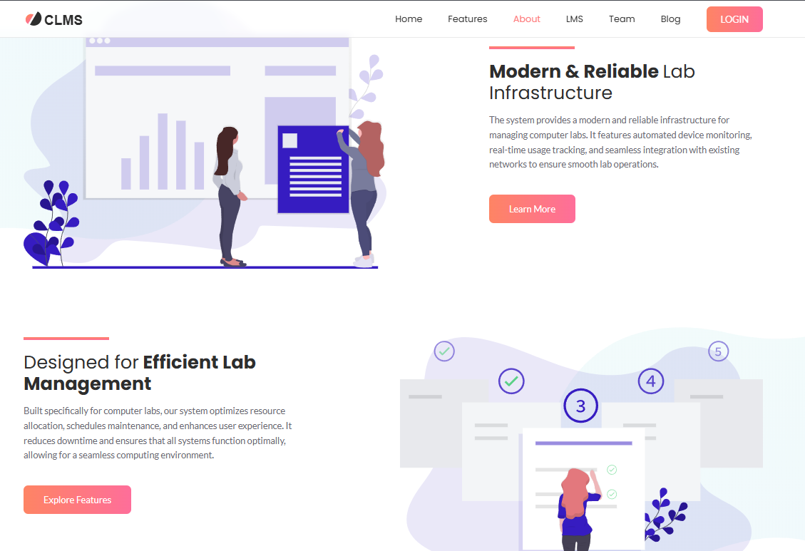

FUTURE SCOPE
- AI-Powered Predictive Maintenance: Integrate AI to predict system failures based on usage patterns.
- Mobile Application: Develop an Android/iOS app for on-the-go management.
- Role-Based Access Control: Finer control over user permissions.
- Cloud Integration: Move to cloud databases for better backup and access.
- User Analytics: Track user behaviour and system usage trends.
- Advanced Reporting Tools: Graphs and charts for management-level insights.
- Integration with Biometric Systems: For even more secure access.
- Multi-Language Support: To accommodate institutions in different regions.
- AI Based Fault Detection: Implement AI for proactive issue detection.
- Remote Monitoring: Enable remote maintenance alerts.

REFERENCE

- ChatGPT
- Google.com
- YouTube
- learn.microsoft.com
- https://www.w3schools.com/php/
- https://www.w3schools.com/MySQL/

BHADRAK ENGINEERING SCHOOL & TECHNOLOGY (BEST),
ASURALI, BHADRAK
PROJECT EVALUATION FORMAT

Name of the project: Group:
SL. NO. | Performance Criteria | Maximum  Mark | Evaluated Marks
1. | Selection of Project as prescribed by SCT&VT | 05
2. | Planning & Execution of Project | 10
3. | Quality of performance | 10
4. | Problem solving capability & end project | 10
5. | Sense of responsibility | 05
6. | Communication/presentation skill | 20
7. | Interpersonal Skill | 10
8. | Report writing skill | 10
9. | Viva voice | 20
 | Total | 100

Sign. of External Sign. of Internal/Project Guide

